CONVENING CIRCULAR

of the

155th Annual Synod

of the

The Diocese of Montreal

2014

CONVOCATION

au

155e Synode Annuel

du

Diocèse de Montréal

2014
Contents
Section A : Convocation Letter to Synod Delegates - Lettre de convocation pour les délégués du Synode 4
Section B : Information for Synod Delegates - Renseignements pour les délégués du Synode 7
Section C : Synod Agenda - Agenda du synode 12
Section D: Nominating Committee of Synod - Comité des nominations du synode 17
Section E: Proposed Canonical Changes / Changements canoniques proposés 20
Section F: Proposed Constitutional Changes - Changements constitutionnels proposés 22
Section G: Motions - Propositions de modifications 24
Section H: Synod Reports - Rapports du synode 28
Diocesan Council 29
Diocesan Council Report 29
Nominating Committee of Diocesan Council 30
Standing Committee on Finance 31
Standing Committee on Finance 31
Standing Committee on Human Resources 32
The Standing Committee on Human Resources 32
Standing Committee on Mission 33
Mission Committee 33
Anglican Church Women 33
Council on Aging 35
Kidstuff 36
Partnerships Committee 36
Primate’s World Relief and Development Fund 37
Stewardship of the Environment Committee 38
Community Ministries 38
Action Réfugiés Montréal 38
Mile-End Community Mission 39
Mission Communautaire Christ Church, Sorel 42
St Michael’s Mission 47
Tyndale St-Georges Community Centre 48
Other Reports 50
Anglican Balanced Funds 50
Anglican Montreal 51
Archives 51
Audit Committee 52
Centre for Lay Education 52
Crosstalk Ministries 53
Ecumenical Officer 55
Fresh Start 55
Lay Readers’ Association 55
Module du Nord Quebecois (MNQ) residence 56
Montreal Diocesan Theological College 57
Proposed development projects 58
Provincial Council 59
Spiritual Direction Group 60
Synod Planning Committee 61
Youth Ministry 61
Youth Chaplain 73
Chaplaincies 73
Concordia University Multi-Faith Chaplaincy 73
Federal Prison Chaplaincy – Cowansville Institution 73
Federal Prison Chaplaincy – Federal Training Centre, Laval 74
Federal Prison Chaplaincy – Drummond Institution, Drummondville 75
Mission to Seafarers – Port Chaplaincy 77
Montreal-Southwest Community Ministries (MSCM) 77
Ste-Anne’s Hospital 78
Reports on National Committees 79
Anglican Fellowship of Prayer – Canada 79
Communications and Information Resources Committee 79
Council of General Synod 80
National Partners in Mission Coordinating Committee 81
Section I: Minutes of Synod 2013 - Minutes du Synode 2013 82
Section J: Audited Financial Statements 2013 - États financiers vérifiés 2013 91
Section K: Draft Budget 2015 - Ébauche du Budget 2015 114
Section L: Parochial Statistics 2013 - Statistiques paroissiales 2013 119

Section A : Convocation Letter to Synod Delegates - Lettre de convocation pour les délégués du Synode

Diocese of Montreal  The Anglican Church of Canada |  | Diocèse de Montréal  Église anglicane du Canada

September 18, 2014

To the members of Synod

Ladies and Gentlemen:

We hereby advise you that the Synod of the Diocese of Montreal will convene for its 155th Annual Session on Saturday, October 18th, 2014 in Fulford Hall, 1444 ave Union, Montreal. Registration opens at 7:30.

Synod is a time to address the business of the Diocese; and it is also an important opportunity to share in God's call. Our theme for Synod 2014, “Called to Grow”, reflects what I believe is a growing hunger for justice and faithful witness in our church communities and beyond.

The Synod Eucharist will be held at 8:30 am in Christ Church Cathedral. The Bishop will deliver his address in worship, in lieu of a sermon. Note: There is a $20 registration fee for ALL attendees, which includes lunch, refreshments and snacks (see registration information available at www.montreal.anglican.ca). Parishes are strongly encouraged to financially support their elected delegates.

It is important to note that, in order to have a voice on the floor of Synod and to be able to vote, delegates must register during the time allotted Saturday morning.

All elected delegates are welcomed to register in the Main Foyer of the Synod office, from 7:30 – 8:30 am Saturday morning.

Clergy are asked to dress in their clerical attire, so that they may be identified by lay and new members of Synod.

Blessings,

Bishop Barry B. Clarke, Chair
The Revd Sophie Rolland, Clerical Secretary of Synod
Valerie Taylor, Lay Secretary of Synod

PS. Please note that the convening circular can be found online at: www.montreal.anglican.ca.
If you do not have access to the internet, please call us at the Synod Office, 514-843-6577 to make other arrangements by October 3rd, 2014.

Diocese of Montreal  The Anglican Church of Canada |  | Diocèse de Montréal  Église anglicane du Canada

Le 18 septembre 2014

Aux membres du synode

Mesdames et messieurs:

Veuillez prendre note que le synode du diocèse de Montréal se réunira pour sa 155e assemblée le samedi 18 octobre 2013 dans la Salle Fulford au 1444, avenue Union, Montréal. Les inscriptions commencent à 7h30.

Le Synode est un moment pour aborder les affaires du diocèse; et c'est aussi une occasion importante de partager l'appel de Dieu. Notre thème pour le Synode 2014, "appelés à croitre", reflète ce que je crois être une faim croissante de justice et de témoignage fidèle au sein de notre communauté et bien au-delà.

La Messe du synode sera célébrée à 8h30 dans la Cathédrale Christ Church. L’allocution de l’évêque tiendra lieu de sermon. N.B. : La participation à ce synode est de 20$ par participant (vous trouverez le formulaire d’inscription à www.montreal.anglican.ca). Ce montant couvre les dîners, les collations et les rafraichissements. Nous encourageons vivement les paroisses à le proposer à leurs délégués élus.

Nous vous rappelons que, pour avoir les droits de parole et de vote durant l’assemblée synodale, les délégués doivent s’être inscrits le samedi matin.

Nous invitons donc tous les délégués élus à se présenter à l’entrée principale du bureau du synode entre 7h30 à 8h30 le samedi matin pour l’inscription.

Les membres du clergé sont priés de bien vouloir porter un habit ecclésiastique (chemise et col romain) afin qu’ils soient facilement identifiables par les laïcs et nouveaux membres du synode.

Que Dieu vous bénisse,

Monseigneur Barry B. Clarke, président
La rév. Sophie Rolland, secrétaire-greffière du clergé
Valerie Taylor, secrétaire-greffière des laïcs

PS. Veuillez prendre note que la circulaire de convocation est disponible au: www.montreal.anglican.ca.
Si vous n’avez pas accès à internet, veuillez nous contacter au bureau du synode au 514-843-6577 afin de prendre arrangement au plus tard le vendredi 3 octobre 2014.

Section B : Information for Synod Delegates - Renseignements pour les délégués du Synode

Information for Delegates to the 2014 Synod
- The Convening Circular
This circular is available online at www.montreal.anglican.ca. If you need a printed version of the circular, please call the Synod Office at 514-843-6577 to make arrangements by October 3rd, 2014. Please do not discard your Convening Circular after Synod. It contains reports of committees, financial statements, and parish statistics that are part of the official proceedings. In order to conserve paper and cut costs, it was decided at the 1996 Synod not to reprint this information in the Synod Journal. The official bound copy of the Journal kept on file in the Diocesan Archives will contain a complete set of reports.
- Directions to Synod
The business meeting of Synod will take place in Fulford Hall, which is located on the second floor of Cathedral Place – Tour KPMG – entrance located at 1444 Union Avenue.
- Parking
Indoor public parking is available in the Cathedral Place – Tour KPMG Parking Garage (on Union Avenue, south of de Maisonneuve). Parking on Saturday is available at $7 (cash only) all day (8 am to 12 am) without voucher. If you prefer to use public transit, the nearest Metro station is McGill.
- Registration
Please note that there will be a $20 registration fee due at the time of registration to Synod. This fee includes all snacks and refreshments, as well as lunch.
- New Delegates
On Saturday morning, from 10:00 – 10:30am, a briefing session for new Synod Delegates will take place in the Chapel on the second floor of Cathedral Place – Tour KPMG. A document entitled “New Delegate Handbook” is available for download from the diocesan website at www.montreal.anglican.ca/synod.
- Coffee Cups
Unfortunately, we do not have facilities to wash 300 coffee cups following each coffee break; taking an eco-stance, this year again the Synod Planning Committee kindly asks you to please bring your own reusable cup or mug to Synod. There will only be a limited supply of eco-friendly cups available.
- Water Coolers and Coffee Stations
Water coolers and refreshment stations will be located on the second floor of Cathedral Place - Tour KPMG near Fulford Hall as well as in the main foyer. You are welcome to bring your own water bottles for refill.
- No Smoking
Cathedral Place - Tour KPMG is a non-smoking area.
- Agenda
The Chairman will attempt to deal with motions at the times listed in the Agenda, but the debating process may make changes necessary.
- Concerning Delegate Status
Only delegates and/or substitute delegates whose names were previously submitted to Synod Office may register and vote at Synod. If both delegate(s) and substitute delegate(s) are unable to serve, the parish must hold another Vestry Meeting to elect a new delegate(s). Please note that Sophie Bertrand (sophieb@montreal.anglican.ca or (514) 843-6577 ext. 232) must be notified (in advance of Synod) of the date of the Vestry Meeting and given the name(s) and the pertinent information of the new delegate(s) elected. Delegates and/or substitute delegates registered on the first day of Synod are the representatives for the entire Synod and may not be replaced at any point during Synod.
- Voting Privileges
We draw your attention to point 13 under Section A – Constitution of Synod:

A.13 No delegates shall be allowed to take part in the proceedings of Synod, so long as any assessment payable to the Diocese by the parishes, missions or cures which they represent, for any prior year remains unpaid.
Diocesan Council, at their meeting of September 8, 1998, approved the following interpretation of Section A.13:

- The intent of A-13 is to illustrate the seriousness of not paying all assessments, but without excluding congregations from any part of diocesan life.
- The impediment at Synod would apply only to votes on matters financial.
- It would apply only to lay delegates (the licensed clergy being present by right).
- It applies to arrears for the previous year.

Renseignements pour les délégués du Synode de 2014
- La circulaire de convocation
Ce document est disponible en ligne à www.montreal.anglican.ca. Si vous n’avez pas accès à internet, veuillez nous contacter au bureau du synode au 514-843-6577 afin de prendre arrangement au plus tard le vendredi 26 septembre 2014. Veuillez ne pas le jeter après le synode, vu qu’il contient les rapports des comités, les états financiers et les statistiques des paroisses, ces informations faisant partie des travaux officiels. Les délégués du synode de 1996 ont décidé de ne pas les ré-imprimer dans le Journal du Synode pour économiser le papier. L’exemplaire officiel du Journal contiendra tous les rapports et sera gardé dans les archives du diocèse.
- Le lieu du synode
La séance de travail se tiendra dans la Salle Fulford au premier étage de la Place de la Cathédrale (la tour KPMG) et l’entrée se situe à 1444, avenue Union.
- Le stationnement
On peut stationner sa voiture dans le Garage de la tour KPMG, place de la Cathédrale. L’entrée se trouve sur l’avenue Union, au sud de De Maisonneuve. Le coût le samedi est de 7$ pour toute la journée (de 8h à minuit) sans bon de stationnement. Si vous préférez prendre les transports en commun, le métro le plus proche est McGill.
- Les inscriptions
Veuillez noter qu’elle coûte 20$ et qu’elle est perçue immédiatement. Le montant couvre les repas, boissons et collations.
- Les nouveaux délégués
Il y aura une séance d’orientation pour eux le samedi matin entre 10h et 10h30 dans la chapelle du premier étage de la Place de la Cathédrale. On peut télécharger un document appelé « Guide pour les nouveaux délégués » depuis le site-web du diocèse à www.montreal.anglican.ca/synod.
- Les tasses à café
Nous n’avons pas la place, malheureusement, de laver 300 tasses après chaque pause-café. Cette année encore, le Comité organisateur du synode vous prie de bien vouloir apporter votre propre tasse ou mug réutilisable au synode. Il n’y aura qu’un nombre limité de tasses par éco-geste.
- Les distributeurs d’eau et les coins-café
Ils se trouveront à côté de la Salle Fulford, au premier étage de la Place de la Cathédrale, dans la tour KPMG, ainsi que dans le vestibule de verrière (entrée principale). Nous vous invitons à apporter votre bouteille pour la remplir d’eau.
- Défense de fumer
La Place de la Cathédrale et la tour KPMG sont des zones non-fumeurs.
- L’ordre du jour
Le président tentera d’y intégrer les propositions de modification qui y seront inscrites, mais il peut y avoir des changements dûs aux débats.
- Votre statut de délégué
Ne peuvent s’inscrire et voter que les délégués et leurs suppléants dont les noms ont été envoyés à l’avance au bureau du synode. Si les deux, délégué et suppléant, ne peuvent remplir leur mandat, la paroisse concernée doit en élire d’autres en assemblée générale. Sophie Bertrand (sophieb@montreal.anglican.ca ou (514) 843-6577, poste 232) est la personne à qui on adresse les noms des représentants ainsi que la date de l’assemblée paroissiale, et ce, avant le début du synode. Les délégués ou suppléants qui sont inscrits le premier jour du synode sont les représentants de leur paroisse pour la durée des travaux et ne peuvent être remplacés pendant leur cours.
- Le droit de vote
Nous attirons votre attention au point 13 de la Section A de la Constitution du synode.
A.13 Dans le cas où une paroisse, une mission ou tout autre organisme n’est pas à jour dans le règlement de leur cotisation de l’année en cours ou des années précédentes, son délégué ne sera pas autorisé à participer aux débats ou votes.
Le Conseil du diocèse, à sa séance du 8 septembre 1998, a approuvé l’interprétation suivante de la Section A.13 :
1. Le but de A-13 est d’illustrer l’importance de payer les cotisations au complet, mais sans pénaliser les paroisses de toute participation aux décisions diocésaines.
2. La pénalisation au synode ne s’appliquerait qu’aux votes sur des questions financières.
3. On ne la ferait appliquer qu’aux délégués laïcs (le clergé étant présent de droit).

Section C : Synod Agenda - Agenda du synode

“Called to Grow”
October 18th 2014

7:30 am | Registration of Delegates |  | Main Foyer
8:30 am | Quorum | David Eramian | Christ Church
8:35 am | Synod Eucharist & Bishop’s charge | Bishop Barry Clarke  Worship Team | Christ Church

Opening Session of Synod
10:00 am | New Delegates Orientation / Coffee break | Michael Johnson | Chapel / Hollis Lounge
10:30 am | Safety Announcements | Janet Griffith | Salle Fulford
10:40 am | Story #1 – St. Peter's TMR | Chris Barrigar | Salle Fulford
10:55 am | Greetings from Ecumenical Partners | Stephen Petrie | Salle Fulford
11:10 am | Opening business/Nominations | Janet Griffith | Salle Fulford
 | - Election of Lay Secretary of Synod
 | - Election of Clerical Secretary of Synod
 | - Election of Diocesan Treasurer
 | - Appointment of Auditors
 | - Approval of Minutes of 2013 Synod
 | - Appointment of Committees of the House | As posted
 | - Privileges of the Floor | As posted
 | - Regrets
 | - Report of Synod Nominating Committee | Convening Circular
 | - Introduction of Nominees | Convening Circular
 | - Presentation of Motions, Memorials and Petitions | Convening Circular
 | - Presentation of Canonical Changes | Convening Circular
 | - Reception of Report of Diocesan Council | Convening Circular
 | - Reception of Reports on Parochial Statistics | Convening Circular
 | - Reception of Other Reports | Convening Circular
11:50 am | Grace | Bishop Barry Clarke
 | Balloting opens | Bishop Barry Clarke | Chapel
12:00 am | Lunch | Coop Le Milieu | Hollis Lounge
12:55 pm | Hymn | Chris Barrigar /  Sally Harrington | Salle Fulford
1:05 pm | Story #2 - Report from Masasi | Bill Gray / Michael Johnson | Salle Fulford
1:25 pm | Finance presentation | Norman Spencer | Salle Fulford
1:55 pm | Questions period re: Finance | Norman Spencer | Salle Fulford
2:10 pm | Council of the North Video | Sue Winn | Salle Fulford
2:30 pm | Stewardship presentation | Michael Johnson | Salle Fulford
2:40 pm | Youth Ministry Report | Youth Team | Salle Fulford
2:55 pm | Afternoon Break |  | Hollis Lounge
3:15 pm | Worship | Youth | Salle Fulford
3:30 pm | Story # 3 –Video (Young adults Sharing) | Afra Saskia Tucker | Salle Fulford
3:45 pm | MDTC video | Afra Saskia Tucker | Salle Fulford
3:55 pm | Balloting Closes | Bishop Barry Clarke
4:00 pm | Anti-Spam Legislation Presentation & Discussion | Michael Patry / David Eramian | Salle Fulford
4:30 pm | Motions / Members forum | Bishop Barry Clarke | Salle Fulford
5:30 pm | Closing Prayer, followed by Musical video by St. Barnabas Youth | Bishop Barry Clarke | Salle Fulford
6:00 pm | Wine and Cheese Reception | Marie Landry at the piano | Salle Fulford

« Appelé à croître »
18 octobre 2014

7h30 | Inscription des délégués |  | Vestibule verrière
8h30 | Quorum | David Eramian | Christ Church
8h35 | Messe du Synode et charge de l’Évêque | Évêque Barry Clarke  Équipe de prière | Christ Church

Session d’ouverture du synode
10h00 | Stage d’accueil pour les nouveaux délégués / Pause-café | Michael Johnson | Chapelle / Salon Hollis
10h30 | Annonce pour la sécurité | Janet Griffith | Salle Fulford
10h40 | Histoire #1 – St. Peter's TMR | Chris Barrigar | Salle Fulford
10h55 | Salutations des partenaires | Stephen Petrie | Salle Fulford
11h10 | Remarques préliminaires/Nominations | Janet Griffith | Salle Fulford
 | - Élection du secrétaire laïc du Synode
 | - Élection du secrétaire clerc du Synode
 | - Élection du trésorier du diocèse
 | - Nomination des vérificateurs
 | - Approbation du procès-verbal du Synode 2013
 | - Création des comités | Comme indiqué à la table de documentation
 | - Privilèges des intervenants | Comme indiqué à la table de documentation
 | - Membres absents
 | - Rapport du Comité des nominations du synode | Circulaire de convocation
 | - Présentation des candidats | Circulaire de convocation
 | - Présentation des modifications, mémentos et pétitions | Circulaire de convocation
 | - Présentation des changements aux canons | Circulaire de convocation
 | - Réception du Rapport du Conseil du diocèse | Circulaire de convocation
 | - Réception des Rapports statistiques des paroisses | Circulaire de convocation
 | - Réception d’autres rapports | Circulaire de convocation
11h50 | Grâce | Évêque Barry Clarke
 | Ouverture du scrutin | Évêque Barry Clarke | Chapelle
midi | Dîner | Coop Le Milieu | Salon Hollis
12h55 | Hymne | Chris Barrigar /  Sally Harrington | Salle Fulford
13h05 | Histoire #2 – Nouvelles de Masasi | Bill Gray / Michael Johnson | Salle Fulford
13h25 | Situation financière | Norman Spencer | Salle Fulford
13h55 | Période de questions concernant la situation financière | Norman Spencer | Salle Fulford
14h10 | Vidéo du Conseil du nord | Sue Winn | Salle Fulford
14h30 | Présentation sur l’intendance (Stewardship) | Michael Johnson | Salle Fulford
14h40 | Rapport de la Pastorale de la jeunesse | Équipe jeunesse | Salle Fulford
14h55 | Pause d’après-midi |  | Salon Hollis
15h15 | Prière | Youth | Salle Fulford
15h30 | Histoire # 3 –Vidéo (Partage de jeunes adultes) | Afra Saskia Tucker | Salle Fulford
15h45 | Vidéo du MDTC | Afra Saskia Tucker | Salle Fulford
15h55 | Fermeture du scrutin | Évêque Barry Clarke
16h | Présentation sur la loi anti-spam et discussion | Michael Patry / David Eramian | Salle Fulford
16h30 | Propositions de modifications / Débat | Évêque Barry Clarke | Salle Fulford
17h30 | Prière de fermeture suivie de la vidéo musicale du groupe de jeunes de St. Barnabas | Évêque Barry Clarke | Salle Fulford
18h00 | Réception vins et fromages | Marie Landry au piano | Salle Fulford

Section D: Nominating Committee of Synod - Comité des nominations du synode

COMMITTEES OF SYNOD APPOINTED BY SYNOD
- Nominating Committee for Boards, Delegations, & Committees Appointed or Elected by Synod

The Territorial Archdeacons, The Executive Archdeacon, The Dean, The Clerical and Lay Secretaries, The Comptroller
Convenor: The Executive Archdeacon

- Diocesan Court
The Revd Dr Chris Barrigar, The Ven. James W. Bennett, The Revd Bill Gray, The Rev. Neil Mancor, The Revd James Pratt, The Revd Michael Johnson, The Revd Canon Ralph Leavitt, , The Revd Eleanor Caruana, The Revd Canon Linda Borden Taylor, The Revd Keith Schmidt, The Ven. Michael Robson, The Revd Karen Egan
COMMITTEES OF SYNOD ELECTED BY SYNOD
Nominations for Election to Diocesan Council by Synod 2014
(3 of each order to be elected for a one-year term)

Clergy Lay
The Rev’d Robert Camara Mrs. Sharon Miller
The Ven. Michael Robson

- More names to come from the floor of Synod

Elected to Diocesan Council by Deanery Chapters
(one lay or clergy elected for a three-year term, alternating)

Clergy Laity
The Rev’d Shirley Smith, Pte-Claire (2012) Ms. Valerie Bennett, South Shore (2014)
The Rev’d Michelle Eason, Ste-Anne (2012) Ms. Jane Aitkens, Chris Church Cathedral (2013)
The Rev’d Paul Tidman, Laurentians (2013)
The Rev’d Keith Schmidt, Hochelaga (2014)
The Rev’d Karla Holmes, Western Montreal (2014)
The Rev’d Andy O’Donnell, Bedford/Brome-Shefford (2014)

Youth
Miss. Antoinette Lynch Joseph,

2014 Diocesan Council

Ex-Officio Members: The Diocesan Bishop, The Executive Archdeacon, The Clerical and Lay Secretaries of Synod, The Treasurer, Members of the Council of General Synod and of Provincial Council

Non-Voting Members: The Comptroller, The Chancellor, The Vice-Chancellor, The Church Advocate, and Chairpersons of Diocesan Council Standing Committees

Diocesan Delegate Nominations for Election to Provincial Synod 2015
(2 of each order, plus 2 alternates of each order
and one Lay Delegate between the age of 16 and 24, plus one alternate)

Clergy Delegates
The Rev. James Pratt
The Ven. Michael Johnson

Lay Delegates
Mrs. Irene Martin
Mrs. Valerie Bennett

Lay Delegate between the age of 16 and 24

- More names to come from the floor of Synod

Section E: Proposed Canonical Changes / Changements canoniques proposés

No change proposed.

Section F: Proposed Constitutional Changes - Changements constitutionnels proposés

Motion 1 - Constitution of Synod (1995)

Moved by: Bill Gray
Seconded by: James Pratt

Be it so MOVED that the Constitution of Synod (1995) Section (D), Paragraph (3.) be amended as follows:

REMOVE:
The Council will meet within thirty days of its election and will, as its first task, elect a vice-chairperson who will hold office until the next Synod. Thereafter, it will meet monthly, except in July and August, or at the call of the chairperson, or at the request of any five voting members, with at least ten days written notice having been given.

INSERT:
The Council will meet within forty five days of its election and will, as its first task, elect a vice-chairperson who will hold office until the next Synod. Thereafter, it will meet at least every three months, or at the call of the chairperson, or at the request of any five voting members, with at least ten days written notice having been given.

Proposition 1 – Constitution du synode (1995)

Proposée par: Bill Gray
Appuyée par: James Pratt

Qu’il soit RÉSOLU que la Constitution du synode (1995) - Section (D), paragraphe (3.) - soit amendée comme suit :

SUPPRIMER:
Le Conseil se réunira dans les trente jours suivant son élection et aura, pour premier mandat, l'élection d'un vice-président qui sera en fonction jusqu'au prochain Synode. Par la suite, il se réunira chaque mois, sauf en juillet et en août, ou à la demande du président, ou à la demande de cinq membres ayant un droit de vote, au moyen d’un préavis écrit d’au moins dix jours .

REMPLACER PAR:
Le Conseil se réunira dans les quarante-cinq suivant son élection et aura, pour premier mandat, l'élection d'un vice-président qui sera en fonction jusqu'au prochain Synode. Par la suite, il se réunira au moins à chaque trois mois, ou à la demande du président, ou à la demande de cinq membres ayant un droit de vote, au moyen d’un préavis écrit d’au moins dix jours.

Section G: Motions - Propositions de modifications

Motion “A” – Election of a Diocesan Treasurer
Moved by: Michael Robson
Seconded by: Bill Gray

Be it RESOLVED, that Synod elect Mr Norman Spencer as Diocesan Treasurer.
Motion «A» – Élection du trésorier diocésain
Proposée par: Michael Robson
Appuyée par: Bill Gray

Qu'il soit RÉSOLU que le Synode élise M. Norman Spencer à titre de trésorier diocésain.
Motion “B” – Nomination of Auditors
Moved by: Ralph Leavitt
Seconded by: Michael Robson

Be it RESOLVED, that Synod nominate the firm of BDO Dunwoody LLP to serve as Auditors for the 2014 fiscal year.
Motion «B» – Nomination des vérificateurs
Proposée par: Ralph Leavitt
Appuyée par: Michael Robson

Qu'il soit RÉSOLU que le Synode nomme la firme BDO Dunwoody s.r.l. à titre de vérificateur pour l'exercice financier 2014.
Motion “C” – Budget
Moved by: Michael Johnson
Seconded by: Bill Gray

Be it RESOLVED, that Synod adopt the 2015 Operating Budget as published.
Motion «C» – Budget
Proposée par: Michael Johnson
Appuyée par: Bill Gray

Qu'il soit RÉSOLU que le Synode adopte le budget de fonctionnement pour l'année 2015 tel que publié.

Motion “D” – The marginalized and vulnerable
Proposed: Paul Kennington
Seconded: Chris Barrigar

Be it RESOLVED, that this synod asks General Synod of the Anglican Church of Canada to affirm ministry with the marginalized and vulnerable as normal church activity.

Context:

- In the light of the third Mark of Mission of the Anglican Communion ‘To respond to human need by loving service, the ordination examination of deacons ‘In the name of Jesus Christ, you are to serve all people, particularly the poor, the weak, the sick and the lonely’ and the ordination promises of bishops to be ‘merciful to all, show compassion to the poor and strangers, and defend those who have no helper’;

- and recognising that the ‘poor, the weak, the sick and the lonely, strangers, and those who have no helper’ are marginalized and vulnerable, and include people who are homeless, people with multiple needs, including mental health issues and addictions, refugees, the poor, hungry and people in any kind of distress or pastoral need, ex-prisoners and people with a criminal record including sex-offenders, irrespective of their race, age, religion, social status or sexuality;

- and service in the name of Jesus Christ to the marginalized and vulnerable includes offering ‘service, mercy, compassion and defence’, in the form of pastoral care, counselling, advocacy, with hospitality, food and drink, welcome and safety in our church grounds and on our church property, in addition to responding to their spiritual needs;

- and fully recognising the need to follow correct procedures, best practice and due diligence in all areas of ministry;

- and noting that there is currently a lack of legal and administrative clarity that all forms of ministry identified in parts 2 and 3 above are indeed ‘normal church activity’ which can lead to uncertainty about insurance indemnity and other legal defences for clergy, corporations and church institutions;

Motion «D» – Ministère auprès des personnes marginalisées et vulnérables
Proposée par: Paul Kennington
Appuyée par: Chris Barrigar

Qu'il soit RÉSOLU que ce Synode demande au Synode général de l'Église anglicane du Canada d'attester le ministère auprès des personnes marginalisées et vulnérables en tant qu’activité normale de l'église.

Contexte:

- A la lumière de la troisième des Marques de la Mission de la Communion anglicane : « Répondre par amour aux besoins humains », l'examen de l’ordination des diacres « Au nom de Jésus-Christ, vous servirez auprès de tous, en particulier les pauvres, les faibles, les malades et les personnes seules » et les promesses d'ordination des évêques d’être « miséricordieux pour tous, de faire preuve de compassion pour les pauvres et les étrangers, et de défendre ceux qui n'ont pas d’aide »;

- et en reconnaissant que «les pauvres, les faibles, les malades et les personnes seules, les étrangers, et ceux qui ne bénéficient pas d’aide sont marginalisées et vulnérables, et notamment les personnes qui sont sans-abri, les personnes ayant des besoins multiples, y compris lorsqu’il est question de dépendances et de la santé mentale, les réfugiés, les pauvres, les affamés et les gens dans n'importe quel type de détresse ou de nécessité pastorale, les ex-détenus et les personnes ayant un casier judiciaire, y compris les délinquants sexuels, quelle que soit leur race, l'âge, la religion, le statut social ou la sexualité;

- et le service offert au nom de Jésus-Christ auprès des marginalisés et vulnérables comprend «le service, la miséricorde, la compassion et la défense», sous la forme de soins pastoraux, de conseils, de plaidoyers, d’hospitalité, de nourriture, d’accueil et de sécurité sur le terrain et la propriété de notre église, en plus de répondre à leurs besoins spirituels;

- et reconnaissant la nécessité de suivre les procédures correctes, les meilleures pratiques et une diligence raisonnable dans tous les domaines du ministère;

- et de noter qu'il existe actuellement un manque de clarté juridique et administrative que toutes les formes de ministère identifiés dans les parties 2 et 3 ci-dessus font partie de «l'activité normale de l'église» ce qui peut conduire à l'incertitude quant à l'indemnité d'assurance et d'autres moyens de défense juridique pour le clergé, les corporations et l'église;

Section H: Synod Reports - Rapports du synode

Diocesan Council

Diocesan Council Report
  - Valerie Taylor and Sophie Rolland
September 10, 2013 Meeting
Janet Marshall reported on the formation of a new Grants and Loans Sub Committee.
Council received the 2014 Budget.
Council adopted the July Financial Statement.
Council heard about the motions that were being brought to Synod.
November 12, 2013 Meeting
Janet Marshall led an orientation for new and returning members of council.
The Rev. Paul Tidman was acclaimed co-chair.
Council received a report on the “Repurposing our Inheritance-Grants & Loans.” Funds for this project will come from the sale of property: 70% invested; 20% low interest loans for property; 10% grants for new ministries. It was noted that there is a desire to release available funds by March of 2014. Mr. Mark Dunwoody spoke about the 10% Grants for new ministry.
Council accepted the Financial Report.
January 14, 2014 Meeting
Council adopted a motion to become a Companion of the Episcopal Diocese of Jerusalem.
Council ratified a short-term loan paid to St. George’s, Clarenceville.
The Bishop reported to council that last year two grant applications came through Council from parishes in our diocese, both of which have been granted by the Anglican Foundation.
Nominations for Golf Tournament Committee were solicited from council.
Council received the October financial statements.
Upon a request by The Cathedral, council authorized the Bishop to select representatives to meet with the Dean to discuss issues regarding the lease of the office space at 1444 union.
In the members’ forum, the Rev Karen Egan gave a report on the most recent meeting of the Council of General Synod.
The bishop read a letter from Isaac Mukasa, the General Synod Representative on African Affairs hoping that more Canadian dioceses will be able to form partnerships and improve relationships with African dioceses. This is in response to increased tensions due to divergent views on same sex issues.
The Chancellor suggested that Bishop Barry send a letter of congratulations to Monseigneur Lacroix, Archbishop of Quebec, upon his recent appointment, by Pope Francis, to the House of Cardinals. The Bishop agreed to do so.
February 11, 2014 Meeting
In his announcements, the Bishop circulated a copy of the Baptismal Covenant revisions which were adopted at General Synod 2013 and noted that the new wording should be included in Baptismal and Confirmation Liturgies.
Council received a presentation on the work being undertaken to create a new visual identity for the Diocese.
March 11, 2014 Meeting
Bishop Barry noted that March 30th, in the Cathedral there would be a service of Ordination to the Priesthood.
Bishop Barry intends to reintroduce into the Diocese, the ministry of the Anglican Fellowship of Prayer. Mrs. Valerie Bennett and Ms. Stacey Neale will be co-Chairs.
Council adopted a motion to increase the membership on the PWRDF Committee from 7-9 members.
Council received a draft Harassment Policy.
Council passed a motion support, in principal, the Anglican Foundation grant application by St Barnabas St Lambert.
Council heard a presentation by Mr. Evans on a program called “Roots” for young leaders.
April 8, 2014 Meeting
Council received the Anti-Harassment Policy which makes it now a public document which can be distributed
The Chancellor updated council on the progress of the review of the terms of the Emphyteutic Lease.
Council received the February Financial Statements.

Nominating Committee of Diocesan Council
  - Michael J. Robson

The Nominating Committee has the primary responsibility for making recommendations to Diocesan Council for the filling of vacancies on the various diocesan committees, having first determined that those recommended will be willing to serve, if Council elects them. The committee consists of 6-9 members, clergy and lay, chosen from across the diocese, as well as the Vice-Chair of Diocesan Council, who is a member ex-officio, and Nicki Hronjak, from the Programme Office. Nicki keeps us on track and without her help we would have far more difficulty doing the work we have been charged with. I have the privilege of serving as the chair of the committee.

The Nominating Committee is presently in a time of transition as a number of members have come to end of their terms or are about to do so. We thank Eric Dryden, Joyce Sanchez, Verna Paris and Eileen Steele (who will finish in November) for their service and know that they will continue to be valuable and valued members in the life of the diocese. There are always vacancies occuring, on one committee or another, throughout the year and sometimes it can take some time to fill a particular opening, so we are always looking for people willing to serve and are happy to receive suggestions. Elsewhere in these reports, you will find more specific information about the various diocesan committees and the work that they do. If you are interested in being part of one of those committees, or can suggest someone who might make a good member, please speak to one of us who are listed below. Even if a particular committee does not have any openings at the present time, we are glad to have a list of names ready for consideration when a vacancy does occur. At the time of writing, the members of the Nominating Committee are Eileen Steele, June Harris, Paul Tidman, Christine Ralph, Nicki Hronjak and myself. Anyone of us will be pleased to pass on suggestions to the full committee.

I want to thank all of the members who served this past year for their hard work and gracious commitment of their time.

Standing Committee on Finance

Standing Committee on Finance
  - Michael Hiles

The Finance Standing Committee has met regularly during the year to fulfill its mandate to assist the Treasurer with respect to the articulation, promotion, coordination, and supervision of the Synod’s financial affairs, and to do so in a manner consistent with strategic goals set out by Diocesan Council.
Synod’s financial management is proceeding in a very competent and satisfactory manner. Our monthly review of the financial statements reveals that expenses are generally managed well against the annual budget, and the income is usually close to what was anticipated.
Thanks are due to the Manager, Financial Services (Stephen Tam) and the Treasurer (Norman Spencer). The Finance Committee and Diocesan Council receive financial statements and all important financial information on time. Financial information is presented clearly and consistently, and it is easy to understand. Financial information focuses on the important aspects of the operations and financial health of Synod.
When there are variances between budget and actual, they usually represent some modest expense that could not have been foreseen when developing the annual plan and budget. When variances are noteworthy, we are advised promptly and they are generally due to either a carefully considered decision, or often a question of timing.
Financial management is tightly controlled, under the joint management of the Bishop, the Executive Archdeacon, the Treasurer and the Financial Services Manager. Our financial capacity and long-term health is always a factor when making operating decisions.
We are fortunate that our accounting and control functions are operating very well under the management of Stephen Tam, Manager, Financial Services. We owe Stephen and his team a vote of thanks for their excellent work throughout the year. We also want to thank the Treasurer, Mr. Norman Spencer, for his commitment in overseeing the financial management of Synod’s affairs, and for advising on longer-term strategy.
In addition to our normal work, we participated in the development of a Loans & Grants policy, based on a motion at Synod 2012, with assistance and leadership from the Executive Archdeacon and Janet Marshall.
Our overall Synod finances remain tight. We are running a small but manageable deficit. We are not facing any financial crises, but long-term deficits are an issue to be taken seriously.
We are mindful that sources of income are generally static at best. We are very reluctant to increase assessments on parishes, many of which also have financial strains. Even though we strive to maintain our total assessment on parishes, we recognize that parishes are fewer than in prior days, and fewer Anglicans are being asked to shoulder a greater burden. It is also difficult for the Synod office to increase other sources of income. We are constantly looking for ways to responsibly cut expenses while continuing to be both viable and effective in pursuing our Christian mission.
While our meetings focus mainly on reviewing financial reports, which consistently demonstrate good management, we sometimes pursue discussions about the wider problems confronting the Diocese. We know that we are not alone in our concerns regarding the financial and overall health of parishes and other entities around the Diocese. We are open to, and looking for, effective ideas that will support the fundamental mission of being a Christian in the intermediate and longer term.

Standing Committee on Human Resources

The Standing Committee on Human Resources
  - Bill Gray

Chair- The Venerable Bill Gray, Territorial Archdeacon

Members: The Reverend Robert Camara, The Reverend Karla Holmes, The Reverend Jean Willcocks, The Reverend Canon Joyce Sanchez, Mr. Frank Dottin, Ms. Dianne Bradshaw, Ms. Leslie Brooks, Ms Eve Marshall, The Ven. Janet Griffith, Executive Archdeacon, Ms. Sophie Bertrand.

The Diocesan HR Committee usually meets monthly excluding the summer and has enjoyed good attendance and support among committee members who have worked hard and enthusiastically in the past year on a number of demanding projects with concrete results.

The work of the Human Resources can be summarized as follows.

- The Clergy Handbook continued to be reviewed on a section by section basis with recommended updates and suggested review by the relevant diocesan office or committee most responsible for the ministry of each particular section.
- The Diocesan Clergy Continuing Education policy and program was revised and updated, based on recommendations resulting from a clergy continuing education survey coordinated by Janet Marshall, Congregational Development Officer. Upon identifying educational priorities for clergy and the diocese we have established an updated diocesan continuing education diocesan policy and handbook. Among other things this policy establishes diocesan requirements, a method for tracking and giving clergy educational credit, creates diocesan sponsored professional educational development opportunities and programs, and opportunities for policy review and input by clergy.
- Established an anti harassment and anti bullying diocesan policy as approved by Diocesan Council as requested by the Bishop of Montreal in his charge to the 2013 Synod of the Diocese of Montreal.
- The Diocesan Social Media Policy was reviewed at the request of Episcopal Council with recommendations for Diocesan Council to update, re-distribute and publicize.
- Retired Clergy representatives were surveyed by the Reverend Robert Camara with regard to assessing their current needs regarding ongoing diocesan support. Recommendations are pending.
- Established a program for creating opportunities and methods for educating clergy about these new diocesan policies and initiatives including updated Safe Church diocesan policies.

Our thanks to the tremendous staff support and follow up work towards implementation by Sophie Bertrand, Human Resources Director, Executive Archdeacon Janet Griffith and Janet Marshall, Congregational Development Officer.

Standing Committee on Mission

Mission Committee
  - Sophie Rolland

Over the last year we in the Mission Committee have been busy rethinking our vision for the committee and its place in the diocese. In conversation with the Bishop, we have narrowed the scope of our mandate in order to better reflect what we are passionate about and share that passion in the diocese.

We are continuing to offer grants up to $2000 to allow churches, groups and individuals to live out new ministry initiatives. For more information on grant criteria, please visit http://www.montreal.anglican.ca/en/Serve/-Grants-and-Loans/Standing-committee-on-Mision. Over the last year we have issued grants for enhanced music ministry, youth ministry projects, a family fair day, and community outings for a local community mission. We have also issued grants for technology such as projectors and music players to help parishes do ministry in their contexts. Lastly, we have offered support to a parish that wanted to send representatives to a parish nursing conference. These grants are offered in conversation with the GUM grants which have different granting criteria.

The other important part of our mandate is to organize events that would be of interest in the diocese. This year we are organizing workshops to discuss issues surrounding our properties and how we can maximize our assets. Lastly, as a committee, we are also a place to liaise with groups and individuals about their ministry goals. For example, this year we recommended to Diocesan Council that the diocese apply to become a Companion to the Episcopal Diocese of Jerusalem – and offered to pay the first year’s costs. We also continue to liaise with community groups.

Anglican Church Women
  - Gloria Augustus

The Anglican Church Women purpose is to unite all women of the Diocese in a fellowship of worship, study, and offering, with the aim of deepening and strengthening their individual spiritual lives and of awakening a greater desire for Christian service in the parish, community and the world.

On October 3 - 6, 2013, I attended the National Anglican Church Women Conference in Halifax Nova Scotia, hosted by the Diocese of Halifax. The Theme for the Conference: Women of Faith, Women of Courage. The Conference was held at the New Anglican Diocesan Centre in the heart of downtown Halifax, beside the Cathedral Church of All Saints, as well as at the Quality Inn on Parkland Drive. Terri Parrill the National Anglican Church Women President conducted our business sessions, that was Terri’s last year as President. The New National President is Delorie Walsh, from the Diocese of Calgary.
We were fortunate to have The Rt. Revd Sue Moxley, Diocesan Bishop, with us at the Conference. The Chaplain for the Conference was the Revd Cathy Lee Cunningham. Each session of the conference starts and ends with a worship service. During our gathering time on Thursday and part of Friday sessions, the Revd Cathy Lee used the approach called World Café base on the theme; Women of Faith, Women of Courage, with mini presentation scripture on ( Luke 7:36-8:3) “The women who followed Jesus.”

Mrs. Margaret de Carvalho, President of the Canadian Mothers’ Union, brought greetings to the Anglican Church Women National Conference, said. “The work of both the A.C.W. and the Mothers’ Union compliment each other and together changes for the better can be accomplished at home and abroad. The vision of the Mothers’ Union is of a world where God’s love is shown through, loving, respectful and nourishing relationships and our motto is Christians helping families around the world. Let us all continue our work through faith, prayer and with God’s help”.

A Candlelit Vigil service was held on Friday morning for Missing and Murdered Aboriginal Women and Girls. Bishop Sue Moxley spoke on the issue, on Violence against women and girls.
During the Friday evening Session we had Panel Discussions on Women of Faith, Women of Courage: Witnesses of the Christian Message in the Marketplace, with four Diverse Panellists, each one share what they went through in their lives, and how they find faith and courage to believe in the Lord Jesus Christ that helped them to find purpose in their lives by the grace of God.

On Saturday we went on a bus tour, visiting some of the historic sites of Halifax. Our first stop was at Mahone Bay, where festivals were being held; we had the opportunity to see some of them, and also some time to shop. We had lunch at St. Martins, Church, hosted by the A.C.W. Our next stop was Lunenburg, UNESCO World Heritage Site. Fr. Michael Mitchell, Rector of St. John’s Church welcomed the delegates and spoke of the history of the Church. We had our worship service at St. John’s Church, with the Renewal of our Baptismal Vows; the Celebrant was the Revd Cathy Lee Cunningham. We had Supper in the Parish Hall hosted by the A.C.W., of St. John’s Church, Lunenburg.

On Sunday morning the National A.C.W., Holy Eucharist Service, with the Installation of newly elected Anglican Church Women Executive Table Officers was held at the Cathedral Church of All Saints. The Celebrant was the Rt. Revd Sue Moxley, Diocesan Bishop and the Preacher, the Revd Cathy Lee Cunningham. The Offertory received from the National A.C.W., Conference service was donated to the Council of the North. The service closed with the Hymn: The Love of Jesus Calls us.

Our Committee meets monthly at Fulford Hall, except July and August.
I am pleased to report on the following events of the Anglican Church Women Committee members.

On Friday, December 6, 2013, the Montreal Diocesan Anglican Church Women held a Memorial service at Christ Church Cathedral, for National Day of Violence, and Action on Violence against Women, remembering all victims of Violence, especially the fourteen female students killed at the École Polytechnique at the University of Montreal.

The Revd Rhonda Waters of Christ Church Cathedral welcomed us. The Celebrant was the Rev. Shirley Smith, Chaplain for the A.C.W., and Priest-in-Charge at St. Stephens Church, Lachine and the Revd Jean Willcocks, Deacon of the Church of the Epiphany read the Gospel and Ms. Sally Richmond, Executive Director of Logifem Inc. delivered the Homily. Thanks to Sally for her inspiring message. She said, “Church is a place of healing we need a purpose and real loving support. Let us pray for courage and hope, let us pray for our community and for one another”.

On March 13, 2014 we had our Lenten Day of Reflection, led by our Chaplain, the Revd Shirley Smith, with Holy Eucharist service in the Chapel at Fulford Hall. The theme “God’s Love Through our Hands”, based on the book: Hidden Women of the Gospels, by Kathy Coffey. We had a spirit filled day of worship and fellowship as we share, listen and learn from each other.

We celebrated our Annual Women’s Day of Celebration on May 8th, the theme was “Reaching out to others”, with Holy Eucharist Service at Christ Church Cathedral. Celebrant, the Revd Shirley Smith, assisted by the Revd Jean Willcocks, Deacon; the Revd Francie Nadeau-Keats of St Andrew & St. Mark Church, Dorval, delivered the Homily. The Revd Francie Keats spoke on the life of Julian of Norwich. The first book ever written in English by a woman was by Julian of Norwich, ‘Revelations of Divine Love’. Julian was struck with a serious illness. As she prayed and prepared for death, she received a series of sixteen visions on the Passion of Christ and the Virgin Mary. Saved from the brink of death, she dedicated her life to solitary prayer and the contemplation of the visions she had received.

Part of Revd Francie Keats sermon ‘The loving gaze of God’. An exercise in prayer recommended by Julian of Norwich: “The Path to Your Door” by Ellen Clark-King.

Lunch was served. The afternoon program started at 1pm with Miss. Caitlin Murphy, Project Director of St. Michael’s Mission, as our guest speaker. Caitlin spoke about her work, the outreach program in the Metro; she spends time in metro stations and some days as crisis worker at the mission. Mr. George Greene, Executive director of St. Michael’s Mission was also present. They are doing an amazing job in reaching out to the homeless, providing food, clothing, shelter and other help. Miss. Murphy, Mr. Greene and the volunteers at St. Michael`s Mission and all other organizations that take care of the homeless and the less fortunate, needs our support, so that they can continue to do the work that we are all call to do; reaching out to others by God’s grace.

From the Thank Offering received at our Annual Women’s Day of Celebration held on May 8, 2014. I am pleased to report that at our meeting of June 19th, we agreed to donate $1,010.00 to the following five organizations: St. Michael’s Mission; Chez Doris; Auberge Madeleine; Council of the North for clergy wives in the Arctic Diocese; and PWRDF for food baskets for Children taking drugs to combat HIV/AIDS.

Our Newsletter, Keeping in Touch (K.I.T.) goes out three times per year and continues to reach more people in the community.

I give thanks to our Anglican Church Women Committee members, for their dedication and hard work. I also would like to thank all the women of the Diocese for their continued help and support. I hope and pray that we will continue this valuable ministry work together in reaching out to those in need and to make a difference in the lives of others in the community and the world.

Council on Aging
  - Geert-Jan Boudewijnse

First of all I want to thank Lorne Eason, Shan Impey-Warf and George Ryder for their zeal during this difficult year.

Last year I reported that we had three vacancies. Unfortunately, these seats have not been filled. We gained two members, but we also lost two members. Most of our meetings were attended by three members.

The Council has an important mandate, namely to serve the spiritual, mental, and physical needs of older persons. To this end, the council may organize workshops, conferences, publish Senior Moments and the like.
The Council should have seven members. Four members is not enough to fulfill its mandate. For instance, we have not found a new editor for Senior Moments.

We have concrete plans for future activities. However, in order to realize these plans we need more volunteers. Unfortunately, this year we had not enough manpower to organize events. And as long as this situation remains, the Council cannot satisfactorily fulfill its mandate.

All Council members are firmly convinced that the Council has an important and relevant mandate. Indeed, we believe that the work of the Council on Aging is more important today, than ever before. However, unless we find new volunteers a different approach needs to be adopted.

Kidstuff
  - Rhonda Waters
The 2013/2014 program year has been challenging for Kidstuff. The committee remains small, with two vacant places all year and the remaining members felt the lack of human resources quite keenly. In spite of initially enthusiastic responses, neither of the workshops planned received adequate numbers of registrations and so were cancelled. The Family Spirituality Survey was completed and sent out to parishes throughout the diocese for wider distribution but we have not received enough surveys back to prepare a meaningful report. Challenging is a good word for the year.
Your Kidstuff committee is unsure what all of this means. We know, however, that is does not mean that ministry with children in our diocese is not happening. In fact, from what we gather, there is more going on now than ever – with creative meaningful work happening in churches and schools and communities across the diocese. Indeed, perhaps people are simply too busy doing the work to do anything else!
The upcoming year will be one of working with the Programme Office, the Bishop’s Office, and the Mission Committee to ensure that the vital work of ministry with children is being supported and recognized at the diocesan level in ways that are truly helpful to the ministers and children concerned.

Partnerships Committee
  - Penny Noël

At the Synod in October 2012, our partnership with the Diocese of Masasi, Tanzania was renewed for a further five years. Bishop Patrick Mwachiko was our guest and he and Bishop Barry signed the renewal papers, promising mutual support and continuing prayers. At that time the Diocese and private subscribers donated sufficient funds for a new well. In February 2013, at the age of 65, Bishop Patrick retired, as is required by Church rules in the Ecclesiastical Province of Tanzania. As no one from the Diocese of Montreal was available to attend the events surrounding the retirement, I (Penny Noël) made the trip just in time for the retirement celebrations, but missed the ordination to the priesthood of Geoffrey Monjesa, who was ordained Deacon here in Montreal in 2012. The visit was highly successful, as many people were worried that our partnership was with the bishop and I was able to assure them that our partnership is with people of Masasi. Work on the well is proceeding, but was not complete. I was also able to meet with Canon James Almasi, the Diocesan Secretary, and Fr Geoffrey Monjesa, Diocesan Project Officer (working closely with PWRDF and CIDA), to discuss our relationship during the time until a new Bishop is elected. I expressed the delight we had felt working with Bishop Patrick, and they were very happy that our Partnership Committee looks forward to working with the new bishop, whoever that may be. (Note: the new Bishop is Canon James Almasi, so not an unknown).
In 2013, we prepared to renew our partnership with the Anglican Parishes of the Central Interior (APCI in British Columbia) and Bishop Barbara Andrews. Archdeacon Michael Johnson visited APCI to attend their Assembly in May, and met with their Committee and had the opportunity to learn more about them. After General Synod in July, Sue Winn organized a lunch for the Delegates from Montreal and from APCI to get to know each other. At this luncheon, a carving from Masasi was given to Bishop Barbara, signifying our commitment to both our partnerships. It was decided to invite their committee to join us for our Synod in October 2013, at which time the renewal of our agreement would be signed. Captain the Reverend Isabel Healy-Morrow (chair), Betty-May Gore, Carmen Fairley, and Laura Suchell came to our Synod with Bishop Barbara joining in via Skype. It was a joyful occasion and the agreement was signed by the two chairs, Isabel and Penny. All of our visitors preached on the Sunday after Synod; Isabel at St George's, St-Anne-de-Bellevue;, Betty May at St Stephen's, Lachine, Carmen at Bedford, and Laura at St Mary's and St James in Como and Hudson. Thanks to all who made their visit a success.
During the year, we also continued supporting our Youth Ambassadors with funding through the Youth Coordinator, Mark Dunwoody.
Special thanks to Sue Winn (vice-chair), Mary Lennon (secretary), the Rev Robert Camara, the Rev Andy O'Donnell, Elizabeth Hutchinson, and Olivia Daniels for making my work such a joy.

Primate’s World Relief and Development Fund
  - Nicki Hronjak

It has been a year of transition for the Montreal Unit of the Primate’s World Relief and Development Fund. Since the departure of Karen Near and William Blizzard, we have been without a chairperson, but not without active participation from committee members!
Roslyn Macgregor, in particular, has given abundantly of her time, chairing several meetings, editing the newsletter and helping to organize events. We recently welcomed Lauren Lallemand, Verna Peris and Marion Standish to the committee, joining Charles Goddard, Verna Asbil-Negm, Philip Goenert and Sue Winn as official members of the planning unit. I say “official” because there are many active parish representatives – while not officially on the committee - who give generously of their time to help plan events and spread the word to their parishes.
Our Annual Dinner was held in June this year. Our guest speaker was Sheilagh McGlynn, facilitator for the justgeneration.ca youth program of PWRDF. Sheilagh engaged us in an enlightening interactive activity and spoke about the Fredsays food security campaign. (more about that in a minute). Guests enjoyed a delicious Caribbean-inspired meal prepared by Andrea Osbourne and Debbie Ryan and we were able to raise over $700 for PWRDF.
The committee is excited about the upcoming Diocesan PWRDF Sunday scheduled for October 19th. The goal of the day is to increase knowledge of, and raise money for, PWRDF food security programs. The theme is inspired by the PWRDF campaign Fredsays, for which the Most Rev Fred Hiltz is spokesperson. We are hoping to get every parish in the diocese involved; to choose one (or more!) of the Fredsays initiatives and pledge a certain number of baskets of food, hot lunches or training courses for those who need them. We are sure that, working together, we can improve global food security and make a difference.
The committee would like to thank former co-chairpersons William Blizzard and Karen Near for their service on the committee, and their commitment to PWRDF.

Stewardship of the Environment Committee
  - Raymond Noël

Committee Membership:
- Raymond Noel (Chair), Diane Normand, Reverend Andy O’Donnell, Darren Perrett
Activities and accomplishments:
- Published five articles in the Montreal Anglican:
  - Geothermal heating of a church
  - Urban agriculture
  - Parishes are making progress on environmental issues
  - Stewardship of the environment beyond our borders (in conjunction with the Partnership Committee)
  - Water: threats and what we can do
- The Diocese, through the Committee, is represented on the national Creation Matters Committee (formerly Greening Anglican Spaces)
- Carried out environmental audits
- Promoted urban agriculture in available space in downtown churches;
- Provided comments to KAIROS on its “Ethical Reflections on Northern Gateway Pipeline”

Community Ministries

Action Réfugiés Montréal
  - Paul Clarke

2014 Report for Diocesan Synod - Action Réfugiés Montréal

The refugee experience continues to broaden its reach. The UNHCR says over 50 million persons are displaced. The media reports on refugee issues every day. At Action Réfugiés we note an increase in requests for sponsorship and in the need to quickly assist detainees needing help. We take every opportunity to speak in churches, classes and public forums. The support of the Diocese and the presence of Bishop Barry Clarke at our public events is appreciated.

Here are the highlights of our activities in the last year:

Compassion and Justice for Refugees is our new Vision Statement.

25 sponsored refugees arrived in 2013 and we submitted 11 new files. As of December 31, 2013 we were awaiting 85 people. To June 2014 we have submitted undertakings for 60 more refugees. The conflicts in Syria as well as the treatment Eritreans in various parts of the world are tripling our work.

As always, in the past year we met over 400 persons at the Immigration Holding Centre. We worked with numerous law interns, social work interns, and volunteers. We have signed a new agreement with the Canada Border Services Agency, ensuring our access to detainees.

We were able to arrange alternative solutions for various people held in detention, as we met various women in late stages of pregnancy in the centre. We have worked closely with a gentleman who was legally denied the opportunity to make a refugee claim: we have helped him find alternative housing and he has been able to produce wonderful pieces of art.

The Executive Director was invited to participate in the PWRDF conference in Toronto held in November 2013. We made important contacts with other refugee coordinators from across Canada. As well we met six times with federal and provincial legislators to discuss refugee issues.

We met the members of two deaneries, spoke in three Anglican parishes at the Sunday worship service, as well as at a Lenten event and a Montreal School of Theology lunch. We participated in an Amnistie Internationale Youth conference and spoke to various classes, clubs and career fairs at McGill.

In the interest of expanding our base of support and the reach of our advocacy efforts we held a Refugee Rights Day event in April. As well, thanks to a grant from Ville de Montréal, we partnered with others to hold a World Refugee Day event near the Olympic Stadium that drew almost 700 persons.

We participated in a national fund-raising event called Ride for Refuge. Anyone can ride their bike to raise funds for Action Réfugiés! In the words of a long-time board member “It was the most fun ever had at an Action Réfugiés event!”

Thank you to Bishop Barry for his support, interest and presence. Thank you to the Anglican members of the Board of Action Réfugiés Montréal for their service: Rev’d Gwenda Wells, Rev’d Robert Camara, Rev’d Dorothy Samuels. Thank you to the Anglican Diocese for its steadfast support in so many ways.

Mile-End Community Mission
  - Lou Hachey

Members of the Mile End Community Mission are a truly wonderful, unique and interesting group of people with varied life experiences and backgrounds. What the majority of our members have in common, however, is their daily struggle with chronic poverty and social exclusion, most often linked to other life-challenging conditions and situations including: chronic physical and mental health conditions, limited education and literacy skills, addiction and homelessness, to name a few.

The majority of our members have shelter in rooming houses or very small, sub-standard apartments. A growing number are homeless. Their struggle to survive well below the poverty line often involves having to deal with various bureaucratic structures, systems and requirements. For many of our members, the challenge of having to replace lost or stolen identification, piece together years of unfiled income tax returns, deal with landlords, housing authority representatives and welfare agents, or obtain needed health and social services often feels like a series of insurmountable ‘road blocks’. Roadblocks that leave, many of our members paralysed with worry about losing what little autonomy they may have, becoming homeless for the first time, or in some cases, returning to the streets. ….a perpetual cycle of ‘living on the edge’.

The understanding, advocacy and fellowship provided by the mission continues to enable our members to feel cared for, supported and part of a safe and engaged community of people helping people…In this regard, we are very proud to highlight the preventative role that the mission’s community, programs and services play in helping our members improve their quality of life, and in doing so, step further away from the edge.

LEADERSHIP-VOLUNTEER PROGRAM

This year, we focused growing attention to the invaluable work being done by our 3 main volunteer Mission-Leaders who have run our Food, our Friperie Joyce and our Community Art programs for a number of years. In fact, one of these Mission members founded our Community Art group 10 years ago. Together with a dedicated core-team of other Mission members who continually step up to the plate to assist them in the daily functioning of these programs and a highly committed core group of volunteers from the community, these crucial programs continue to thrive.

Acknowledging and embracing the natural flow of Mission members who consistently help with the operation of these programs, it has become ever more clear to us that, given the chance, Mission members actively seek ways to be included in society... to have a reason to get up in the morning and leave their rooms, their apartments, their indoor or outdoor shelters... to be part of a team and a community of others in similar situations- to be part of a community where what they think and what they do does make a difference! All we need to do is stand back and let this process take its natural course while providing support and encouragement. With this renewed look at our members who are often viewed as ‘dependent on ‘the system’, we see life, hope, inspiration and community engagement.

Embracing these realizations, we have begun holding regular Leadership Team meetings with our volunteer Mission members and are in the process of finalizing a set of Leadership Team Guidelines as part of our new Leadership Development Program. For those members who are not yet ready or able to be part of this team, we find other ways to validate and incorporate their input, talents, words of wisdom and experience into decision-making and developments within the Mission’s community.

The Mission is an inspired community where everyone helps each other. ..a people’s mission-for the people, by the people!

FOOD PROGRAM
This past year, we were able to feed a larger number of disadvantaged individuals and families living in the Mile End and surrounding areas though our free weekly Meal and Snack Program. Serving a total of 8,280 breakfasts and lunches, we surpassed last year’s total number of meals served by 1,280. In addition to this, we also distributed 10,000 bags of groceries through our weekly Food Bank and Emergency Food Bag program, reaching further beyond the Mile End neighborhood.

The sustainability of our Food Program continues, thanks to regular donations of food from Montreal Harvest, local restaurants and businesses. Additional donations received through the ongoing generosity of partner organizations, neighbors and parishioners throughout the Anglican Diocese further sustains our annual Christmas Food and Toy drive, making it possible this past year to provide 145 individuals and families with wonderful Christmas baskets and toys for the children and provide a full course Christmas meal for 350 individuals and families with toys for an additional 85 children.

FRIPERIE JOYCE
Each week, we receive numerous bags of donated clothing, small house ware items, books, cd’s, bedding etc. from our kind supporters in the Mile End neighborhood as well as across a number of Diocese parishes. Some of the clothing and other articles we receive are distributed to people who find themselves out of pocket, or unfortunately sometimes, living on the street. The vast remainder of goods continues to be sold very cheaply to those members of the Mile End community who are often living on the edge. Profits raised from the sale of goods help support our programs and annual outings.

COMMUNITY ART PROGRAM
This year, our Community Art Program continued to provide a safe and creative space for mission members to express themselves through different art mediums. Total participation in the program over the course of the year was 400. An additional 32 members also visited the Museum of Fine Arts this past year, and 2 of the mission’s youth were able to participate in the museum’s summer camp for one week.

DROP-IN PROGRAM
Our Drop-In program with a weekly participation of approximately 200 members includes a welcoming atmosphere with fresh coffee brewing and a variety of snacks waiting…It’s a time and place where members are able to sit with friends, read the newspaper, look though our library of books, use our free access public telephone and 2 computers with internet. With so many talented members, spontaneous guitar and piano playing, singing and dancing also occurs on a regular basis during Drop-In. Within this friendly and welcoming atmosphere, a revolving door of members pop into the office to say hi, get supportive counselling, info & referral and sometimes, just a few words of encouragement .

FREE COMPUTER, INTERNET AND TELEPHONE ACCESS at the mission continues to be highly popular and allows members to stay in touch with friends and family, search for housing, employment or other life opportunities.

YOGA
2014 marked the eighth year of free weekly yoga classes for Mission members and members of the Mile End community, with approximately 300 participants throughout the year.

SPECIAL EVENTS:
Thanks to the continued engagement, energy and creativity of Reverend Roslyn Macgregor, Mission members were able to take part in truly special Ash Wednesday, Easter and Christmas Day services at the Mission.

A special partnership with the Church of St. Cuthbert, St. Hilda and St. Luke has begun regarding a new initiative called ‘Love in Motion’. Initiated by Reverend Roslyn Macgregor and the Mission’s Lori Olson in February of this year, this initiative brings children aged 3 to 9 from the and the CHL Church parish and the Mile End Mission together to discover their faith and form a youth group.

Funding from the Diocese Standing Committee on Mission, enabled us again this year to bring a bus full of Mission members to a delicious and fun ‘sugaring off’ event during the winter and spend a day at a beautiful beach at Yamaska National Parc this past summer.

COMMUNITY DEVELOPMENT
We continue to be well connected to local community and social services- working on initiatives regarding food security, housing and homelessness with the local CSSS, and numerous other community programs and services we are connected to through our 17 year involvement on the local community table ‘Solidarity Action: Greater Plateau-Community Development Corporation’.

Our annual ‘Open House’ event was a great success again this year, welcoming many newcomers who always wanted to come in and see what we do at the Mission. Anyone who would like to visit the Mission is most welcomed to join us for lunch any Tuesday, Wednesday or Thursday at noon or give us a call to schedule a visit. We’d love to see you!

Our Board of Directors remain very active and committed, and continue to include the valued input of 4 Mission members on the Board’s slate of directors.

The Mission’s theme continues to be “Nourishing our Community”. At the Mile End Mission, we help nourish people with food…but even more than that, - we all help to nourish each other- equally, with caring, respect, support, fellowship, belonging and purpose.

We are so grateful to all members of the Anglican Diocese for your ongoing support and encouragement of our work. Together, our Mission is possible!

Mission Communautaire Christ Church, Sorel
  - Holly Ratcliffe

The Sorel ministry : the faith community and the Café Christ Church outreach mission

The Sorel faith community
The Sorel worshipping community is composed largely of Roman Catholic francophones from the neighbourhood of le Vieux Sorel. The language of worship is unilingual French. All come because they are searching for a credible faith community and spiritual life that gives meaning to their everyday lives. And, they say they find it here. While the average Sunday attendance seems to hover around 16, this statistic does not reflect the depth of the commitment of these people to this, as one member put it : « miraculous » mission community. Almost all are involved in some way or another in the life and work of the congregation and the Café. Given the many cultural barriers between francophone québécois and the Anglican Church, it is essential that there be no expectation of rapid growth in such a mission, or of an eagerness on the part of members to become Anglicans. But if described as an oecumenical faith community, the faith community in Sorel does attract inactive Roman Catholics informed by Vatican II.

I thank all the committed members of Christ Church Sorel who have helped in the life of the community. Special thanks this year go to M. Jocelyn Gravel, people’s warden (marguiller des fidèles) and to the ven. John Lee, our honourary assistant. 2014 saw the return of Mme Shirley Newell to live in Montreal. She had offered to come to live in Sorel (at the ripe young age of 81) as an Anglican volunteer in mission, and spent five years here. We thank her for her generosity and witness.

Café Christ Church Sorel
What is the Café Christ Church Sorel? It is a simple act of opening the doors of the old rectory for radical hospitality. Volunteers, most but not all from the faith community, offer coffee and a donut and a listening ear to whomever comes in. But behind that simple act, the Café, open once a week on Thursday afternoons, seems to respond to a deep need for community, and for escaping a sense of isolation. Within a two hour period, anywhere from 30 to 50 people might come. The Café offers other activities including an atelier de créativité once a month, a Christmas carol singalong and party, a once a month lunch of « fèves au lard » as well as special meals on Christmas eve and Easter morning, all after the mass. The Café has potential to develop in other ways to respond to local needs.

In 2012, work was begun to set the Café Christ Church onto a new foundation as a separate non profit organization so that it might better respond to those needs. That work advanced in 2013, thanks to the support of the Comité provisoire (proto-board) du Café Christ Church. I want to thank Jocelyn Gravel, président du comité, and committee members René Lachapelle (community organizer in Sorel-Tracy), Guy Desjardins (member of the faith community), Nicole Landry, Raymond Séguin (volunteers at the Café), the Ven. Michael Robson and, as his replacement, the Rev’d Ros Macgregor (Diocesan representative on the comité) for their commitment and solidarity.

However, the work was impeded from being completed by problems involving conflict with some of the volunteers of the Café. Ultimately, the Café was closed in May 2013 for reorganization because of the need to respect diocesan requirements concerning safe church, specifically, the requirement of adhering to the Ten Steps of volunteer screening and management recommended by Volunteers Canada, and outlined in the diocesan document « The Ten Steps of Screening in Faith » translated into French as « Les dix étapes sûres du filtrage dans la foi ». At this point in time, the Café and the work of setting it on a course toward non-profit status are inactive.

The conflict situation could not be resolved even after recourse to conflict management help and a mediation process. I became exhausted and burned out. I resigned from the Sorel ministry officially on 1 May 2014, but in fact had not been carrying out my functions there as of the beginning of December 2013, while I sought help for myself, inspired by Bishop Barry’s openness about having sought out help for himself. I am deeply grateful for our bishop’s courage and example in this regard, and his support of me in this difficult time. I have benefitted greatly from that time of support and reflection.

I spent ten years developing the Sorel ministry, and have been deeply inspired by its creative potential. So I have been in deep reflection about what this situation might have to teach the Church as we lean into new forms of mission in a post-Christendom context. Three recommendations come to mind.

Recommendations
1 Radical hospitality to the stranger also requires radical accountability at the core of the community.
We are living in a world which does not share traditional Christian values. Bullying and undermining of those in leadership are even considered to be appropriate behaviours for getting what one wants in a culture that condones uncivil behaviour. The destructive, eroding effect of indirect communication patterns and in particular of negative gossip on the health of the community is still tolerated. While we want to be radically welcoming of our neighbours and are getting better at it, we also need to be attuned to these other intra-communal realities and develop creative responses to the need for appropriate boundaries if we are to witness effectively to Jesus’ call to love one another in action as well as words. We need to know how to practise ourselves, and educate communities to practise « non-enforceable moral behaviours » (see Gilbert Rendle, Behavioral Covenants in Congregations, Alban Institute).
Specifically, the Christian faith communities of the future will need to learn from the monastic tradition of a community rule of life, the 12 traditions of AA, and more recent studies in the area of behavioural covenants in churches. A behavioural covenant is one which committed members in a congregation take on of their own free will, and by which they accept to be accountable to the community, so that there may be a basis for coming to common understanding in communities of people who are very different. The diocesan emphasis on making sure our churches are safe churches through the screening of volunteers is only one element of this challenge.

2 Another important recommendation would be to respect the wisdom behind Jesus’ sending out his disciples two by two.
A new Christian mission is not well served by one minister on a part time basis. I believe that we as Anglicans in this diocese are being called to develop new and vital francophone missions in the Québec context which are led by a team or better yet, a small community of committed bilingual Christians with a common vision (priests, deacons, spiritual directors, religious, community organizers, and people with other gifts as needed). Not only is a wider variety of gifts and talents made available for the growth and development of the mission. Where there is a common understanding of the inner work of ongoing personal and communal discernment as well as the outer tasks to be done, a built in support system is made possible which might help prevent situations of clergy burnout in the future.

3 For missioners immersed in a second language and culture I would also recommend the reinstitution of regular furloughs, or rest periods of return home to the English speaking, Anglican world, as missionaries in previous centuries were encouraged to take.

Into the future
Next year’s report for Sorel will certainly be more hopeful, as the planning and preparation which went into a new project of restoration of the church is brought to fruition, and as le rév. Yves Samson, newly appointed priest to Sorel develops his ministry with help from his lay reader M. Denis Gévry, M. Jocelyn Gravel, warden, and other faithful members of la Communauté Christ Church Sorel.
The future will also see greater collaboration with other Anglican and, I hope, United Church francophone missions. Contacts have already been formed with Anglican francophone faith communities in the Diocèse of Québec in Trois Rivières, Québec, Gatineau, Port Neuf, etc. The United Church is undertaking similar missions, and offers a wonderful vehicle of communication through their francophone magazine called Aujourd’hui Credo. Our witness to oecumenism could only be strengthened by greater visible collaboration between the two denominations.

I care deeply for the Sorel ministry and pray for continued diocesan support of it, and for great blessings in its future.

Le ministère de Sorel : communauté de foi et mission de présence Café Christ Church

Communauté de foi de Sorel
La communauté chrétienne qui se réunit à Sorel se compose en grande partie de francophones catholiques du voisinage de l’église, appelé le Vieux-Sorel. L’office se déroule uniquement en français. Toutes ces personnes viennent parce qu’elles recherchent une communauté de foi crédible et une vie spirituelle qui donne un sens à leur vie quotidienne, et elles affirment les trouver ici. Bien que l’assistance moyenne le dimanche semble tourner autour de 16 personnes, cette statistique ne reflète pas la profondeur de l’engagement de ces personnes envers — comme le dit l’un des membres — cette « miraculeuse » communauté de mission. Presque toutes s’impliquent d’une manière ou d’une autre dans la vie et le travail de l’assemblée et du Café. Étant donné les nombreuses barrières culturelles qui existent entre les Québécois francophones et l’Église anglicane, il est essentiel qu’il n’y ait pas d’attentes quant à une croissance rapide de ce type de mission, ou quant à un empressement de la part des membres à devenir anglicans. Mais si on la décrit comme une communauté de foi œcuménique, la communauté de foi de Sorel attire bel et bien des catholiques inactifs inspirés par Vatican II.

Je remercie tous les membres dévoués de Christ Church Sorel qui ont contribué à la vie de la communauté. Cette année, j’adresse un merci tout particulier à M. Jocelyn Gravel, marguiller des fidèles, et au vénérable John Lee, notre assistant honoraire. L’année 2014 a vu le départ de Mme Shirley Newell, qui est retournée vivre à Montréal. Elle avait offert de venir vivre à Sorel (à l’âge respectable de 81 ans) comme bénévole en mission de l’Église anglicane, et a passé cinq ans parmi nous. Nous la remercions pour sa générosité et pour son témoignage.

Café Christ Church, Sorel
Qu’est-ce que le Café Christ Church de Sorel? C’est simplement le fait d’ouvrir les portes du vieux presbytère pour exercer une hospitalité radicale. Les bénévoles — dont la plupart, mais pas tous, viennent de la communauté de foi — offrent du café, un beigne et une oreille attentive à quiconque y entre. Mais derrière ce simple geste, le Café, ouvert une fois par semaine les jeudis après-midi, semble répondre à un besoin profond d’être avec les autres et d’échapper à un sentiment d’isolement. Au cours d’une période de deux heures, entre 30 et 50 personnes peuvent se présenter. Le Café offre d’autres activités, dont un atelier de créativité une fois par mois, une fête de Noël où on chante des noëls en chœur, un dîner mensuel de fèves au lard ainsi que des repas spéciaux la veille de Noël et le matin de Pâques, tous après la messe. Le Café est susceptible de se développer d’autres manières afin de répondre aux besoins locaux.

En 2012, nous avons entrepris de donner au Café Christ Church un nouveau fondement en tant qu’organisme sans but lucratif distinct, pour qu’il puisse mieux répondre à ces besoins. Ce travail a progressé en 2013, grâce au soutien du Comité provisoire du Café Christ Church. Je désire remercier Jocelyn Gravel, président du comité, de même que ses membres, René Lachapelle (organisateur communautaire à Sorel-Tracy), Guy Desjardins (membre de la communauté de foi), Nicole Landry, Raymond Séguin (bénévoles au Café), le vénérable Michael Robson et sa remplaçante, la révérende Ros Macgregor (rôle de représentant du diocèse au comité) pour leur engagement et leur solidarité.

Ce travail n’a toutefois pas pu être complété en raison de problèmes dus à un conflit avec certains des bénévoles du Café. Finalement, le Café a été fermé en mai 2013 pour réorganisation. Cette décision a été motivée par la nécessité de respecter les exigences du diocèse en matière d’Églises sûres, en particulier le fait de devoir adhérer aux dix étapes de la sélection et de la gestion des bénévoles recommandées par Bénévoles Canada et présentées dans le document Les dix étapes sûres du filtrage dans la foi publié par le diocèse. Actuellement, le Café de même que les démarches visant à en faire un organisme sans but lucratif sont inactifs.

Il n’a pas été possible de résoudre cette situation conflictuelle, même après le recours à une aide en matière de gestion de conflits et à un processus de médiation. Exténuée et vidée, j’ai démissionné du ministère de Sorel officiellement le 1er mai 2014, mais en fait, je n’y remplissais plus mes fonctions depuis le début de décembre 2013, pendant que je demandais de l’aide pour moi-même, inspirée par la franchise de l’évêque Barry quant à son propre recours à une aide professionnelle dans le passé. Je suis profondément reconnaissante du courage démontré par notre évêque et de l’exemple qu’il a donné à cet égard, ainsi que de l’appui qu’il m’a accordé pendant cette période difficile. Ce temps de soutien et de réflexion m’a été très bénéfique.

J’ai passé dix ans à développer le ministère de Sorel et j’ai été profondément inspirée par son potentiel créateur. Par conséquent, j’ai beaucoup réfléchi aux leçons que l’Église pourrait tirer de cette situation, à notre époque où nous tendons vers de nouvelles formes de mission dans un contexte de post-chrétienté. Trois recommandations me viennent à l’esprit.

Recommandations
1 Une hospitalité radicale envers l’étranger exige aussi une obligation radicale de rendre des comptes au sein de la communauté.
Nous vivons dans un monde qui ne partage pas les valeurs chrétiennes traditionnelles. Le fait d’intimider les responsables et de saper leur autorité est même considéré comme une façon acceptable d’obtenir ce qu’on veut dans une culture qui approuve les comportements grossiers. L’effet destructeur et corrosif des habitudes de communication indirecte, et en particulier du commérage négatif, sur la santé de la communauté est encore toléré. Nous désirons être radicalement accueillants envers nos voisins et nous le sommes de plus en plus; toutefois, nous devons aussi être à l’écoute de ces autres réalités, de nature interne, et répondre de façon créative à la nécessité de tracer des limites appropriées si nous voulons rendre un témoignage efficace à l’appel de Jésus nous demandant de nous aimer les uns les autres aussi bien en actes qu’en paroles. Nous devons savoir pratiquer, et enseigner à nos communautés à pratiquer, des « comportements moraux impossibles à faire respecter » (voir l’ouvrage de Gilbert Rendle intitulé Behavioral Covenants in Congregations, publié par l’Alban Institute).

Plus précisément, les communautés chrétiennes de l’avenir devront tirer les enseignements des règles de vie communautaire qui constituent une tradition monastique, des 12 traditions des AA, et d’études plus récentes relatives aux contrats de comportement dans les Églises. Un contrat de comportement est un engagement que les membres dévoués d’une assemblée prennent de leur plein gré, et par lequel ils acceptent d’être responsables devant la communauté, afin que l’on puisse en arriver à une perception commune dans des communautés où se retrouvent des gens très différents. Notre diocèse insiste sur la nécessité de nous assurer que nos Églises sont des milieux sûrs grâce à la sélection des bénévoles, mais cela ne représente qu’un des éléments de ce défi.

2 Une autre recommandation serait de respecter la sagesse qui a inspiré la décision de Jésus d’envoyer ses disciples deux par deux.
Un seul membre du personnel ministériel à temps partiel n’est pas en mesure de bien servir une nouvelle mission chrétienne. Je crois qu’en tant qu’anglicans membres de ce diocèse, nous sommes appelés à créer de nouvelles missions francophones dynamiques dans le contexte québécois, dirigées par une équipe ou, mieux encore, par une petite communauté de chrétiens dévoués et bilingues dotés d’une vision commune (prêtres, diacres, directeurs spirituels, membres d’ordres religieux, organisateurs communautaires et personnes possédant d’autres dons au besoin). Une plus large gamme de dons et de talents est ainsi disponible pour la croissance et le développement de la mission; en outre, une perception commune du travail intérieur axé sur un discernement personnel et communautaire constant, de même que des tâches extérieures à accomplir, permet la présence d’un système de soutien intégré qui peut aider à prévenir les situations d’épuisement professionnel du clergé à l’avenir.

3 Pour les personnes engagées dans la mission qui font une expérience d’immersion dans une langue et une culture secondes, je recommande aussi de rétablir les congés réguliers, c’est-à-dire des périodes de repos qui leur permettent de retourner à leur monde anglophone et anglican. Au cours des siècles précédents, on encourageait les missionnaires à prendre ce type de congés.

Vers l’avenir
Le rapport de l’an prochain concernant Sorel sera certainement plus encourageant. La planification et la préparation qui ont été consacrées à un nouveau projet de restauration de l’église auront porté leurs fruits, et le révérend Yves Samson, prêtre nouvellement nommé à Sorel, aura développé son ministère avec l’aide de son lecteur laïque, M. Denis Gévry, de M. Jocelyn Gravel, marguiller, et d’autres membres fidèles de la Communauté Christ Church de Sorel.

L’avenir verra aussi une plus grande collaboration avec d’autres missions francophones anglicanes et, je l’espère, de l’Église Unie. Des contacts ont déjà été établis avec des communautés de foi francophones anglicanes du diocèse de Québec situées à Trois-Rivières, à Québec, à Gatineau, à Portneuf, etc. L’Église Unie entreprend actuellement des missions similaires et offre un merveilleux outil de communication : Aujourd’hui Credo, sa revue francophone. Notre témoignage à l’œcuménisme ne pourrait qu’être renforcé par une plus grande collaboration visible entre ces deux Églises.

Le ministère de Sorel me tient à cœur, et je prie pour que le diocèse continue à le soutenir et que son avenir soit riche de grandes bénédictions.

St Michael’s Mission
  - George Green

St. Michael’s Mission continues to be a necessary and vibrant Mission in the inner city of Montreal, ministering to at lease 250 homeless per day.
The Mission is fortunate to have a great group of volunteers, currently we have 30 who help in the kitchen, on the floor and with the clothing and food bank. Their work is invaluable and their skills extraordinary, from haircuts, to chopping veggies our volunteers do it all. We would be unable to provide our clients with such extraordinary services and meals without the help of these dedicated people and on behalf of the Mission would like to thank them for all their hard work. I am continually humbled by their involvement
The clothing and food banks are reliant on the generosity of the community to provide enough food and clothing for our clients. We partner with other agencies and organizations to keep our shelves fully stocked throughout the year but this year with the growth in numbers of those in need has become quite the challenge for St Michael’s.
I am sure you are all aware of the great effort which has been put into the inauguration of our new Outreach. This would not have been possible without the implication and generosity of SDS Villa Marie Borough, as well as Makavic, Bombardier, STM and other active members of business who embrace the possibility of changing the face of homelessness in downtown Montreal.
Our renovated clinic/office is always busy and very functional with:
- Doctors without Borders / Medicine du monde / McGill University Nurses
- CLSC / Dawson College Social Services / YMCA – Street Outreach
- Intervention workers / Montreal Police Department / Drug Rehab
and so many other agencies use the premises daily. We also have this space as well “as one on one” interviews with clients in crisis, which is now being copied by other agencies across the City of Montreal.
As a pioneer with the EMRII program we have enjoyed great success with the level of communication between the police department and street people. When a police officer says to me ‘The homeless used to run from me......now they run towards me', this is a huge step. An excellent program for the Montreal Police Department and of course St. Michael's Mission.
In closing, this has been a remarkable time for St Michael’s. We are still able to be in service to an often forgotten segment of our population we continue this service and ministry Thanks to the Anglican Family, your continued support, prayers and willingness to change the face of homelessness is a constant renewal of my faith. And we always remember….They are not helpless – They are homeless!

Tyndale St-Georges Community Centre
  - Jen de Combe

“Tyndale means everything because they have helped me with so many things that were negative. I learned so many things at Tyndale. I have made so many friends and met amazing people. I have been through so many challenges at home and at school but Tyndale gives me the courage to speak up and talk about my feelings. I used to be a shy and not confident girl a couple of years ago but now I am not shy and so confident. My weakness was math but now I think I am pretty good at it. Thank you for everything you have done for me,” 12 year old girl in our After School Program.

I am happy to report that we were blessed with another wonderful year at Tyndale St-Georges Community Centre. This is in large part thanks to the generosity of the Anglican Diocese of Montreal.

A New Pedagogy
This year, we began the work of training our staff and volunteers who offer one-on-one tutoring in the Pedagogy of Confidence. This is an educational philosophy that is based on the latest research into how developing brains learn, which the Centre is adopting as its core pedagogy. Working from each individuals’ strengths, our members are built up to become strong learners with tools that help them classify and retain information, guided by a philosophical underpinning that builds up self-esteem. This year we offered four training sessions to our staff and volunteers so that they could implement this pedagogy into our curriculum. This has had a two-fold impact: students have displayed increased confidence and stronger academic performance, and staff and volunteers feel more confident in their ability to work with the students and to connect with them on a deeper level.

Our experience with the Pedagogy of Confidence also led us to question the structure we had set up for our Early Literacy Program for Kindergarten students preparing for Grade 1, and for our High School Preparation Program. Research shows that students who show weakness in school readiness often compound that weakness when transitioning into a new level of school. Working with a trained Pedagogy of Confidence instructor we are revamping our programs to give our participants that extra boost before they make the shift into elementary and high school.

Expansion of our High School Program
Our High School Program expansion has proven to be a great success. We have 50 students who regularly attend the program. The High School Program Director has been keeping track of the student’s grades. Just over 80% of the students are on track to successfully complete their grade level and approximately 70% of the students have shown academic progress since starting the program. Many of the students currently enrolled in this program will also be participating in one of our two summer youth programs: the Youth Internship Program, which sets students up with an internship in their field of choice, or the Youth Co-Op, which provides students with skill building workshops and their first work experience.

Internal Growth
Internally the organisation continues to grow. This year we have completely revised our HR and Supporting Policies. This was a collaborative effort bringing together our entire management team, in the effort to build the best policies for the Centre. We have also embarked on a visioning process which is set to be complete at the end of the summer. Already staff and participants have met for several rounds of visioning conversations. This has resulted in a more engaged staff that has a renewed sense of passion and creativity for the work we are doing in the community.

Changes to our Adult Development Department
New this year is the inclusion of health programming and personal development programming in our Adult Development Department. This has proven to be a big draw for the community. We now meet weekly for our Walking and Jogging Club and offer a Yoga and Stretch class during the school year. This summer we joined forces with three community organisations to offer a Seniors Summer Camp. This camp seeks to break social isolation and to raise awareness of activities available to seniors throughout the year.

As you can see there is never a dull moment at Tyndale St-Georges! We are an organisation that recognises the great challenges our community faces, and seeks to develop our approach and programming so that their needs are truly met. We believe that the members of our community have enormous potential and if given the right opportunity will reach great heights. The needs, however, in our community continue to emerge. Two-thirds of the children in our neighbourhood live below poverty level. Many families are led by a single parent. School readiness and high school graduation rates continue to be below Montreal averages. These are the realities in our neighbourhood that we as a community of faith are called to address.

Thank you for working with us to help our community face these challenges. Through your support God’s presence is being felt in the community of Little Burgundy.

Other Reports

Anglican Balanced Funds
  - Norman Spencer

The Anglican Balanced Fund – Synod Report 2014

Market value of net assets ($ millions):

July 31, Dec 31, Dec 31,
2014 2013 2012

Cash and short-term securities $1.6 6% $ 1.2 5% $ 0.2 1%
Bonds 8.4 31% 8.6 32% 7.8 35%
Canadian equities 6.6 24% 6.4 24% 5.7 25%
Non-Canadian equities 10.5 39% 10.3 39% 8.8 39%
$27.1 $26.5 $22.5

Distributions $0.56* $1.01 $ 0.91
*6 months

Distributions (%) 4.0% 3.8% 4.0 %

Net asset value per unit $34.68 $33.34 $28.72
(after fees)

Performance indicators during the same period:

July 31, Dec 31, Dec 31,
2014 2013 2012

TSX 15,330.7 13,621.6 12,435.5
TSX – change in year 12.55% 9.54% 4.02%
Dow Jones 16,563.3 16,576.7 13,104.0
Dow Jones – change in yea (0.08%) 26.50% 7.26%
10 Yr. Canada Bonds 2.15% 2.79% 1.80%
Canada Prime Rate 3.00% 3.00% 3.00%

The mix of cash and bonds versus the higher risk / higher return equities reflects a prudent but balanced investment policy.

Since Letko, Brosseau & Associates took over management in March 2004 the Fund has generated an average annualized return of 8.1%.

The trustees have met with the managers quarterly and have reviewed the underlying investments.

I am grateful to my fellow trustees for their support and their most professional approach to their task.

Anglican Montreal
  - Ann Cumyn

Most reports start at the beginning and progress to the end. It seems appropriate for this report to start at the end. You have all received the latest edition of the diocesan newspaper with its amazing new look. The Board cannot claim the initiative or the work involved in the redesign, but was part of the final decision on the new look. A description of how the Anglican Montreal came into being can be found on the front page of the September 2014 issue. Congratulations to the committee that worked on the redesign!

The Anglican Montreal Board of Management meets three to four times a year to review the performance of the diocesan newspaper and encourage the Editor. It draws up a budget for the coming year and receives an up to date report from the Editor, discussing any issues that may arise. It also receives news from the Anglican Journal that may affect it. The Anglican Montreal is affiliated with the Anglican Journal which undertakes its distribution. The current members of the Board are Peter Denis, Sophie Rolland and Ann Cumyn. The ex-officio members are Editor Harvey Shepherd and Program Administrator Nicki Hronjak.
The newspaper continues to operate within budget, although circulation, which is based on church membership, continues to decline. The editor fulfills his duties effectively and with enthusiasm. The Montreal Anglican is circulated with the Anglican Journal. The Montreal Anglican received $8,000 in 2013 from the Anglican Journal Appeal.

Archives
  - Richard Virr

Since our last update, I am pleased to report that Heide Kaspar-Glorieux, Sam Keuchguerian and Barbara Hall have continued to contribute many hours each week as volunteers in the Archives. With their participation, we have responded to more than three hundred requests in the past year. By far the most substantial research project was the identification and reproduction of documents that may be of interest to the Truth and Reconciliation Commission. In addition, our volunteer contingent also undertook a wide variety of archival tasks, including weeding, arranging and describing present holdings and recently-transferred acquisitions. I am exceedingly grateful for the contribution of time and talent that each of our dedicated volunteers has so generously provided. Without their capable assistance, valuable work in the Archives would soon grind to a virtual halt.

Recent transfers to the Archives have included: deposits from individuals, including parishioners from across the diocese and beyond; serial acquisitions, such as the Montreal Anglican and the Anglican Journal; semi-active and permanent records from the Accounting Department; and, records and artefacts from: Grace Church, Arundel; Saint Paul, Lachine; Church of Saint James the Apostle, Montreal; Trinity Memorial Church, Montreal; Church of Saint Columba, Notre-Dame-de-Grace; Saint George, Rockway Valley; and Church of the Redeemer, Weir.

Finally, I owe a debt of gratitude to Barbara McPherson her care and enthusiasm; without her, the myriad activities that the Archives under takes would not happen.

Audit Committee
  - Michael Patry

The members of the Audit Committee are presently James Pratt, Stephen Petrie, Roman Susel and Michael Patry. The mandate of the Committee is to oversee the audit functions of the Synod and to make policy recommendations on any matter affecting audit, financial reporting or compliance.

The Committee reviewed and accepted the Auditors plan for the audit of the Diocese’s 2013 financial statements. Upon completion of the audit, the Committee met with the Auditors, the Honorary Treasurer and the Manager of Financial Services to discuss the audit and to review the draft 2013 audited financial statements of the Diocese. The Committee was satisfied with its review and communicated its approval of the statements to the Synod.

It is also the responsibility of the Audit Committee to review, amongst other, the written representations of the auditors, the Diocese’s internal controls, the audit fees and compliance with regulatory requirements. These were reviewed and approved.

Once again the year’s audit process went smoothly, reflecting the very good working relationship between the Diocese’s accounting staff and the auditors. This resulted in the maintenance of the fee structure at reasonable levels and timely production of the financial statements.

The Audit Committee would like once more to express its appreciation to all concerned for the way in which the audit was carefully carried out. Special thanks go to Norman Spencer, our Honorary Treasurer, and to Stephen Tam, our Manager of Financial Services, for making sure the audit was properly managed.

Centre for Lay Education
  - Tim Smart

Thanks to the Steering Committee of the Centre for Lay Education with whom I work throughout the year: Linden Rogers, Ann Skowronski, John Simons, Karen Birkett, Dorothy Wilson, Jim McDermott, Michael Johnson, and Afra Saskia Tucker.

In the fall of 2013 our Tuesday Evening Course was entitled “Women in Religion”
Our invited speaker included six women, with six different perspectives on faith and life.
Our invited speakers from various faith traditions included: Prof. Christine Jamieson, Sukhy Basra, Shana Stafiej, Shanta Srivastava, Kelsang Drenpa, and Rabbi Lisa Grushcow.

In the spring of 2014, for our Tuesday Evening Course, we hosted a 6 evening course entitled, “Painting the Stars” a DVD discussion group that drew 12 people out each evening for an exploration of the intersection of faith and science.

Throughout the year, Jim McDermott continued his monthly gatherings, “Faith on Tap” at McKibbin’s Irish Pub on Bishop Street. People come together to discuss faith, politics and religion and how those areas of our lives intersect. New people are always welcome.

The director continued to enjoy being pastor to the Lay Readers and hosting the monthly workshops for Lay Readers at MDTC, with guest speakers from McGill and elsewhere, covering topics in OT, NT, Pastoral Care, Preaching, Voice Projection. Tania Lesack is our new president and she is well supported in her role with many other capable Lay Readers who serve the Association.

The Marriage Preparation Courses had fewer registrations this past year, causing us to wonder about the future of this ministry. 2014 saw fewer courses being offered. We are also in need of couples who would like to facilitate these weekends, with appropriate training. My thanks to those who have been active this year as facilitators: Lucie Lejeune and Geert-Jan Boudewijnse, and Joyce Schaaf.

We have two ongoing Education for Ministry (EFM) groups: one group at the Church of the Resurrection on Monday evenings, with Sophie Rolland and Robert Callendar as mentors; and the other at MDTC on Wednesday evening, with Karla Holmes and Jim Pratt as mentors. On May 5th, at the Diocesan College Convocation held at St. Phillips in Montreal West, we honored 10 new EFM Graduates: Gail Turnbull, Lee Bryant, Verna Dottin, Nancy Greene-Gregoire, Tania Lesack, Vivian Lewin, Leslie West, Sandy Keymer, Leslie Blackman, and Nathaniel Greene. Congratulations to all!

Linden Rogers, along with assistance from Dorothy Wilson, keep our Resource Centre in order. Everyone is encouraged to come in and see our collection of books and DVDs and you are invited to borrow resources for a one month period.

Every month, the Director puts out an email Newsletter informing people of upcoming educational events. Send me your email to get added to the list. I am usually in my office on Tuesdays and Wednesdays, but you can be in touch with me anytime by email: revtimsmart@gmail.com

Please visit our website for more information.
http://dio-mdtc.ca/lay-ed/

Crosstalk Ministries
  - Linda Faith Chalk

Crosstalk Ministries continues to seek to fulfill our mandate to make strong disciples of our Lord and Saviour Jesus Christ. I previously remarked that every year with Crosstalk is different and we are continually blessed with the directors and support of people who feel called and challenged by the ministry. While the head office is now located in Valerie Taylor’s house this has meant that her home has been used for many Crosstalk gatherings including a new initiative, a Bible study for youth and teens which is an offshoot of Senior camp.

This past year saw the cancellation of Junior Camp due to a low number of campers applying. The numbers have been falling over the years in this age category and so this has caused speculation as to the future of a camp for children of this age group or whether or not we have the resources for a bilingual setup and in looking around at other camping agencies in consultation with them is it time that we develop another ministry in this time slot? There are many directions in which we can look.

Crossroads meets monthly from September to June the third Sunday of each month at St. George’s Place du Canada(or on alternate Sunday evenings as the parish calendar dictates). We are grateful to St. George’s for providing their parish hall as a place to meet as it is central for all. This ministry continues with Angela Henderson as Coordinator. There is continual good fellowship as well as participation of many of the Senior Camp staff and the campers as well as people of all ages who want to come for a time of worship.

The speaker for Senior Camp was a young ministry intern from Vancouver, Karol Boschung. He was well received by the campers and his talks on how to Break the Cycle of turning away from God, reaching despair and finally returning to Him. Efforts in recruiting campers at a camping fair meant that the attendance increased to 57. The staff rose to the challenge of ministering to so many and witnessed growing discipleship during the week. Timothy and Victoria Huyer directors state: “We continue to thank God for our staff and how He has blessed them with so many amazing talents and a dedication to the work of Camp. Camp succeeds because of our staff who trust in God to use them, transform them and perform miracles in the lives of young people through them. We are also thankful for everyone who prayed for campers and staff that week.” Because the fees can be an issue for some families there has been an effort to keep the amounts low and several fund raising events have managed to put money into the bursary fund. Camp Livingstone, our host site for the week, its directors, Brian and Carol Murphy, graciously provide their facilities to us at discounted rates and also help to promote Senior Camp.

In the report for the Day Camps, Valerie Taylor shares both the process and the extent of the ministry. “This year’s Program, Luke Street, received a complete facelift. The Program Manual Chapters were edited or rewritten, new music was chosen and a revision of the Slideshow was undertaken, which was really popular with the Campers!

We were blessed with 15 Travelling Team Members who, divided into 5 Teams, reached 20 Churches and Communities in 5 Provinces. Over 800 children participated in these Day Camps. Later in August a special Team took the Program to Haiti for a week, this was our first ever-International Francophone Camp!

Throughout the year the Committee met monthly and also organized 3 Team Gatherings and 2 Coffee House Fundraisers. Without the support and exceptional talents of this core group and a number of other keen volunteers it would be impossible to produce a Program of the high standard which we seek to maintain.

Team Members, as well, give so freely of themselves not just for the 6 weeks of their Mission but in many different ways during the year.”

2013 saw an increase in our use of technology with the inauguration of the Senior Youth camp blog which means that the ministry now uses two blog spots one for Senior Youth Camp and one for Day Camps. Wentworth Brookes worked to bring together fragmented Facebook postings. Four issues of Networks were produced by our editor Randy Howarth.

Tuesday fellowship continues to meet through September to June and changes locations in order to provide an opportunity to travel to encourage others. A small group continue to gather together for Bible study, prayer and mutual support. Nick Brotherwood and Chris Barrigar coordinate this ministry together.

Grateful Recognition
Not only do we have a committed team of ministry directors and co-ordinators, our Financial Director Mr. Rod Cornell works hard to provide current financial information and we are grateful to him for all that he does as well as the Diocese for handling our payroll.

God has been gracious in providing each of our directors and the ministry teams that work with them: we are truly blessed. It is my prayer for them that the harvest will be great.

I give thanks for Isaiah 40 who accommodate so many of our activities as well as giving us storage space, their generosity is so very much appreciated. I equally give thanks to all who uphold the ministry in prayer and with financial donations.

Ecumenical Officer
  - Stephen Petrie

Ecumenical and interfaith dialogue got a boost in 2013 from an unlikely source. The Quebec Charter of Values, Bill 60, united different organizations and faith communities in opposition to the very narrow thinking of the Quebec government. Various marches, rallies, petitions, and other creative responses all brought voice to a more inclusive and tolerant vision of our multicultural society. Undaunted, the government saw a means to attract support and pushed ahead with their plans to implement the charter.

The Christian Jewish Dialogue in Montreal (CJDM) conducted an Eco Action Day in May that focussed on an area around Marymount School. This year the focus will be in St. Henri. We also wrote and presented a brief against the Charter to the parliamentary committee. In addition we produced several videos that focussed attention on that which draws us together as a society rather than on that which divides us. The hope is that these will provide some balance to the government propaganda. Other responses from other religious groups are planned if the Charter is reintroduced following the election.

A Christian Muslim women’s group has begun meeting at McGill and I’m grateful to Afra Saska Tucker for agreeing to be a member. The diocesan Affinity Group she began two years ago has been busy over the past few months in the planning of the annual Christian commemoration of the Shoah that is sponsored by the CJDM and will take place in Trinity Memorial Church in April.

Our ministry together with our Lutheran sisters and brothers continued with joint participation in activities during the year. The Lutheran Council meets regularly and we share in each others news. The Easter Vigil at St. John’s is a particularly moving start to the Easter season.

It has been a pleasure to work with Dr. Adriana Bara as the new Executive Director at the Canadian Centre for Ecumenism. We worked together on the planning committee for the Week of Prayer for Christian Unity service which was held in Christ Church Cathedral this year. The Centre is planning an Ecumenical Institute in October of this year. More details will follow.

If there is any way I can try to be of help in our ecumenical and interfaith relations, please do not hesitate to contact me.

Fresh Start
No report submitted.

Lay Readers’ Association
  - Tania M. Lesack

The Montreal lay readers continue their long-standing ministry of leading worship and preaching in their own parishes and beyond, as requested and as needed. We are grateful for the support of Bishop Barry and of our Pastor, Tim Smart.

Training for lay readers in 2013-2014 followed in the established pattern of monthly Saturday workshops through the Centre for Lay Education though the academic year, including the Study Day in November and a three-day retreat in the spring. The workshops are open to all, not just lay readers, and are for the most part well attended. The Executive of the Lay Readers Association discussed the possibility of holding training sessions off the island of Montreal, so that lay readers from outlying parishes in the diocese might more easily attend.

The 2013-2014 workshops included sessions on preaching, both on how to prepare a sermon (Rev. Neil Mancor) and how to use one’s voice (Carol Hague), ‘the Church - Who needs it?” (Rev. Canon Dr. John Simons), “The Gospel According to Matthew” with Dean Ellen Aitken (may she rest in peace), We were delighted and honoured to have Bishop Barry lead our study and discussions on the topic of spirituality and discipleship at our annual Study Day. We were also pleased to have Dan Hines from the Anglican Parishes of the Central Interior of British Columbia lead our spring retreat, speaking on “The Journey Toward an Undivided Life” leading us as we learned to slow down, listen and reflect in a quiet and focused space.

There is a hiatus in training sessions in the summer. Workshops will resume in September. Our first planned session for this academic year will be led by Rev. Karen Egan on “Preaching the Good News”. Our Study Day will be held on Saturday, November 22 at the church of St. John the Baptist in Pointe Claire from 9 to 3 pm, and will be followed by the commissioning service. Our guest speaker will be Sidney Black, Archdeacon for all the indigenous parishes in the Diocese of Calgary and co-chair of the Anglican Council of Indigenous Peoples.

It is strongly recommended for lay readers in the Diocese of Montreal to complete the four –year Education for Ministry Program as part of their training. This year 4 lay readers graduated from EFM.

At the annual general meeting of the Montreal Lay Readers Association on May 21, 2014 a motion was passed recommending that the honorarium for a Lay Reader taking a service outside his or her parish be $75.00, with travel expenses are to be paid at the Diocesan rate.

Moving Forward: There are a number of parishes where there are opportunities for francophone lay ministry, however, at this moment, there is no training available through the Montreal Lay Readers Association in French. There is also a need for more resources in French, we were grateful to lay reader Glen Marcotte, for sharing copies of Les heures du jour et prières (Daily offices and prayers for use by lay readers in the Diocese of Quebec). We welcome opportunities to work alongside of the lay readers from the Diocese of Quebec.

The Lay Readers Association will be asking its members to identify how they live out their ministry both in their parishes and beyond, as part of a process to begin looking at the training needs of the lay readers and leading into discussions about the role of the lay reader in the twenty-first century.

Module du Nord Quebecois (MNQ) residence
  - Jennifer Bourque
Since Easter 2010, there is a weekly Anglican Eucharist at the Module du Nord Quebecois (MNQ) residence, currently housed at the YMCA on Tupper Street. The residence houses patients and their escorts from Nunavik who must come to Montreal for medical treatment. Some people are here briefly; others are here for long hospital stays, or for long courses of treatment that cannot be provided in the north. All are welcome to attend services—some people come regularly—this is their “home” parish in Montreal. Occasionally, we have assistance from Inuit priests, bishops, lay readers and catechists who concelebrate, assist with readings and prayers, or translate. Clergy from this diocese take the services on a rota, presiding in English, while the congregation follows in the Inuktitut books, and—most often—sings enthusiastically in Inuktitut.
Thanks is due to the Rev. Jim Pratt, the Rev. Linda Faith Chalk, the Rev. Bruce Glencross, the Rev. Gwenda Wells, and the Rev. Nicholas Pang who, along with myself, take services. Further thanks is due to the clergy and lay people of parishes in Nunavik, who read, lead prayers and hymns, and translate, often only on a moments’ notice.
Most especially, this year, thanks is due to the the Mission Committee, who authorized a grant for 22 hymnals and 30 bilingual (Inuktitut-English) BAS eucharist booklets. Previously, we used 5 Inuktitut BCPs (a stretch for a congregation that might number as many at 15 or 20) and hymns sung from memory or a handful of photocopies.
The new hymnals, particularly, have allowed for many more people to participate in the services, as even those who cannot understand English at all can sing familiar hymns.
These services are a blessing for those of us who preside, and, I’m convinced, for many who come. It is a time to pray, to sing, to reconnect with a community, even when far from home, and living the fear and isolation of one’s own or a loved one’s illness. This ministry is but a very small and limited way of worshiping with and caring for the many faithful Anglicans from the North who are temporarily or permanently in Montreal. I invite you to remember this ministry, and those who come to Montreal from the North, in your prayers.

Montreal Diocesan Theological College
  - John Simons

Convocation was held on May 5 at St. Philip’s Church, Montreal West. For the first time in over 30 years, no students graduated with the M.Div. degree or the Diploma in Ministry. On the other hand, seven students received recognition for completion of the Education for Ministry program. The degree of Doctor of Divinity honoris causa was conferred on Dr. Richard Cawley who also addressed Convocation.

Just more than a month after Convocation, we were deeply saddened to lose Dean Ellen Aitken of the Faculty of Religious Studies. Ellen succumbed to an aggressive cancer after a brief illness. She will be greatly missed by friends and colleagues around the world, but especially by us at the college where she was an honorary faculty member, and a gifted teacher and preacher who combined rigorous scholarship with spiritual wisdom.

The loss of Dean Aitken came at a critical time in the life of our consortium as we work together to strengthen and diversify our curriculum. As it nears the end of its first century, the Montreal School of Theology (originally the Joint Board of Theological Colleges in Affiliation with McGill University) is blessed with energy and vision, and an international-ly accredited program which Dean Aitken had helped to shape. The centenary of the Joint Board will be celebrated on September 24 and will be followed by a Summit on Theo-logical Education in Montreal which will bring together faculty, administrators, students and governors from all the institutions of theological learning in the city.

There have been changes in faculty and staff at the college. Dr. Patrick Wedd resigned as College Musician at the end of the academic year 2012-13. We were pleased this year to welcome Mr. Mark MacDonald as the Patrick Wedd Organ Scholar. Dr. Karen Egan assumed the role of Director of Pastoral Studies on a part-time basis for the academic year 2013-14. I am pleased that as of August, 2014, she will be working full-time in this position. Dr. Egan has also been elected Director of the Montreal School of Theology. Ms Beth Reed works as our part-time Administrative Assistant, and Ms. Afra Tucker is our Development Coordinator.

In the summer of 2014, Dr. Elizabeth Rowlinson announced her resignation as the Honorary Chaplain after 18 years of service. She will be greatly missed by students and faculty. At the time of writing, no steps have been taken to appoint a new Chaplain. This will be my last year as Principal. The Board of Governors has mandated a search committee to nominate a successor who, God willing, will begin at the college in the summer of 2015.

Also in the summer of 2015, we plan to offer once again the exciting discernment program for young people previously known as the Montreal Ministry Challenge (2003 and ’05), the Montreal Ministry Internship (2011), and now, the Montreal Mission Internship.

We are most grateful to clergy and parishes who supervise our students and provide field placements for them, and to adjunct faculty who contribute to the Anglican Studies seminar. And for all of you who support us through your prayers and donations of love and labour, we give thanks to God.

Proposed development projects
  - Janet Griffith

As the parishes in the Diocese of Montreal look to repurpose or develop property for the purposes of providing or funding mission development, these parishes have begun or are considering possible property development:

St. George's, Chateauguay
Initial meeting with Omnia re finding a potential developer to either buy land or preferably build a seniors home that will provide access by elevator to the church's main floor and basement.

St. Mark's Longueuil
Omnia provided an initial study which indicates that the city would allow limited building on the land not to exceed 2 stories for usage of religious, social, school. Currently one year remains in the city's lease to use our land for a park. The church building is historic. The parish hall can be demolished. The corner with the rectory was sold to the city a number of years ago. The worshipping community has recently moved to St. Barnabas, St. Lambert. Work is continuing regarding the possibility of building a Quebecois ministry.

St. John the Evangelist (across from Place des Arts) the piece of land the parish hall occupies may be given favourable consideration for development by the city. It would need to house a parish hall. Omnia has had initial conversations with the corporation of parish.

St. Barnabas, Pierrefonds is located on a main street. There is a viable worshipping community with big dreams for outreach ministry but their building is literally falling down and needs a minimum of 800,000 work. Could the area be redeveloped to provide monies for ministry that may or may not include space on the same site for the worshipping community? Omnia report states that the zoning would allow 8 stories. The mayor is very supportive of partnerships with other community service agencies. This is considered a B heritage building.

St. Paul's Lachine (44e avenue) is in an area designated "English heritage". it is one block from bus, but about 10 blocks from the train and no metro. 47,000 square feet of land. Consideration has been given regarding the possibility of moving the Diocesan offices to this site but due to limited parking and public transportation a commission recommended to the bishop that this was not a viable option. There is no longer an Anglican worshipping community on the site. At time of writing there have been offers from other denominations to use the space as a church.

Granby has a large piece of land currently used for municipal parking. They would like to build a seniors’ housing unit on the site. We would have to discuss if it would be owned by the developer or the parish.

Bedford is interested in having a developer build seniors housing on some of their large pieces of land.

St. James the Apostle, Catherine Street wishes to develop their land. Some initial meetings have taken place.

Cathedral/Synod office is considering options regarding 1444 union avenue. The expense of occupying the 2nd and 3rd floor costs roughly 200,000 per year.

St. Philip's, Montreal West straddles NDG. They have had several developers propose various projects including an upscale seniors 1000 sq ft condos and a private school was proposed at one point. They need to move forward due to finances.

Trinity Memorial, Sherbrooke Street has had further proposals from developers and are looking at their options. Their financial situation is challenging.

In May, we sold an old rectory in Pincourts and we need to sell a large slice of land in Sorel—a recent offer fell through.

St. Georges-Place-du-Canada has an offer on the piece of land that is currently occupied by their parish Hall.

We have a small piece of land for sale in St. Hippolyte and the small church in Bolton East (St. Michael’s).

St. Mary’s Kirkland is in need of some extensive outer refurbishing and the parish has already accomplished a considerable amount.

Mr. Wayne Heuff and staff of Omnia continue to provide oversight and direction in attempting to move forward on larger property issues.

Provincial Council
  - James Pratt
Provincial Council met from September 19 to 22, 2013, in Corner Brook, Newfoundland. The highlights of resolutions passed include:

●Dioceses working together in three clusters (Newfoundland, Maritimes, and Quebec) to cooperate on mission and to hold at least one joint mission-focused event.
●Facilitating conversations among diocesan staff in each cluster to investigate and evaluate areas for sharing and cooperation.
●Creating a program of parish-to-parish partnerships between parishes in the Province and parishes in the dioceses of the Council of the North.
●Sponsoring a provincial Train-the-Trainer event for youth ministries.
●Expanding the Diocese of Fredericton’s 12-12-12 post-ordination training program to serve the whole Province.
●Moving toward building the technological capacity to hold meetings by videoconferencing rather than in person.
●Creating a provincial directory of university chaplaincies, campus ministries and parishes near university campuses, as a way of keeping students connected.

The complete text of the resolutions is available at http://www.province-canada.anglican.org/council%202013/Motions%20passed%20by%20the%20%20Provincial%20Council%20Sept%202013.pdf

The youth leader Train-the-Trainer event took place in Montreal in June, 2014, under the leadership of Mark Dunwoody and the Rev. Cathy Laskey, with assistance from Judy Steers of the national church.

Spiritual Direction Group
  - Vivian Lewin

Spiritual Direction in our Diocese is a ministry licensed by the Bishop. Discernment is a spiritual gift so, like other ministries, the call to Spiritual Direction needs to be discerned both individually and by the community of faith. The License commissions Directors whose ministry has been discerned and who have received special preparation and agreed to adhere to accepted standards of practice.
The 10 currently licensed Spiritual Directors in our Diocese includes ordained clergy and lay people trained via courses offered by the Ignatian Spirituality Centre, General Theological Seminary, and/or the Shalem Institute. All receive ongoing education and direction themselves, and we are committed to maintaining confidentiality and accountability in our practice via individual or peer supervision, and to using the services of trained, prayerful “matchers” who identify suitable accompaniment for individuals who seek it.
These Directors provide accompaniment without charge. Some people come at regular intervals; others participated in retreats; others are seeking God’s guidance in specific situations. Members of the group give sermons and retreat talks; serve as directors on retreats, individually or as part of the ecumenical team who offer the Montreal Directed Retreats four times a year; meet as supervisors with directors in formation; and organize parish retreats and quiet days.
The Spiritual Direction Group is discerning how best to serve, and how best to support each other in this graced ministry, in the future. To do this, we invited Dr. Damian Zynda, a skilled facilitor and teacher, to lead us in a day long study in May 2014 We look forward to sharing the fruits of this discernment in a timely manner.
Our three matchers can interview those seeking direction and connect them with experienced guides (including many highly qualified directors who are not Anglican). To arrange a matching interview or obtain a current schedule of future meetings, send an email to sdgroupmontreal [at] yahoo.ca
Vivian Lewin serves as Chair of the group and the Rev’d Ralph Leavitt is Treasurer.

Synod Planning Committee
  - Susan Winn

I am most grateful for a strong and enthusiastic team of clergy and lay members.
When we met in early 2013 we made a decision to hold a one-day Synod on Saturday, October 19th. Our theme was “Called to Serve”.

With registration beginning at 7:30 am. and a Wine and Cheese reception at 6 pm. the day was long, but was very successful. Evaluations of the day indicated that attendees were in favour of the one-day format. The committee was delighted to see so many stay for the refreshments at the end of the day. Marie Landry played the piano while we mingled and chatted and her music added a lovely tone at the end of the day. We look forward to keeping this format for Synod 2014 on October 18th, 2014.

A highlight of the 2013 Synod was the signing of a renewal of our Diocesan Partnership with APCI. Four delegates from APCI were with us, and Bishop Barbara Andrews joined us by Skype from 100 Mile House. Dr. Andrea Mann, Director of Global Partnerships for the Anglican Church of Canada, was our keynote speaker.

Worship in the Cathedral followed a liturgy used at General Synod (Joint Assembly) in Ottawa in July 2013. Delegates enjoyed this beautiful time of worship and music conducted by Patrick Wedd. The youth of our Diocese led a very moving time of worship at the end of Saturday.

The business of Synod was conducted in a timely manner thanks to the chairmanship of our bishop and the preparation of all the presenters.

The theme in 2014 will be “Called to Grow”. A Conference Synod will be held over three days in October 2015.

Youth Ministry
  - Mark Dunwoody
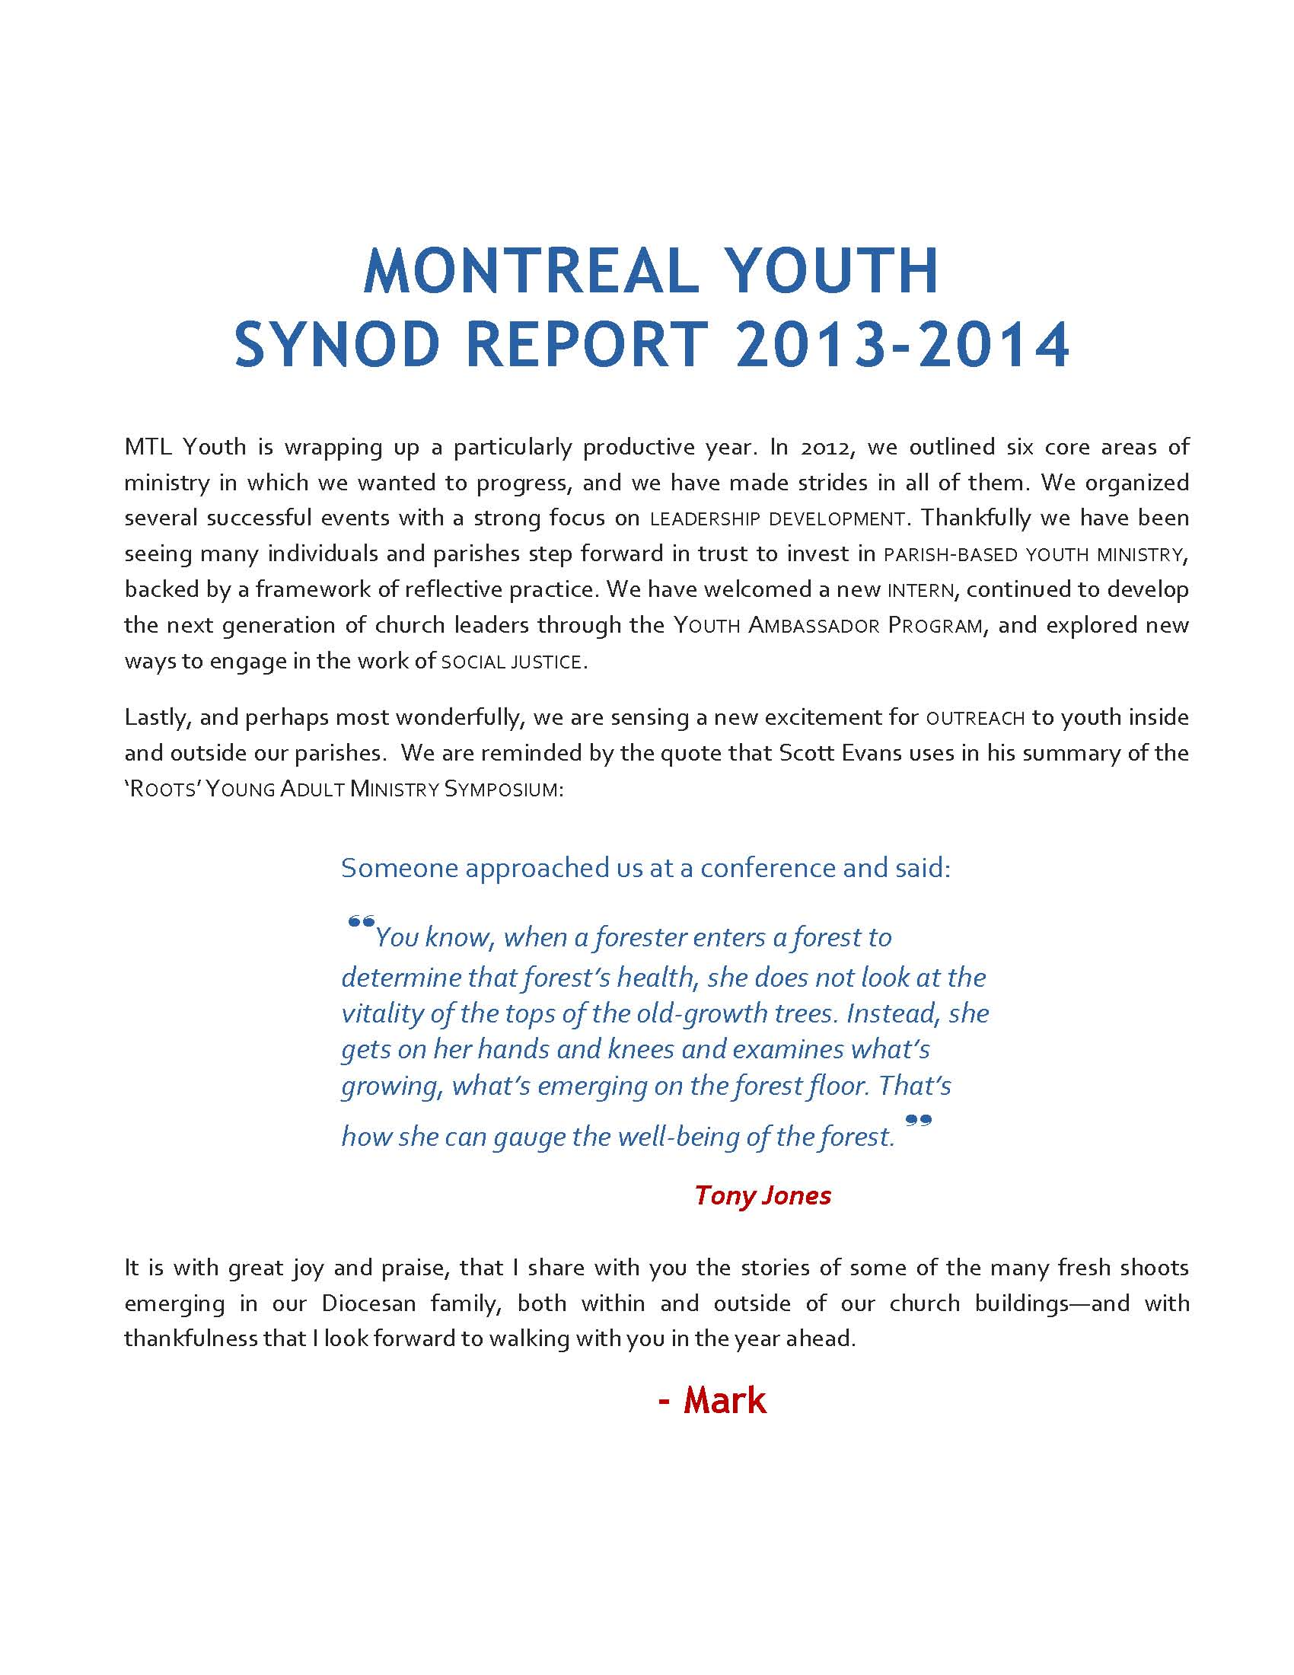
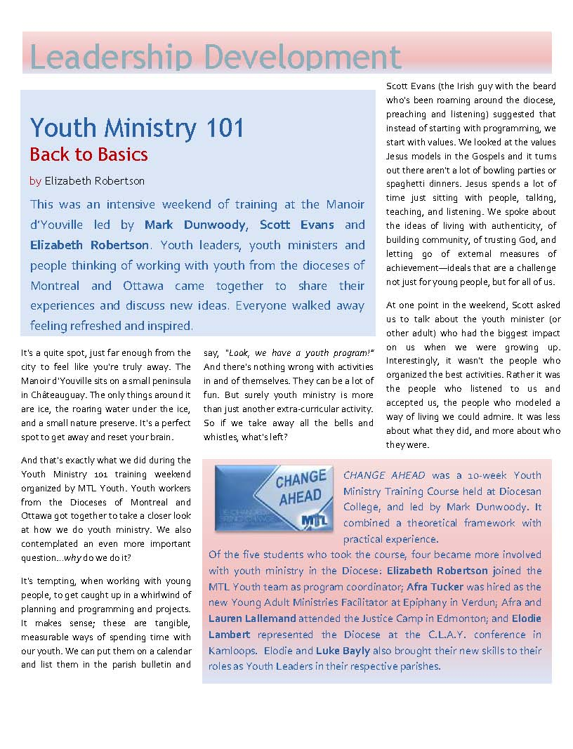
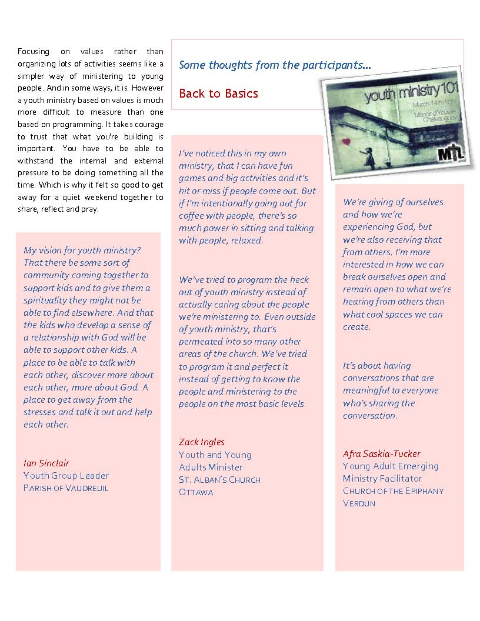
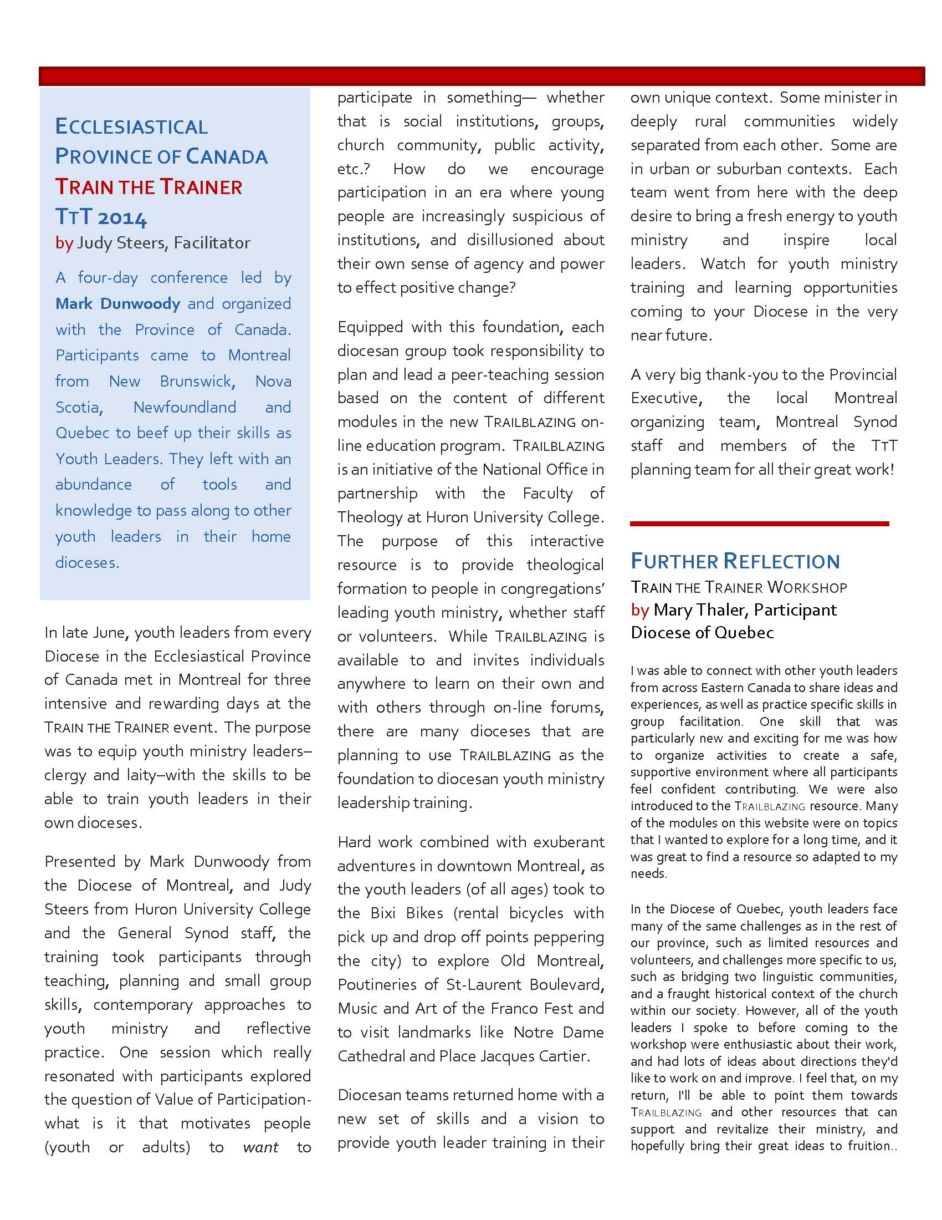
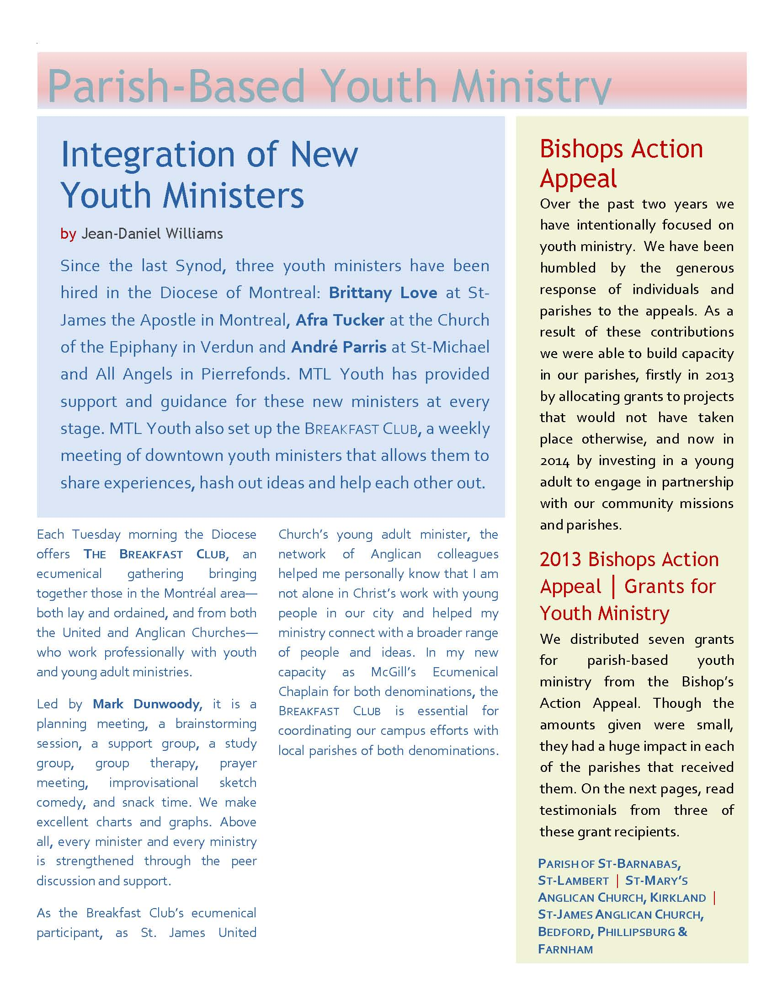
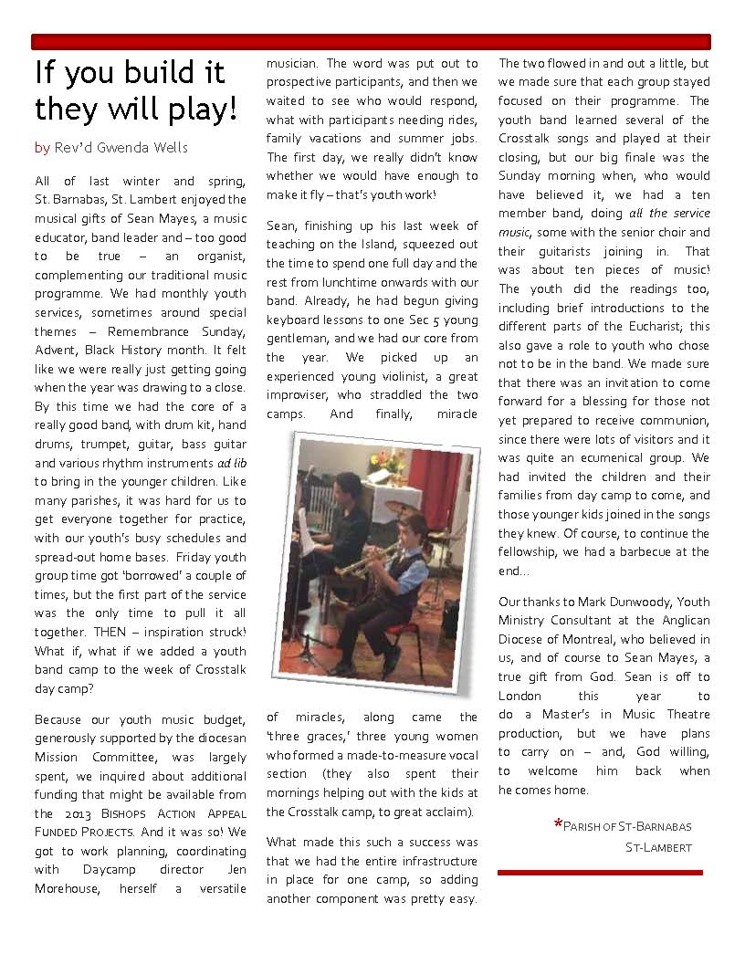
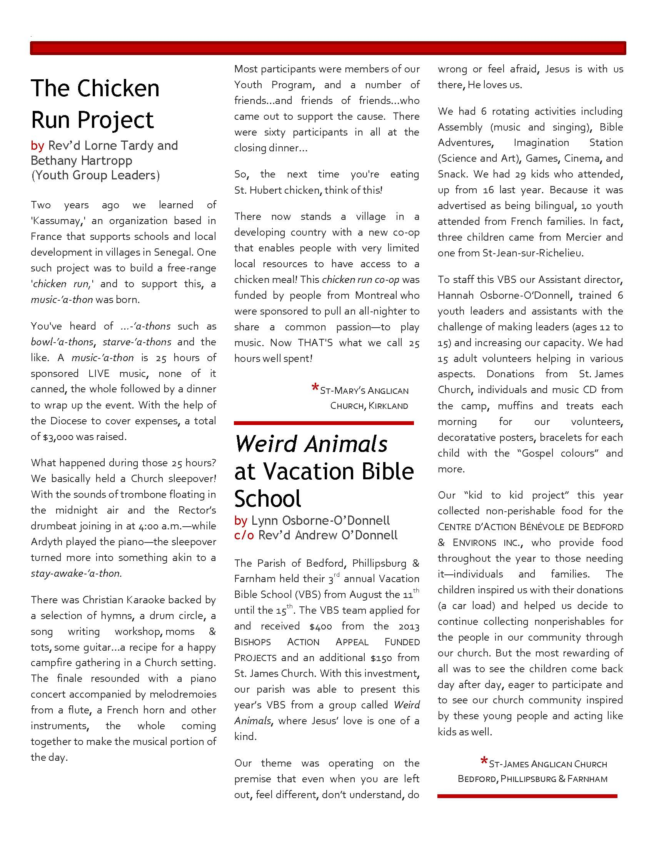
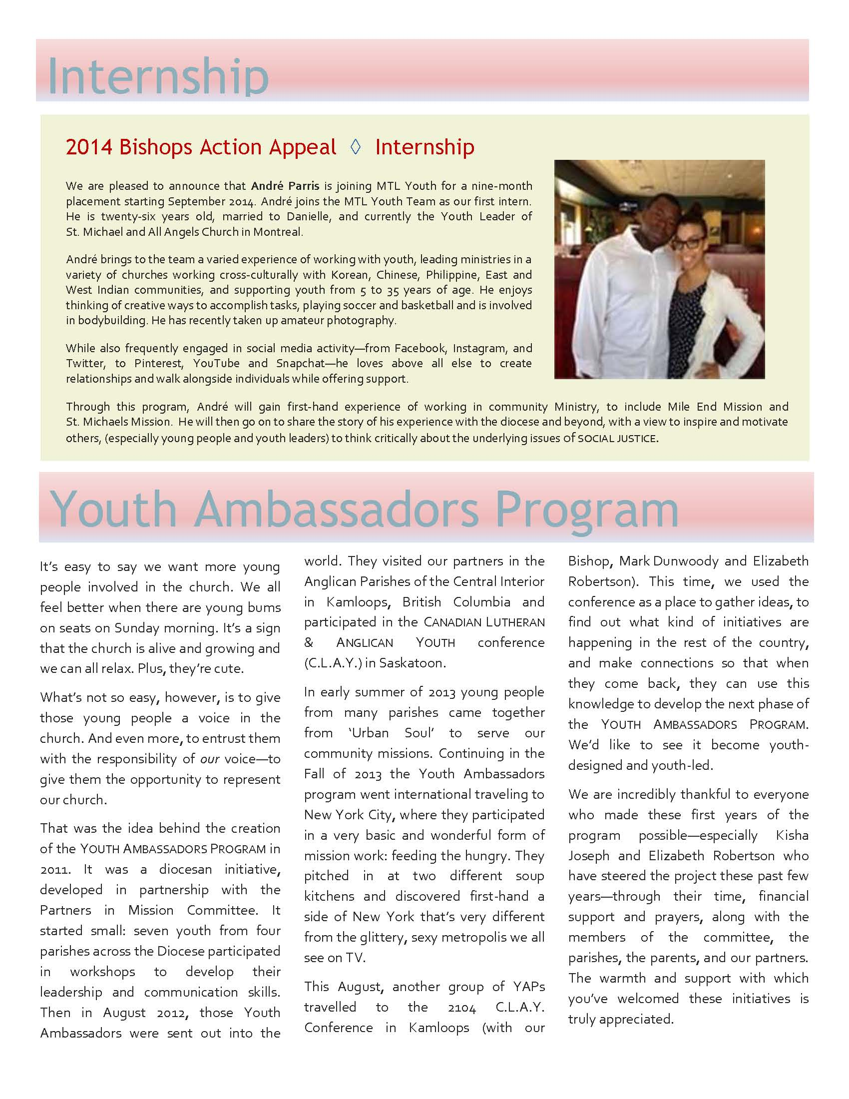
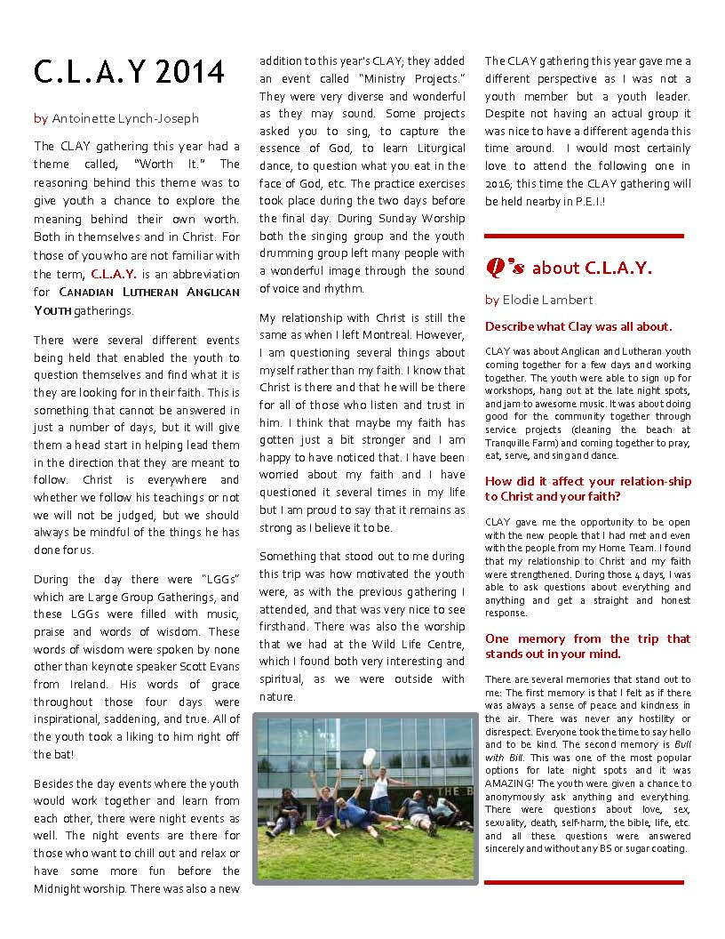
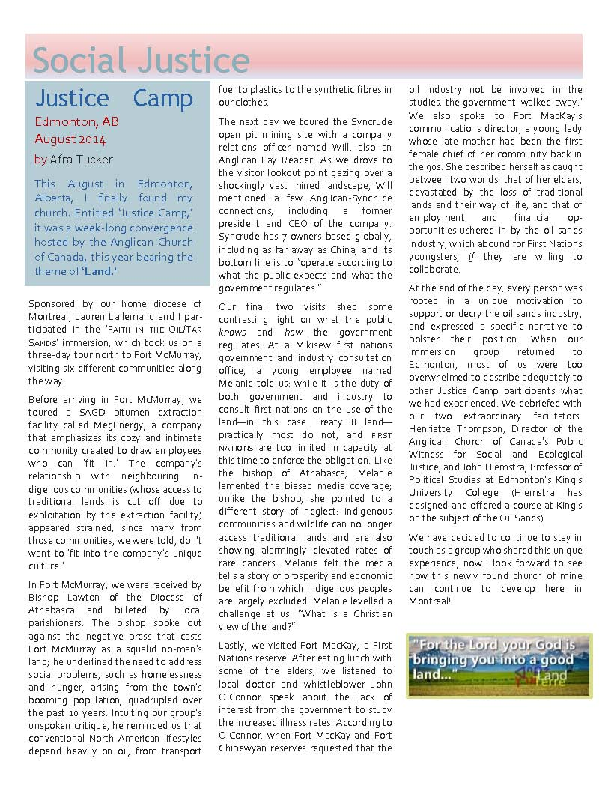
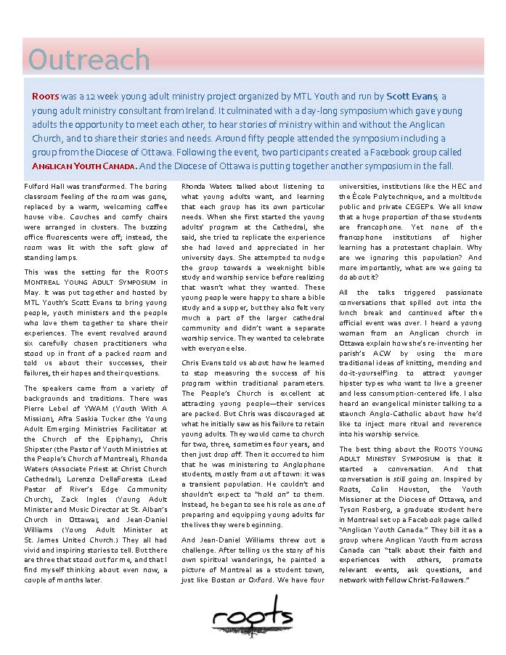

Youth Chaplain

No report submitted.

Chaplaincies

Concordia University Multi-Faith Chaplaincy
  - Ellie Hummel

“What do you consider family?” “Which holy day do you celebrate with your community?” “Tell us about an experience that has changed your life.” “How do you calm down when life gets crazy?”
These are some of the questions Concordia University Multi-faith Chaplaincy asks students when they come to our conversation couch. The principle is easy: we take a couch to a public place or event on campus, ask students to sit down on our comfy couch and spin the prize wheel. On the wheel are a series of topics, like “religion”, “purpose”, “love”, “spirituality” and when they land on a topic, we ask them a question about this topic. Like the questions above. We have had amazing conversations with students, eye-opening experiences and also just a good time.
In many ways, the conversation couch symbolizes what Multi-faith Chaplaincy is all about. We seek to be a welcoming place for people, a place where they can hang out and be themselves, a place where they can breathe and regroup from their heavily scheduled days. We also invite people to reflect and dig deep into questions of spirituality, faith, religion, authenticity and those questions that help them develop as young adults. Other questions we discuss are the questions that daily life and our world offers; questions around peace-building in a world of conflict, questions of the role of faith in society and in Quebec in particular, questions about being ourselves in a diverse world.
Our conversation couch has been a great way to engage students in these conversations in a non-threatening way. Other ways are meals, programs on spiritual practise, interfaith events, religious literacy, class presentations and volunteer opportunities and, maybe most importantly, hospitality and presence.
Multi-faith Chaplaincy continues to play a vital role at Concordia University to engage students and walk with them on their journey of life and faith. I am grateful that I can offer this ministry on behalf of the Diocese of Montreal. Thank you so much for sharing in it through your generosity of money, prayer and relationships for the past many years!

Federal Prison Chaplaincy – Cowansville Institution
  - Tim Smart

Following another time of uncertainty (and no salary) at the beginning of April 2014, I was hired again as a chaplain at the men’s medium security prison in Cowansville.

While new prison blocks go up and a new building for the Administration has been built, services for inmates continue to decline. We are close to 700 inmates now.

This current federal government values punishment over rehabilitation as they put more money and energy into building projects and then announce cuts in areas of staffing and programming which might assist inmates in their rehabilitation and restoration. When you take away hope and focus on the warehousing of people, you make both prisons and the streets unsafe.

My weekly schedule is like this: On Mondays I meet with the men individually to listen to their complaints, their hopes for themselves, the process of rehabilitation, and their frustrations about the roadblocks they face along the way to their release. I visit those who are in Detention, the place where you are locked up for 23 hours a day.

On Monday evenings, I welcome in volunteers from various churches in the local area as well as Montreal, for an evening of singing, praying and reflecting on a biblical passage together. For the men, the presence of volunteers is a sign of hope that they have not been forgotten and have not been written off, but are capable of redemption and love.

Twice a month, on a Monday afternoon, I meet with the “Impact Group” a group of twelve men (English-speaking) serving long sentences inside prison. Together we hear each other’s stories, offering support and accountability to each other. Sometimes guest speakers are invited to address the group.

On Fridays, twice a month, I welcome volunteers from Yamaska Literacy who assist Anglophone, Francophone and Spanish speaking people to read and write more fluently in English. We have prisoners who are tutors and well as students in this literacy program. We have recently started a book club for the more literate men reading and discussing many bestsellers. Yamaska Literacy gave a $500 budget for buying books.

This past year, with the assistance of volunteers from Sac à Mots in Cowansville, we have established a tutoring program in French. Many English inmates appreciate being able to have one-on-one tutoring in French.

We ask for your prayers and thank-you for your presence among those who are “outcasts and sinners”. If any of you would like to volunteer at the prison, please be in touch with me.

Federal Prison Chaplaincy – Federal Training Centre, Laval
  - Peter Huish

I am grateful to yet have a role as institutional chaplain in two penitentiaries, located in Laval, in spite of significant re-arrangement of their resources by the Correctional Service of Canada. A part of this change has been the administrative merge of these two institutions which now have a combined inmate population of approximately 800 (and still growing) compared to some 450 about 3 years ago. This reflects the “tough on crime” approach of the federal government and the squeezing of administrations together in an attempt to mitigate the cost of the increase in prison populations across the country.

You might imagine the impact on chaplains of such changes. The numbers certainly speak of more work but the increase in need is not simply arithmetical. The stress of over-crowding, double-bunking, rationalization of food services, dramatic cuts in inmate earnings for employment, in addition to the despair that goes along with longer sentences, tightening of traditional staged and managed release practice, all contribute to much greater pastoral demands upon us and the volunteers who so generously give of themselves in helping chaplains to make the walls that divide our community less absolute than they are.

This need and difficulty notwithstanding, there is Grace at play in this privileging support for recovery and healing of community that takes place in spite of the dividing walls. The adherence and persistence of volunteers who could not imagine life otherwise for themselves, and the always surprising arrival of new volunteers, in this chaplaincy endeavour, is truly inspiring to me. I am grateful to yet have a role in chaplaincy, with these volunteers as my examples.

I am grateful also because the institutional role provides an essential link, qualification and accreditation for the work we do in the community at MSCM (Montreal-Southwest Community Ministries) which is reported elsewhere in this Circular.

One of the significant changes that have taken place in the federal prison chaplaincy is the removal of Canada’s faith communities from the role they had as contractors and providers of chaplaincy services. A claimed benefit of replacing the faith communities with a single contractor is the saving of a couple of percent of what was already a severely under-resourced and under-valued service. We now have to work more intentionally to ensure that inmates have the pastoral care needed from their communities of faith and that, equally importantly, the faith communities themselves hear a prophetic call to care for and to include their outcast brothers and sisters in their understanding of what it is to be church.

I commend prison chaplaincy, and all who are implicated in it, to your prayers and to your consideration of how we might support it.

Federal Prison Chaplaincy – Drummond Institution, Drummondville
  - Holly Ratcliffe

The changes across Canada in federal penitentiaries by the government continued this year. The closing of Kingston (ON) and Leclerc (Laval QC) penitentiaries in September 2013 had a direct effect on other penitentiaries.

Until 2013 Drummond Institution had had a large concentration of sex offenders. Within six months however, the character of the population at Drummond changed dramatically, as all sex offenders were moved out, and street gangs and drug offenders transfered in. I continued to hold a bilingual ecumenical Bible study in the chapel every Monday evening and see inmates individually. Of course, I had to begin again to develop relationships with inmates and discovered that this new population had a very different profile.

The biggest loss for me had to do with the biweekly group which I had been animating for 18 months. This was a group of offenders preparing for restorative justice encounters with victims who have suffered similar crimes to those committed by the inmates (though not their own victims). The group came to an end because almost all of those who were involved in it had been transfered to other institutions. And it was going to take some time to develop the rapport needed with the new inmates for that kind of commitment on their part. I would add that the healing and potentially transforming effects on all participants of « Rencontres détenus victimes » (inmate victim encounters) had become such a passion for me that in June 2013 I took an intensive interdisciplinary course in « Accompagnement en justice réparatrice » offered through the theology department of l’Université de Sherbrooke (Longueuil campus) and thoroughly enjoyed it.

The Government’s changes in chaplaincy services affected a number of prison chaplains at another more personal level. As it turned out, this year would be the last year that the three Anglican chaplains would be hired by the Diocese of Montreal. Fortunately, Kairos Pneuma Inc., the organization which so far has got the contract to hire all prison chaplains across Canada, is itself composed of seasoned federal chaplains (one is the Rev’d Greg Frazer, an priest formerly of this diocese) who understand inmates’ needs as well as chaplains’ concerns.

At Établissement Drummond Institution I continued until May 2013 to be the sole chaplain on site, working only two days a week for an inmate population of over 400 and climbing. The new fiscal year saw two new chaplains arrive at Drummond : a full time lay RC site chaplain from Madagascar, as well as another part time Protestant minister of Haïtian origin. However, when my contract came up under the new system in 2014, it was clear that Drummond needed more Roman Catholic presence for the demographic needs of that institution. Although my work was valued, my ministry at Drummond Institution ended with the contract ending April 2013.

However, English and French speaking volunteers continue to visit the guys at the Monday evening protestant service, in part thanks to an existing collaboration with the Rev’d Heather Thomson, Anglican university chaplain in Lennoxville, who coordinates this as a community project for students of Bishops University and the Cégep in Sherbrooke. Thanks be to God!

Les changements aux pénitenciers fédéraux effectués par le gouvernement partout au Canada se sont poursuivis cette année. La fermeture du pénitencier de Kingston (Ontario) et de l’Établissement Leclerc de Laval (Québec), en septembre 2013, a eu un effet direct sur les autres pénitenciers.

Jusqu’en 2013, l’Établissement Drummond comprenait une forte concentration de délinquants sexuels. Toutefois, sur une période de six mois, la nature de la population carcérale à Drummond a complètement changé : tous les délinquants sexuels ont été emmenés ailleurs, et des membres de gangs de rue et des auteurs d’infractions liées aux drogues y ont été transférés. J’ai continué à tenir une étude biblique œcuménique bilingue dans la chapelle tous les lundis soir et à voir des détenus individuellement. Bien sûr, j’ai dû recommencer à nouer des relations avec les détenus, et j’ai découvert que cette nouvelle population avait un profil très différent.

Pour moi, la plus grande perte a été celle du groupe qui se réunissait toutes les deux semaines et que j’animais depuis 18 mois. Il s’agissait d’un groupe de contrevenants qui se préparaient à des rencontres de justice réparatrice avec des victimes ayant subi des crimes similaires à ceux qu’ils avaient commis (pas leurs propres victimes, cependant). Le groupe a pris fin parce que presque tous ceux qui y participaient ont été transférés dans d’autres établissements, et qu’établir avec les nouveaux détenus la relation nécessaire pour qu’ils soient disposés à prendre ce type d’engagement allait exiger un certain temps. J’ajouterais que le pouvoir de guérison et les effets potentiellement transformateurs des « Rencontres détenus victimes » sur tous les participants étaient devenus pour moi une telle passion qu’en juin 2013, j’ai suivi un cours intensif interdisciplinaire sur l’« Accompagnement en justice réparatrice » offert par la Faculté de théologie de l’Université de Sherbrooke (campus Longueuil), cours que j’ai beaucoup aimé.

Les changements apportés par le gouvernement aux services d’aumônerie ont touché plusieurs aumôniers de prison à un autre niveau, de façon plus personnelle. Comme la suite l’a montré, cette année serait la dernière année où le diocèse de Montréal engagerait les trois aumôniers anglicans. Heureusement, Kairos Pneuma Inc., l’organisme qui a eu jusqu’ici le contrat d’embaucher tous les aumôniers de prison partout au Canada, est lui-même composé d’aumôniers fédéraux chevronnés (l’un d’eux est le révérend Greg Frazer, anciennement un prêtre de ce diocèse), qui comprennent aussi bien les besoins des détenus que les préoccupations des aumôniers.

Jusqu’en mai 2013, je suis restée le seul aumônier sur place à l’Établissement Drummond; je ne travaillais que deux jours par semaine pour une population en croissance de plus de 400 détenus. Avec le nouvel exercice financier, deux nouveaux aumôniers sont arrivés à Drummond : un aumônier catholique laïque à temps plein sur place, originaire de Madagascar, ainsi qu’un autre pasteur protestant travaillant à temps partiel, d’origine haïtienne. Cependant, il était clair qu’il faudrait à Drummond une plus grande présence catholique pour répondre aux besoins démographiques de cet établissement lorsque mon contrat serait soumis au nouveau système en 2014. Même si mon travail était apprécié, mon ministère à l’Établissement Drummond a pris fin lorsque mon contrat s’est terminé en avril 2013.

Toutefois, des bénévoles anglophones et francophones continuent à visiter les hommes à l’occasion du culte protestant du lundi soir. Ces visites sont, en partie, le résultat d’une collaboration avec la révérende Heather Thomson, aumônière universitaire anglicane à Lennoxville, qui les coordonne en tant que projet communautaire pour les étudiants de l’Université Bishop’s et du Cégep de Sherbrooke. Rendons grâce à Dieu!

Mission to Seafarers – Port Chaplaincy
No report submitted.

Montreal-Southwest Community Ministries (MSCM)
  - Peter Huish

Although challenges to our financial viability continue, even grow, this is an auspicious moment in the life of our project which in spite of viability concerns is carried by the vision of gospel hospitality for the stranger, those of our brothers and sisters who have been excluded and often completely isolated in our society’s “correctional” practices: MSCM works in accordance with the principles of Restorative Justice for a safe community, through the accompaniment and re-integration of those who have served time in a penitentiary.

We will celebrate at year’s end the 15th anniversary of our founding and on 11 September, 2014 the 13-year anniversary of our weekly community meeting, Open Door which is assisted by Christ Church Cathedral and the Diocese of Montreal in allowing us use of Fulford Hall for these Tuesday evening meetings. We are grateful for this generous donation of premises, especially grateful are the 30 to 40 participants in each gathering. Open Door is the centre-piece in our shared endeavor of community-making.

We have enjoyed modest financial support over the years from the chaplaincy division of the Correctional Service of Canada but the continuation of this beyond March 2015 is in doubt given government disinterest in supporting social programs. This is especially worrying as the largest part of our funding, for our participation in the 5-year national demonstration project for Circles of Support and Accountability, comes to an end in October, 2014. Ironically, the evaluation from this demonstration project to be released this Fall, is expected to show that Circles provide significant reductions in re-offending by those who are accompanied in this way, and hence significant benefits for public safety, and yet, there is no prospect for further funding for us and the 14 other sites across the country who have participated in the measurement project.

Nevertheless, there are indications that financial support by personal donors is growing and that this might become a key in our viability. We are grateful for this and will pay more attention to growing in this area while trimming operating costs as much as we can, commensurate with yet being able to function appropriately. It is clear to all of us, most pointedly to our many volunteers who give so much of themselves year after year, and to our beneficiaries who go on to productive lives in the community, in their families, that there are large and multiple benefits of the very modest financial investment made in our work. A recent study of a similar project in another Canadian city showed a 6.4:1 social return on investment. We are sure that at MSCM we do at least as well as that.

Two highlights of our year are worth mentioning, each a resumption of activities delayed by setbacks and an office move reported last year:
• We convened a Community Building Workshop in March, in a fine space at a religious house in Laval, which was attended by a very diverse and fruitful mix of almost 30 of our larger community. Those who participated were deeply rewarded in their commitment to this extra-ordinary experience of personal authenticity and “true” community.
• Also in March, in a van loaned to us by CSC, and paid from the Stanley Wilson Fund which we use to visit the most isolated prisoners, 6 of us travelled to Port Cartier Institution, over 800km on the far North Shore of the St. Lawrence, to spend a day visiting with inmates in the chapel of that remote maximum security institution. We visitors were equally as blessed as those visited.

Please visit our project website mscm-qc.org to learn more about our project. Your questions, comments and support are always welcome. I invite you to contact me at 514 812 4863.

Ste-Anne’s Hospital
  - Stephen Petrie

Recently I was sorting through some old paperwork in my office and I came across a memo from the Executive Director of the hospital. It spoke about the coming transfer of the hospital from the federal government to the provincial government. It was filled with reassurances about the need to provide all the same services for the veterans and their families. The content of the memo was very familiar but what caught me off guard was that it was written in 2009. Five years ago. Five years of discussions, Five years of rumours. Five years of uncertainty.

Last year we had 3 separate deadlines announced for the transfer - March 31, September 30, and December 31. Each came and went with no new information. Finally in January the news came that all matters had been agreed to except the designation of the hospital as a bilingual institution. Canada said it must be and Quebec said no. As I write this we are in the midst of an election in Quebec so one can only hope that the outcome may finally break this political logjam.

The effect of the transfer limbo is that more and more experienced staff have taken early retirement or sought transfers to other government departments. Providing the best possible care for the veterans remains the driving mission of the hospital but it is unfortunate to see some highly qualified and experienced staff transfer out because they cannot deal with the uncertainty any longer.

One bright mark over the past year is that we have not closed any further wards. We currently have 100 empty beds with the three floors that are closed. As beds open we have been able to fill them but the average age upon admission now is well over 90. It is projected that another floor will close by the end of the year if we do not transfer to the province and begin admitting the general public.

Once again I want to thank Neil Mancor for providing on call backup two days a week. His ministry here is much appreciated.

Reports on National Committees

Anglican Fellowship of Prayer – Canada
  - Valerie Bennett / Stacey Neale

As Diocesan Representatives of the Anglican Fellowship of Prayer – Canada, it is our responsibility to raise awareness about this important resource. We are very grateful for the publicity afforded us in the May 2014 issue of the Montreal Anglican and the opportunity to offer monthly prayers for Diocesan wide activities through this newspaper. Now we must widen our efforts to reach out to individuals across the Diocese who are interested in learning more about AFP-C.
The main purpose of AFP-Canada is to promote and enable the practice of Christian prayer by all. This organization takes an inclusive approach to the ministry of prayer and aims to make it a central part of Christian life. To this end, AFP-C has many resources to help individuals and congregations grow in all forms of expressions from private prayer to starting prayer chains and offering healing services.
Our personal goal over the next few months is to reach out to clergy to further discuss AFP-C and seeing where the needs are to broaden prayer in the corporate life of the church. AFP-C has workshops and videos that can help to lift up prayer by re-enforcing current activities and adding new ones to broaden this important practice. In time we would like to see some parish representatives join us in spreading the message about AFP-C and the wonders of prayer.

Communications and Information Resources Committee
  - Sue Winn

CIRC is one of four coordinating committees created at the General Synod in Ottawa in July 2013. These coordinating committees of five members and several associates replace the Standing Committees of previous years. This was a cost-cutting measure as the committees will continue to meet by conference call and video-conferencing. An initial face-to-face meeting was held last November at the same time as the Council of General Synod.

Our mandate is to provide support to members of the Communications Department in Toronto. These staff members include Anglican Video, the Anglican Journal, the Website (Anglican.ca), Social Media…all the ways the National Church Office seeks to communicate with Dioceses and Parishes.

There are two significant news items. The Director of Communications, Vianney (Sam) Carriere died in early August following a long struggle with cancer. Sam was highly respected and much-loved. He will be sorely missed by all who knew and worked with him.

The second item of note is the appointment of a new editor for the Anglican Journal. Marites (Tess) Sison has been a senior writer for the Journal and has won numerous awards for her work. It will be exciting to watch the unfolding of new plans for both print and online media approaches to the Journal news.

Council of General Synod
  - Karen Egan

The Council of General Synod met two times since the last Diocesan Synod, once in November 2013, and again in May 2014. I attended both meetings in full, and Antoinette Lynch-Joseph, our youth delegate was there in November.
The business of COGS is to oversee, to advise, and to a certain extent, direct the work of the National Church between the times that the General synod is in session. We also take action, to the best of our ability, on any motions generated at the General session. There are always a number of routine functions, such as approving budgets for the Anglican Church of Canada, and hearing reports from various committees and subcommittees. During the time that COGS is in session, there is a daily report, which can be read from the front page of the national website, and is also available by email subscription. I will use this report to highlight some of the less routine things that have happened at COGS, and some of its more specific work this session.
At General Synod 2013 in Ottawa, a motion came to the floor that directed the Synod to begin the process of exploring the change in the marriage canon which would allow bishops to permit same sex marriages in their respective dioceses, and to return to General Synod 2016 with a resolution to be debated which would allow for the six year process to allow the changes to the marriage canon to begin. The Council, with strong direction from the Primate, has established a commission to begin to collect the legal and other opinion so that would put Council in a position to do that in its final year of the three year term. Currently this commission is seeking submissions to this commission. Over the rest of the term, more work will be done to fulfill the request of General Synod.
At the COGS meeting in November 2013 there was also a commemoration of the twentieth anniversary of the landmark apology that Primate Michael Peers gave to our Indigenous brothers and sisters, regarding the Anglican Church of Canada’s participation in the Indian Residential School system, and the abuse that students suffered at the hands of their teachers and support staff. This was a very moving evening, where we heard recollections from both Michael Peers and from several of the First Nations Elders who were present at that very event, including Sidney Black, a current COGS member. In addition, Bishop Mark MacDonald, the National Indigenous Bishop shared with the extended council a very moving reflection which emphasized the pivotal role that that apology has had on the process of healing and reconciliation within our church, and in the Indigenous community at large. The Commemoration ended with the Eucharist, in which hymn singing played a very memorable part for me.
There was also a recognition that the work of reconciliation is not complete, and work continues towards that goal. With this in mind, the Primate was requested by ACIP to set up a commission to examine the issue of reconciliation and the church’s repudiation of the Doctrine of Discovery, and at this meeting it was announced that that commission was being planned. Subsequently in December, that commission was named, and work is underway.
In the May 2014 session, COGS had the privilege of receiving a presentation by Bishop Lydia Mamakwa describing the creation of the new diocese of Mishamikoweesh in north-western Ontario and northern Manitoba. In early June, the synod of that new diocese began to meet, and Bishop Lydia was seated as the diocesan bishop. This dream come true for the Indigenous Anglicans in this large area was approved at the General Synod in 2014, but motions continued to come to the floor paving the way for this change at subsequent COGS meetings. Needless to say this is something that gave a true celebratory flavour to the COGS meetings.
It is a privilege and an honour to represent the Province of Canada in these COGS meetings, and in many ways it is the culmination of nine years of work at the national level, after having attended General Synod in 2007, 2010 and 2013. I am currently also serving the national church as a member of the Planning and Agenda Team for COGS, and as a full member of the Communication and Information Resources Committee which fittingly, meets via video conferencing!

National Partners in Mission Coordinating Committee
  - Robert Camara

This is a new configuration of a committee of General Synod – formerly also including Eco-Justice in its mandate. At General Synod in July 2013 in Ottawa, it was decided that the committee would only focus on Partners in Mission.

The committee met for the first time in November 14-17, 2013 in Toronto during the meeting of the Council of General Synod. This will probably be the only face-to-face meeting that the committee will have during its 3-year mandate as the coordinating committees have adopted to meet via video conferencing as a means of reducing expenses. This first meeting was an opportunity to meet the other members and to build community and better understand the mandate of the committee.

Partners in Mission is the body which oversees and provides support to the numerous partnerships that exist on a national and international level with the Anglican Church of Canada. It also seeks to provide support and assist in fostering relationships between diocesan relationships within Canada and abroad, helping Canadian Anglicans to know, love and follow Jesus in serving God’s mission with others beyond our borders. Our own Montreal relationships with the Anglican Parishes of the Central Interior and the Diocese of Masasi are part of that overall global relationship which the National Partners in Mission Coordinating Committee seeks to encourage, assist and foster.

The committee has since met twice in 2014 via video conferencing. It continues to work on the relationships with the Church in Cuba, with the Diocese of Jerusalem, the Canadian-African Bishops Conversations, the Church in the Philippines, the Church in Melanesia, and relations with Canadian Dioceses who have partnerships and are seeking to establish partnerships.

The committee works with Dr. Andrea Mann and the Rev’d Dr. Isaac Mukasa, staff support at Church House, and is chaired by Bishop Peter Fenty.

Section I: Minutes of Synod 2013 - Minutes du Synode 2013

Minutes of Synod
October 19 2013

Opening Session Saturday, October 19, 2013

Opening

The Right Reverend Barry Clarke called the 154th Synod of Montreal to order at 8:30am upon the declaration of the Chancellor, Me. David Eramian, that there was a quorum in both Houses.

Opening Prayer & Hymn-
The Bishop invited the Rev. Dr. Chris Barrigar and Mrs. Sally Harrington-Phillipo to lead the opening prayers.

Welcome
The Bishop welcomed Members, and Visitors to the Synod.

Emergency Procedures
The Executive Archdeacon, the Ven. Janet Griffith outlined the emergency procedures to be followed in the event of a fire alarm.

Greetings from Ecumenical Partners
Bishop Barry welcomed and invited Monseigneur Christian Lepine, from the Roman Catholic Church, the Rev. Cathy Hamilton, from the United Church and Pastor Eric Dyck of the Evangelical Lutheran Church, to bring greetings. The Bishop also invited Dr. Adriana Bara, Director of the Centre for Ecumenism, to say a few words.

Election of Lay and Clerical Secretaries of Synod
Me. David Eramian moved, seconded by Mrs. Susan Finkenbine the nomination of Miss Valerie Taylor as Lay Secretary of Synod. There being no further nominations the motion was voted upon. Carried

The Ven. Janet Griffith moved seconded by Canon Joyce Sanchez the nomination of the Rev. Sophie Rolland as Clerical Secretary of Synod. There being no further nominations,
the motion was voted upon Carried.

Election of Diocesan Treasurer- Motion “A”
Mrs. Ann Cumyn moved, seconded by the Ven. Michael Johnson, the nomination of Mr. Norman Spencer as Diocesan Treasurer. There being no further nominations, the motion was voted upon. Carried.

Appointment of Auditors-
The Ven. Michael Robson moved, seconded by the Ven. Ralph Leavitt, that the firm of BDO Dunwoody be appointed as Auditors for the Synod for the coming year; there being no further nominations, the motion was voted upon. Carried.

Approval of Minutes of Synod 2012- Section “I”
The Ven. Janet Griffith moved, seconded by Mr. Jim Shepherd, that the minutes of the 153rd Synod of 2012 be approved with the addition that the Rev Marcia Mundy was present. The motion was voted upon. Carried.

Appointment of the Committees of the House
The Ven. Janet Griffith moved, seconded by Mrs. Penny Noel that the members of the Committees of the House, as posted, be appointed by Synod. The motion was voted upon. Carried.

Privileges of the Floor
The Ven. Janet Griffith moved, seconded by the Ven Michael Johnson, that Privileges of the Floor be granted to:

Ms. Mary Abata
Mr. Colin Babin
Dr. Adriana Bara
Mr. David Burnstun
Mr. Frank Dottin
Mr. Mark Dunwoody
Pastor Eric Dyck
Ms. Carmen Fairley
Ms. Betty-May Gore
Mr. Bob Grier
Rev. Cathy Hamilton
Captain the Rev. Isabel Healy-Morrow
Ms. Nicki Hronjak
Mr. Geoffrey Jackson
Ms. Jennifer James-Phillips
Monsignor Christian Lepine
Ms. Antoinette Lynch-Joseph
Ms. Andrea Mann
Mrs. Janet Marshall
Mr. Raymond Noel
Ms. Ardyth Robinson
Mr. Harvey L. Shepherd
Ms. Laura Suchell
Mr. Stephen Tam
Mr. Richard Virr
Ms. Catherine Welch
Ms. Aura West
Mrs. Susan Winn

The motion was voted upon. Carried.

Regrets
The Ven. Janet Griffith reported that Regrets had been received from: -

The Rev. Nick Brotherwood
The Rev. Eleanor Caruana
The Ven. Dr. Brian A. Evans
Mrs. Mary Fox
The Ven. Gordon Guy
The Rev. Bradley Hicks
The Rev. Jack E.A. Hyde
The Rev. David W. Sinclair
The Rev. John Serjeantson
The Rt. Rev. Bruce Stavert
Mr. Richard Virr

Report of Nominating Committee
The Ven. Janet Griffith presented the report of the Nominating Committee, as printed in the Convening Circular, Section D-1.Mrs. Anne Geoffrion moved, seconded by Alain Brosseau reception of this report. Carried.

Additional names were solicited for election to Diocesan Council-

Clergy –The Rev. Rhonda Waters, the Ven. Michael Robson, the Rev. Michelle Eason, Deacon Nick Pang, the Rev. Karen Egan, Canon Joyce Sanchez.
Laity –Mrs. Ann Cumyn, Mrs. Penny Noel, Mr. Charles Goddard, Mrs. Sue Winn
Mr. Winston Dillon moved seconded by the Ven. Michael Johnson that nominations cease. Carried.
Nominations to Synod Planning Committee
Additional names were solicited-
Clergy- The Rev. Brian Perron, the Rev. Jennifer Bourque
Laity- Mr. Reginald Patterson, Mrs. Deborah Hinton
The nominees were acclaimed.

Presentation of Motions, Memorials and Petitions
The Executive Archdeacon reported that Motions could be found in Section G, page G1 of the Convening Circular.

Presentation of Canonical Changes
The Executive Archdeacon reported that the Motions containing Canonical Changes could be found in Section E, page E1 of the Convening Circular.

Reception of Reports of Diocesan Council
The Ven. Janet Griffith moved, seconded by Mrs. Ann Cumyn, the reception of the summary of meetings of Diocesan Council, and reproduced in the Convening Circular, pages H3 –H4. The motion was voted upon. Carried

The Reception of all Other Reports
The Ven. Janet Griffith moved, seconded by the Rev. Andy O’Donnell the reception of all other reports in the Convening Circular, Section H-4-23.
The motion was voted upon. Carried.
The Bishop invited delegates to give short notices about coming events of interest.
Bishop Bary challenged us to raise one million pennies for Mile End Mission
Canon Bruce Glencross asked for volunteers to serve on the Mission Matters Golf tournament Committee. The Tournament raised 13K this year.
Deacon Nick Pang announced that The World Council of Churches will be meeting next week The WCC only meets every 7 years. The deliberations may be followed on the National Church Website.
There were several announcements of upcoming events at parishes
On behalf of Synod, the Ven. Janet Griffith welcomed Bishop Barry back, after his Sabbath leave.
Bishop Barry then adjourned the opening session, for the Synod Eucharist, including his Charge.
The Bishop announced that the afternoon session would convene at 1230pm in Fulford Hall.

Afternoon Session Saturday, October 19, 2013

Synod reconvened at 12:30p.m.
Video Presentation- Mr. Mark Dunwoody presented a short video- “ The Boy and the Starfish”
Bishop Barry invited the Rev. Karla Holmes to lead the Worship.
The Bishop noted that the sign–up sheet for Members’ Forum is to be found on the Secretary’s Table, and that balloting will close at 3:15pm.
Bishop Barry then welcomed Mr. Paul Clarke, Director of Action Refugiées and invited him to speak.
Motions and Signing of Partnership Agreement with APCI
A Skype connection was established with Bishop Barbara Andrews at 100 Mile Housein the Anglican Parishes of the Central Interior (APCI.)
Motion “D”
Mrs. Sue Winn, seconded by the Rev. Robert Camara moved, Motion D. The motion was voted upon. Carried.
Motion “E”
Mrs. Sue Winn, seconded by the Rev. Robert Camara moved Motion E. The motion was voted upon. Carried.
Signing of the Companion Diocese Covenant
Bishop Barry and the Chairs of the two Partnership Committees then signed the Covenant for another 5 years of Partnership between our two Dioceses.

Reception of Reports on Parochial Statistics- (deferred from the morning session).
Mr. Jim Shepherd moved, seconded by Mrs. Elizabeth Hutchinson the reception the Parish Statistics, as circulated. The Chancellor noted that there are several errors in the Statistics, which will be corrected as soon as possible.
The motion to Receive was voted upon. Carried

Guest Speaker- Ms. Andrea Mann
Bishop Barry invited Ms. Andrea Mann from the Office of National Church to speak about Partnership within the Anglican Communion.
There followed a short period for Members to offer comments and questions.
The Bishop thanked Ms. Mann for her interesting presentation.

Financial Report and Budget
The Treasurer, assisted by Mr. Stephen Tam, proceeded with the Power-Point Presentation, beginning with the 2012 Audited Statements, Results and Forecasts up to December 31st, 2013.
The Treasurer commented that over the past couple of years a lot has changed and that a sound financial environment has now been created in the Diocese. Thanks are due to the Bishop, the Exec. Archdeacon, Mr. Stephen Tam, Mr. Michael Hiles and the Finance Committee for all their hard work and assistance throughout the year.
There is now greater transparency and clarity. Capital Assets are now shown at Market Value. The operating loss has held at 0.3$milllion since 2010.The Net Assets increased from $11.3million to $11.4million. Additional income largely due to sale of Real Estate.

The Treasurer gave a brief summary of the Balance Sheet for 2013. The majority of the assets are invested in the balanced Anglican Fund managed by the firm Letko Brosseau. The Board of the Anglican Fund meets monthly. Other Capital assets consist of properties owned by the Diocese.

The Treasurer then reviewed the Statement of Operations for 2013. Operating losses have been stemmed and controls have been improved. Revenue and expenses remained close to Budget and a loss of approx. $0.3million was incurred in 2013. The financial position of the Diocese is sound. It is estimated that Net Assets at the end of 2013 will stand at approx. $13.3million, up from $2.0 million in 2011.
The Treasurer asked if there were any questions regarding the Financial Statements.

There being no questions, the Rev. Bruce Graham moved, seconded by the Rev. Bill Gray, acceptance of the audited Financial Statements. The motion was voted upon. Carried.

The Budget
There are few changes. Revenues and charges to Parishes remain consistent. Total revenue at $2.1million compared with $2.0million in 2013. Expenses are $2.4million compared with $2.3million in 2013.
The budgeted loss of operations is $316K.
The 2014 budget includes 3 special expense items. These three $100K items are –Property Administration, Fund Raising and Youth Costs.
Several Members asked for points of clarification regarding these items and regarding Parochial Assessments.
Mrs. Ann Cumyn seconded by the Ven. Michael Johnson moved the Budget Motion. Bishop Barry asked if there were further comments or questions.
The Ven. Janet Griffith commented that the $100K for Youth Ministry is a lump sum for use in a variety of Youth-related Programs.
The Bishop then called the question on the Budget.
The motion was voted upon. Carried.

Following a snack break, Synod Business was resumed.

Youth Ministry Report
Mr. Mark Dunwoody invited Ms. Elodie from L’Eglise de la Nativité, and who has just started taking the Youth Leadership Training course, to say a few words about the benefits of this Program.
Ms. Keisha Joseph then spoke about the Youth Ambassadors Program of which she is the coordinator. In the latter part of the summer this group travelled to New York where they had opportunities to serve in shelters for the homeless. Ms. Joseph asked delegates to encourage young people of their acquaintance to consider participating in the Youth Ambassadors Program.
Mr. Dunwoody spoke about his vision for the time ahead, after being in the Diocese for the past year and a half.
The Bishop asked if there were any questions.
Several members commented regarding the struggles of encouraging young people in their individual communities. Mr. Dunwoody is very open to visiting individual congregations to offer suggestions and support.

MAP/ Stewardship Report
The Bishop invited Mrs. Janet Marshall to report on the work of MAP. Mrs. Marshall opened with a PowerPoint Presentation outlining work that has happened over the past three years and visioning for the future.
Members of the Stewardship Council and MAP Task Force were then invited to tell some of their stories beginning with the Rev. Nail Mancour who spoke about the recent Stewardship Café and the Diocesan Feasibility Study.
Mr. Robert Miller, from St. Joseph’s Brossard spoke about the South Shore Ministry Initiative, which is looking at collaborative Ministry in that area. Several meetings have been held over the past year. The venture now involves 3 churches, which would share 2 priests. The process is still underway, although a draft agreement has been formulated.
Mr. Michel Gagnon spoke about the Visioning Team at St. James the Apostle, which has decided to hire a worker who will focus on Young Adult Ministry.
Kidstuff Chair, the Rev. Rhonda Waters, spoke about the committee’s plans for a survey, which will go out to parents and caregivers and will hopefully assess current spiritual needs for Children’s Ministry in the Post-Christendom era.

Report from Joint Assembly Delegates
The Delegates from our Diocese began their presentation with a short video. Each Delegate then gave a short impression of their experience of the Joint Assembly.

Section G- Motion “F”
The Rev. Bill Gray moved, seconded by Mr. Archibald Robinson, Motion “F”, found on page G-2 of the Convening Circular. The Mover noted that a friendly amendment had been included earlier in the day.
Several members spoke in favour of the motion, although concerns were expressed by the Rev. Sophie Rolland, Canon John Simons and the Rev. Dr. Chris Barrigar regarding the wording of the friendly amendment.
The Rev. Holly Radcliffe spoke in favour of the friendly amendment.
The mover agreed to remove the friendly amendment. The Chancellor ruled on the wording of original motion.
Following further discussion another friendly amendment was proposed, with the final wording reading: -
“Be it resolved that the Synod of the Diocese of Montreal through our Diocesan Bishop immediately express to the government of the province of Quebec our solidarity with all who would be negatively affected by the provisions in the proposed charter of Quebec values and register our strong opposition to the adoption and implementation of the relevant sections which would discriminate and violate our constitutional protections of individual rights. Nonetheless, as Anglican Christians we affirm the value of a religiously neutral state and of equality between men and women.”

The Question was then called. The motion was voted upon. Carried.

Section E- Proposed Canonical Changes
Motion “1”
The Rev. Bill Gray moved, seconded by Canon Joyce Sanchez Motion “1” as printed on page E-1 of the Convening Circular. The motion deals with changes in the wording of this Canonical motion regarding Housing Allowances.
Several Members spoke against the changes in wording, noting that housing costs do vary widely on and off the Island and that it would be awkward for new Incumbents to have to negotiate housing allowances.
The mover responded, offering some clarification regarding the intentions of setting a minimum base figure for housing, across the board.
The Bishop then called the Question. The motion was voted upon by Houses. Carried in both Houses, the Bishop concurring.

Members’ Forum
Bishop Barry invited those who had signed up for Members’ Forum to speak at this time.
The Ven. Michael Robson announced that tickets are available for an upcoming dinner and concert to be held at Christ Church Rawdon.
Mrs. Penny Noel reported that, on a visit to our Partners in the Diocese of Massasi she had seen that construction of a well is now underway. Funds for this project were raised at our 2012 Synod.

Announcement of Elections

Bishop Barry announced the results of balloting for members of Diocesan Council

Clergy- Lay-
The Rev. Rhonda Waters Mrs. Sue Winn
The Rev. Nicholas Pang Mrs. Valerie Bennett
The Rev. Robert Camara Mrs. Penny Noel

Bishop Barry advised Diocesan Council Members that the first meeting of the new Council will take place on Tuesday November 12th 2013, commencing at 4pm with a Celebration of the Eucharist in St. Anselm’s Chapel. This will be an extended meeting.
The Executive Archdeacon presented a vote of thanks to all those responsible for the preparation, planning and work of this Synod, and especially to Bishop Barry.

Closing Prayers Adjournment and Dismissal

The Bishop invited the Youth Ambassadors to lead in Closing Worship.
Bishop Barry called for a motion to adjourn, which was moved by Canon Bruce Glencross.
Synod adjourned at 6:00pm.

Section J: Audited Financial Statements 2013 - États financiers vérifiés 2013
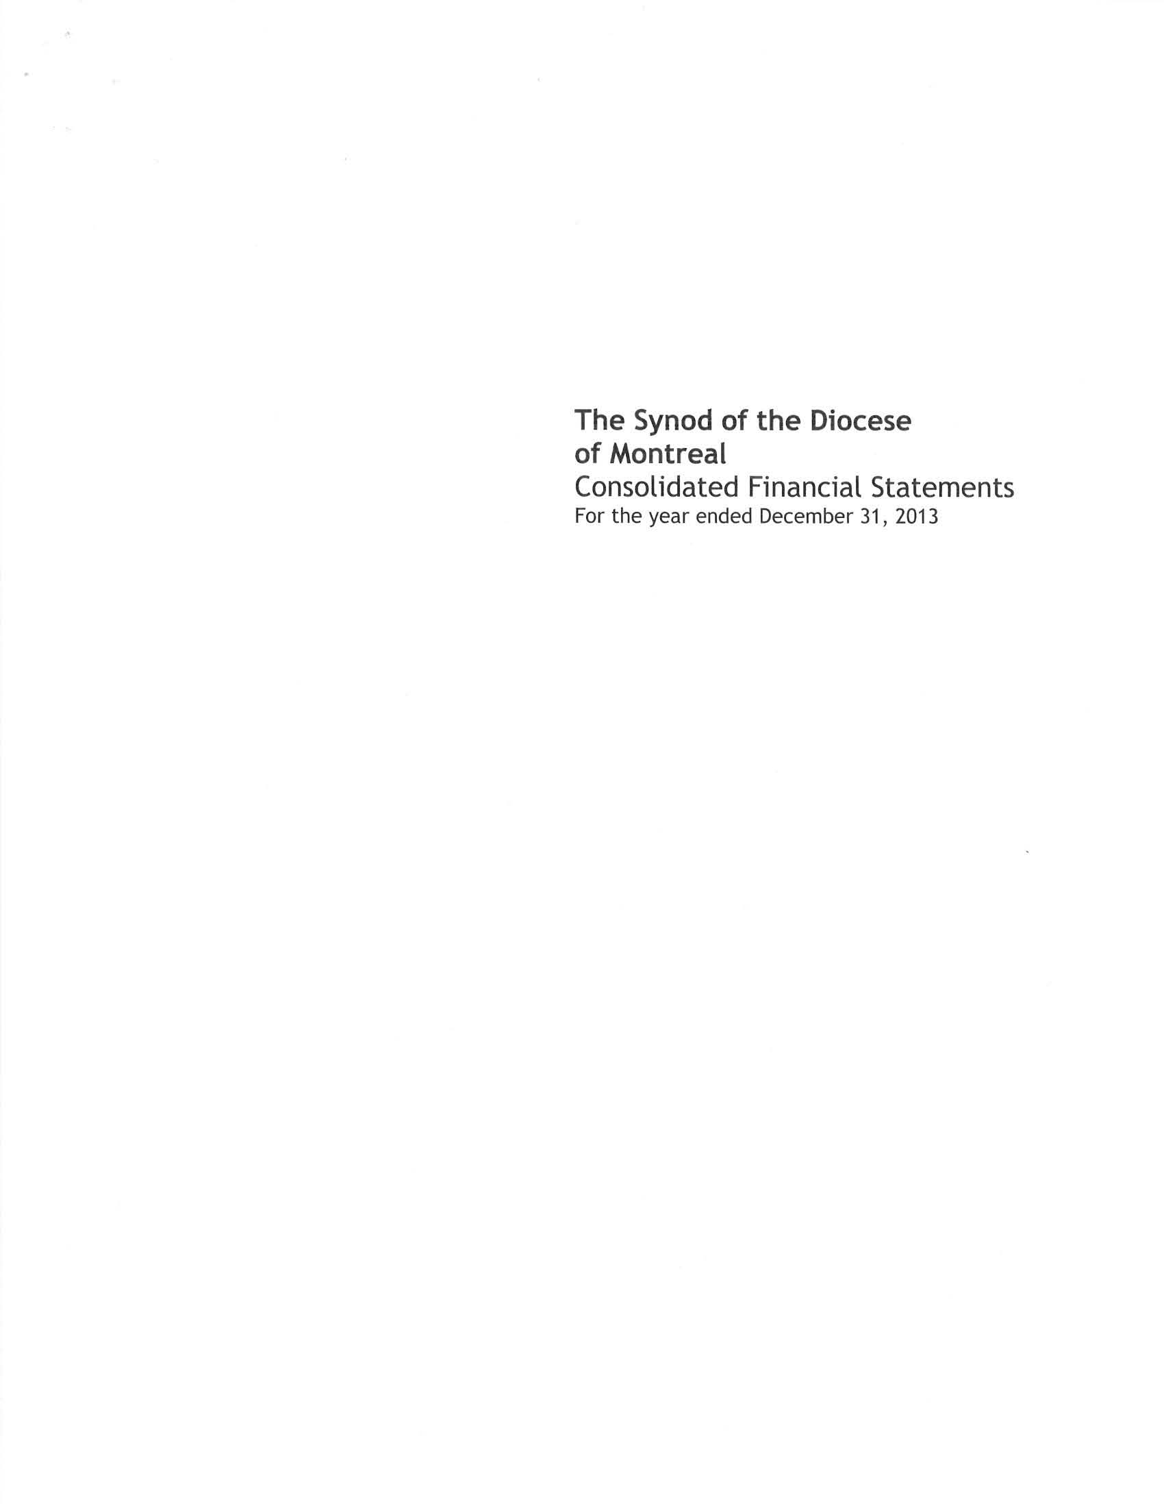

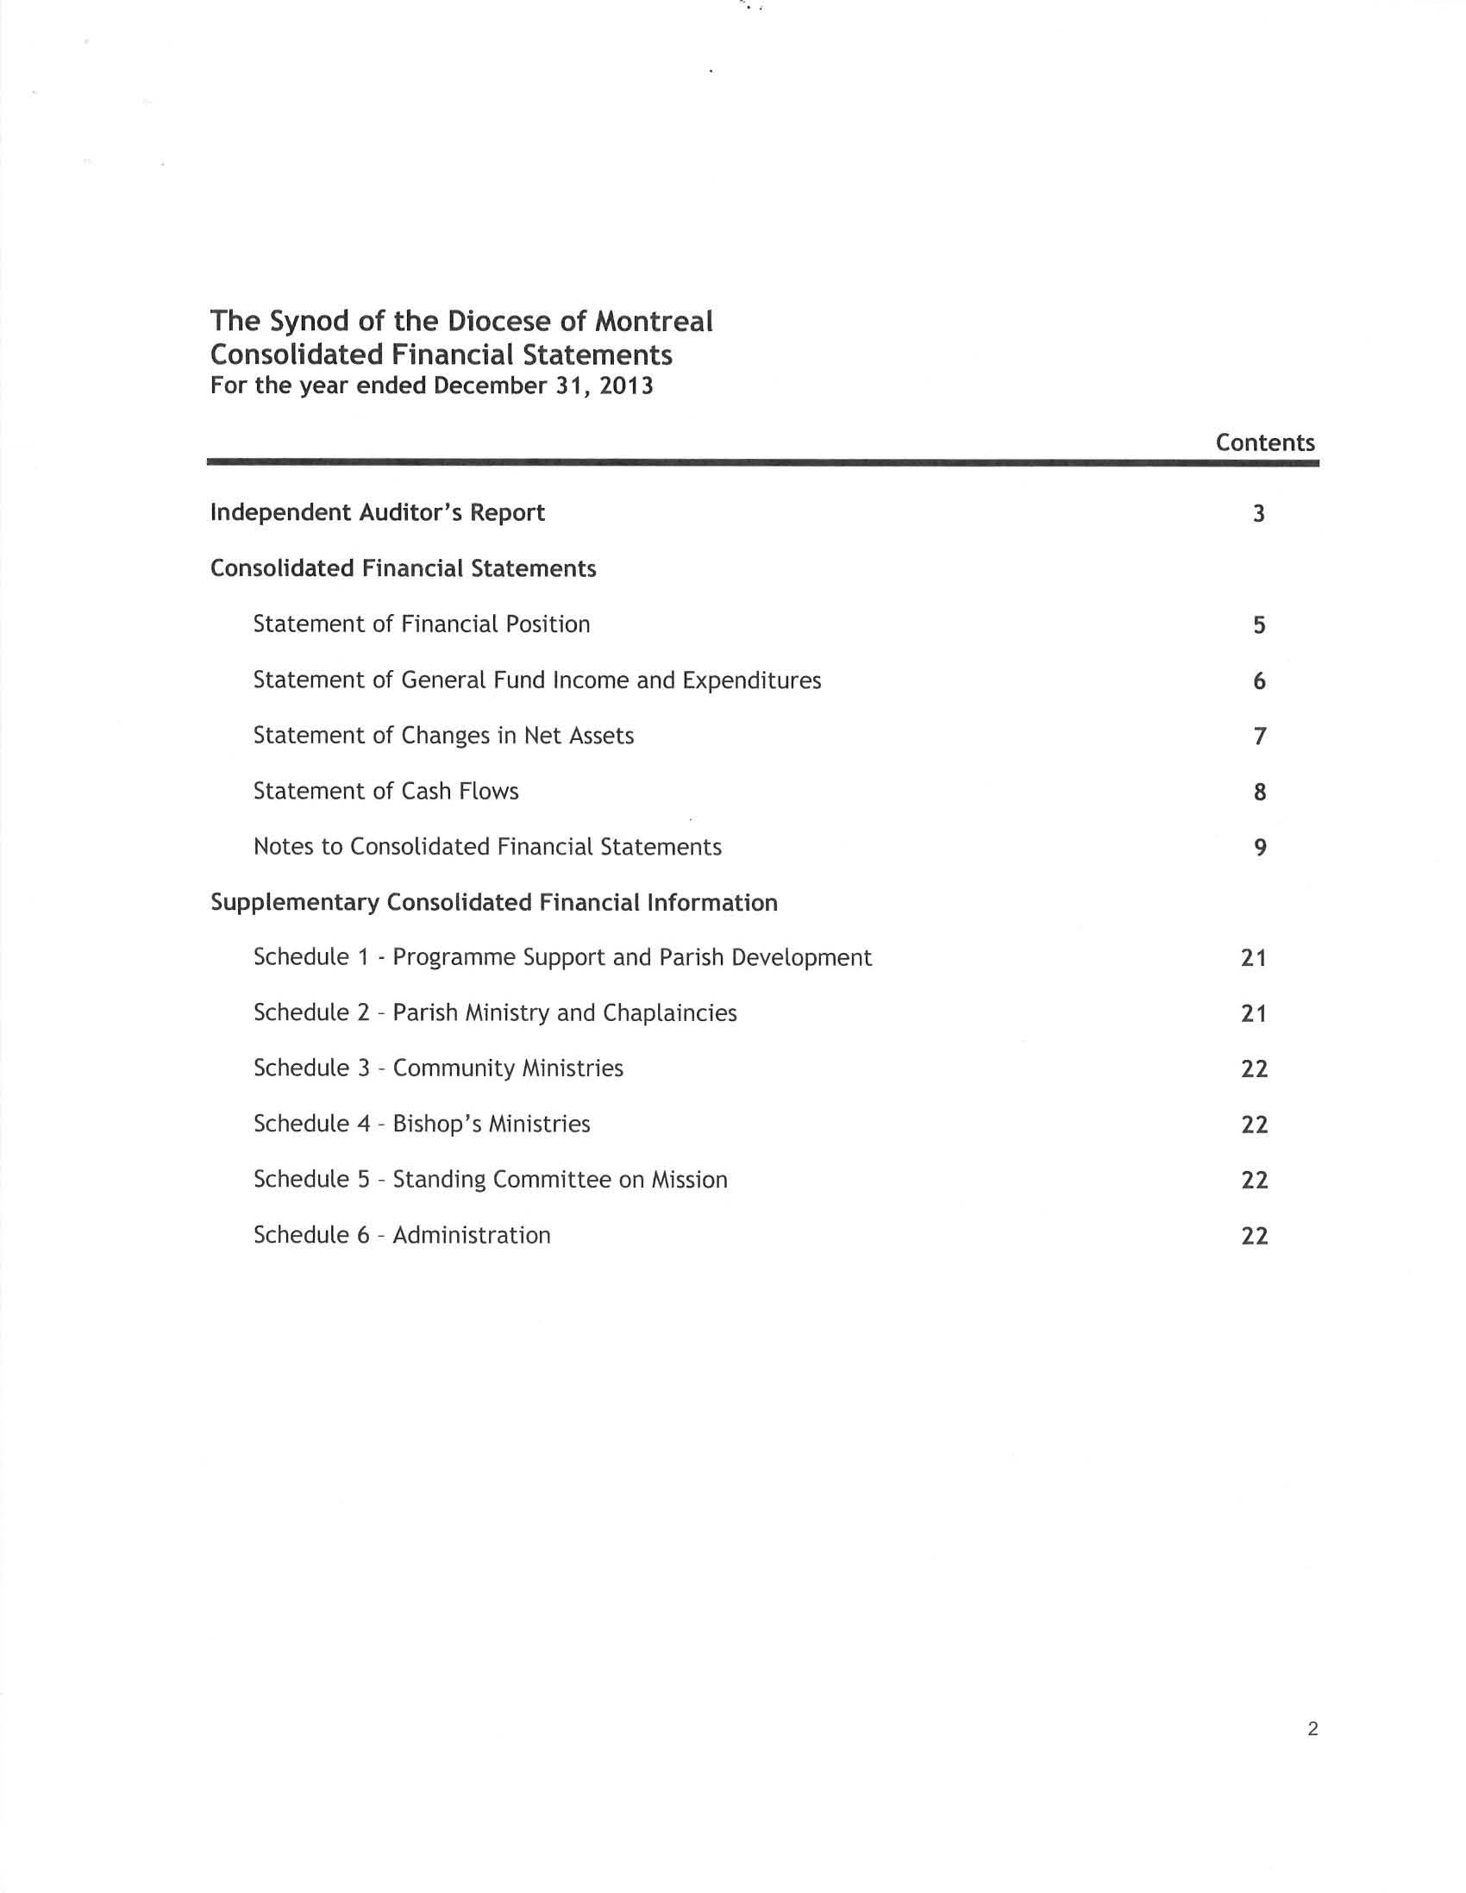
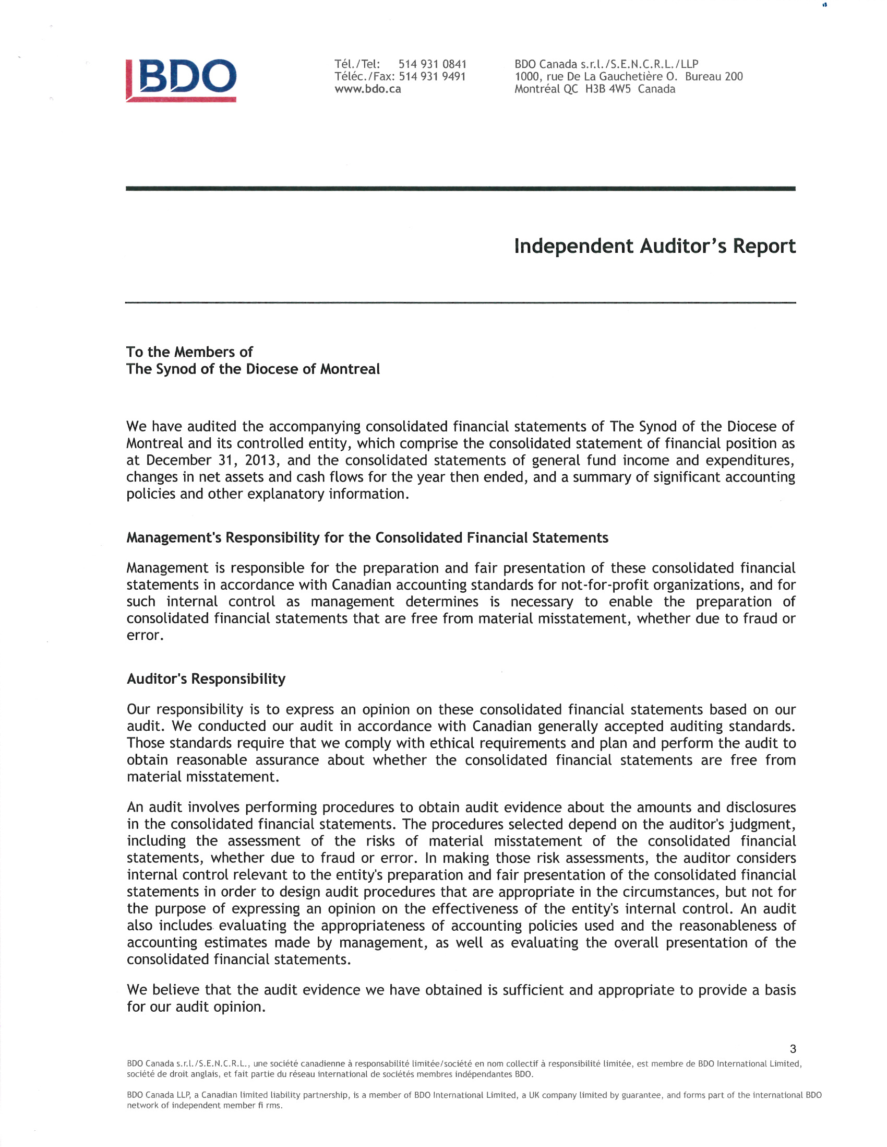
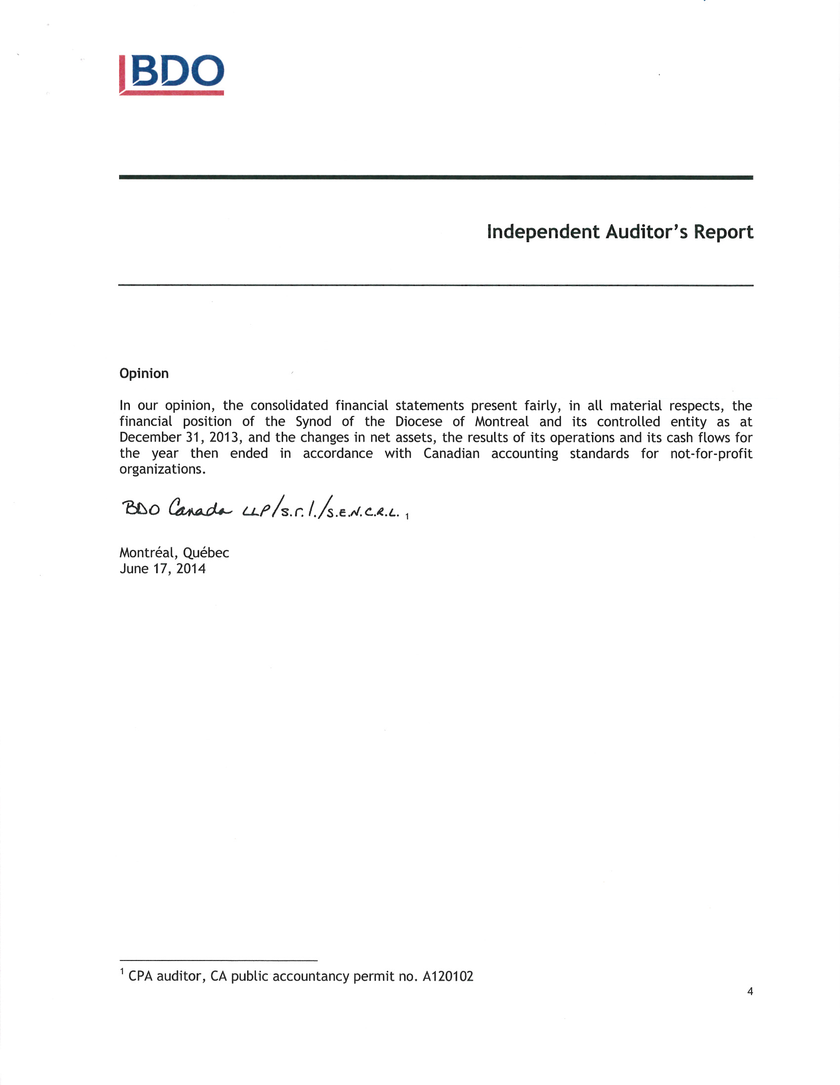
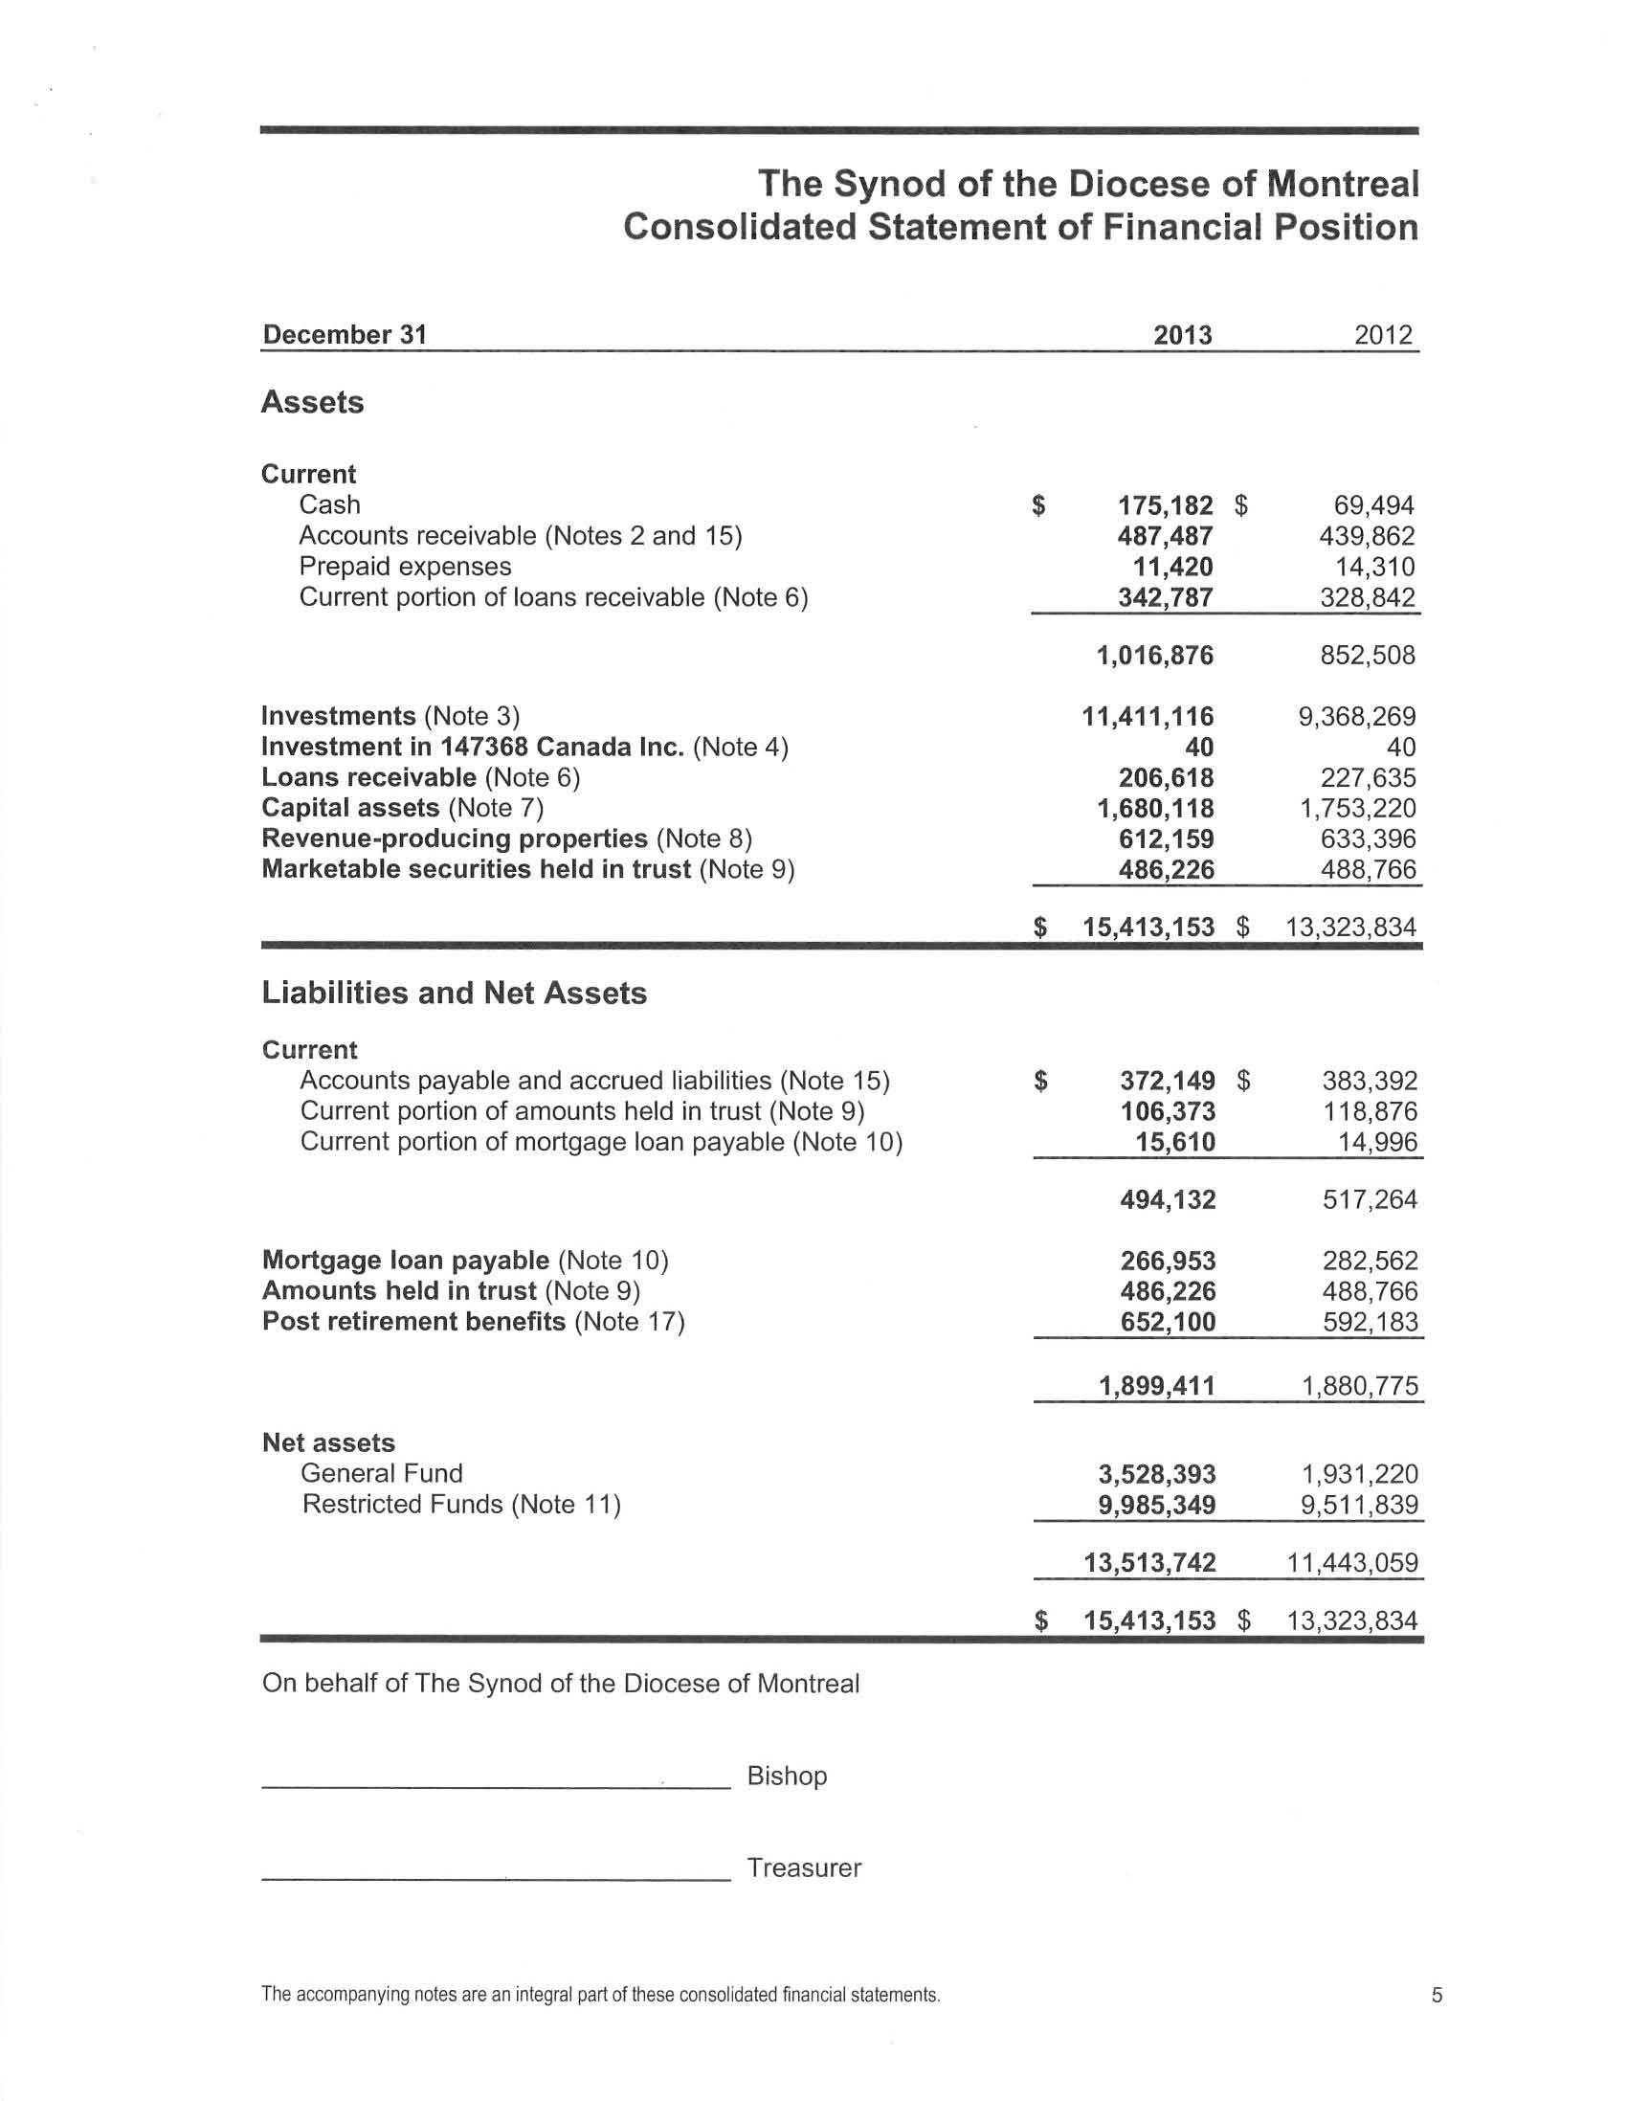
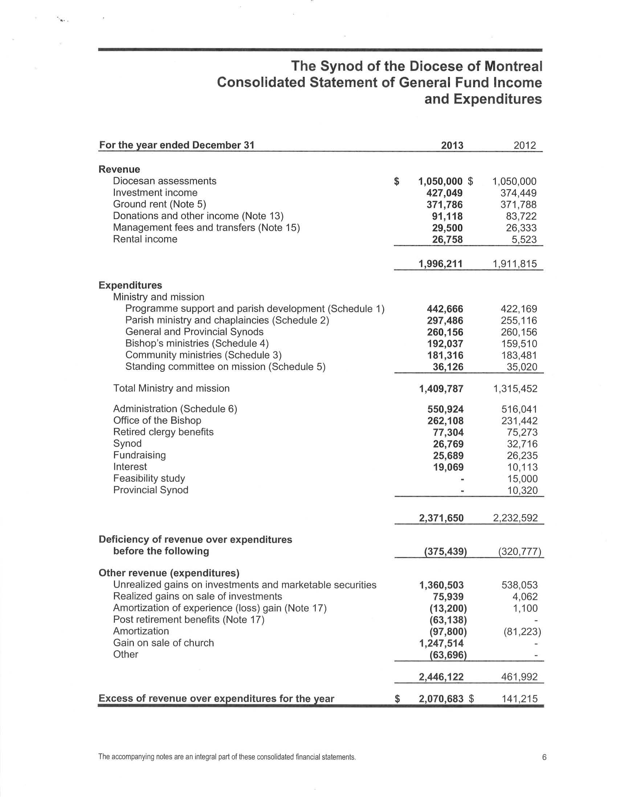
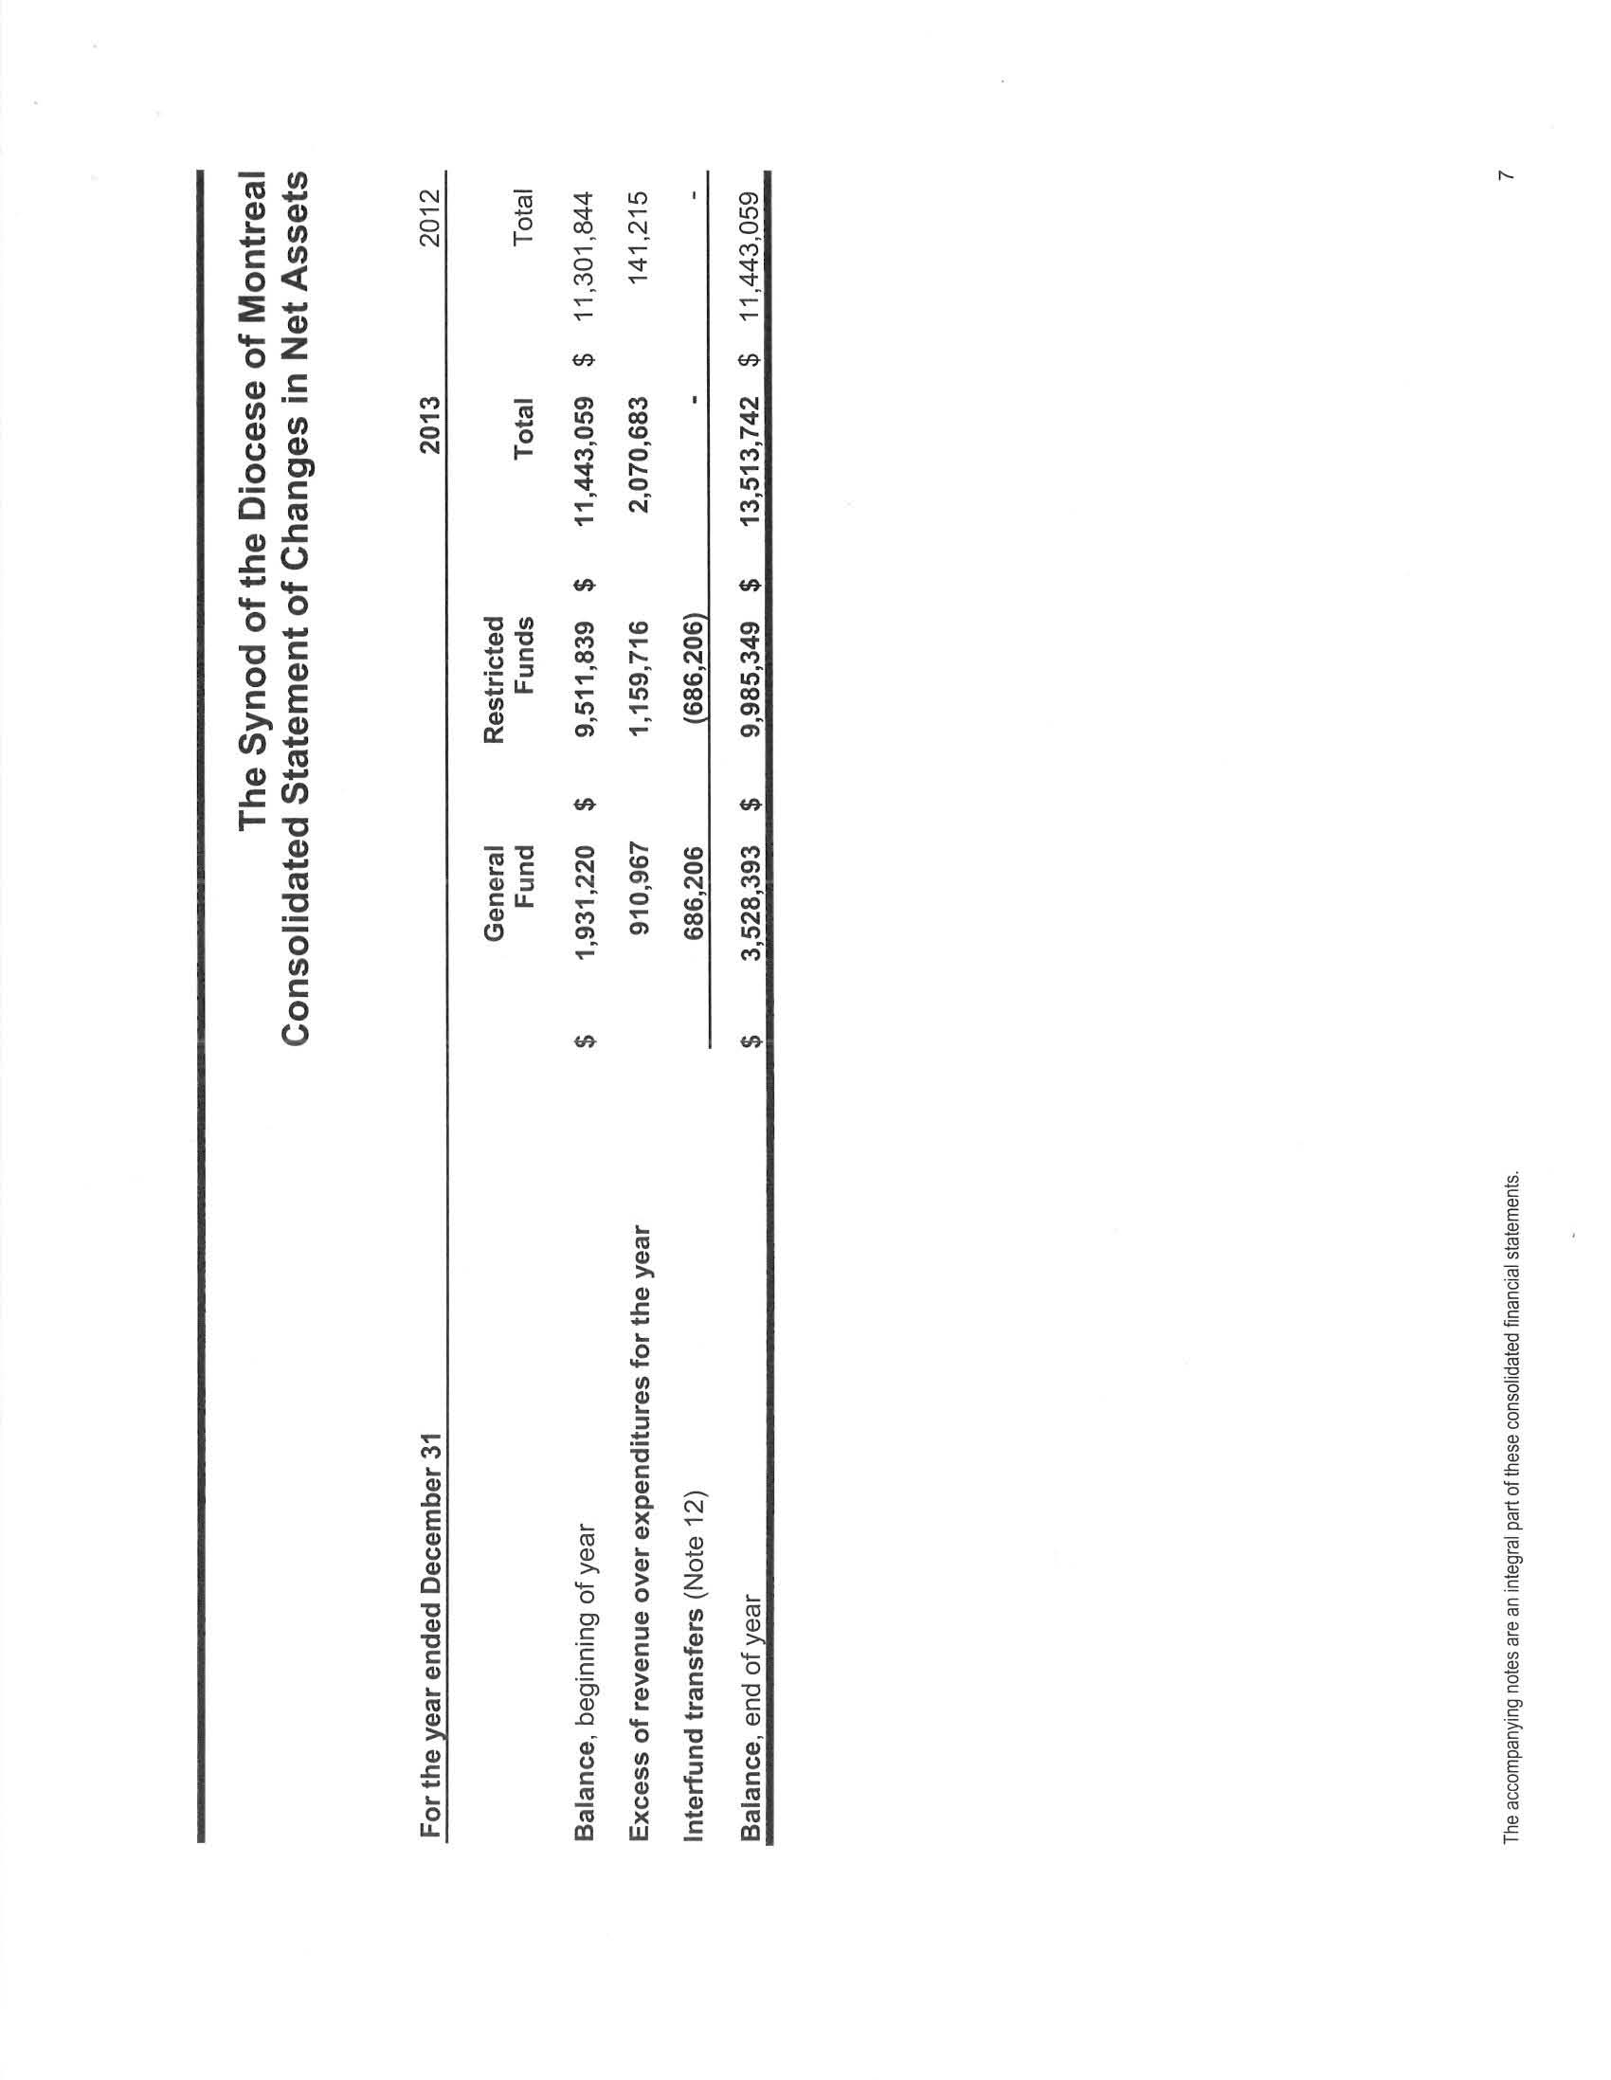
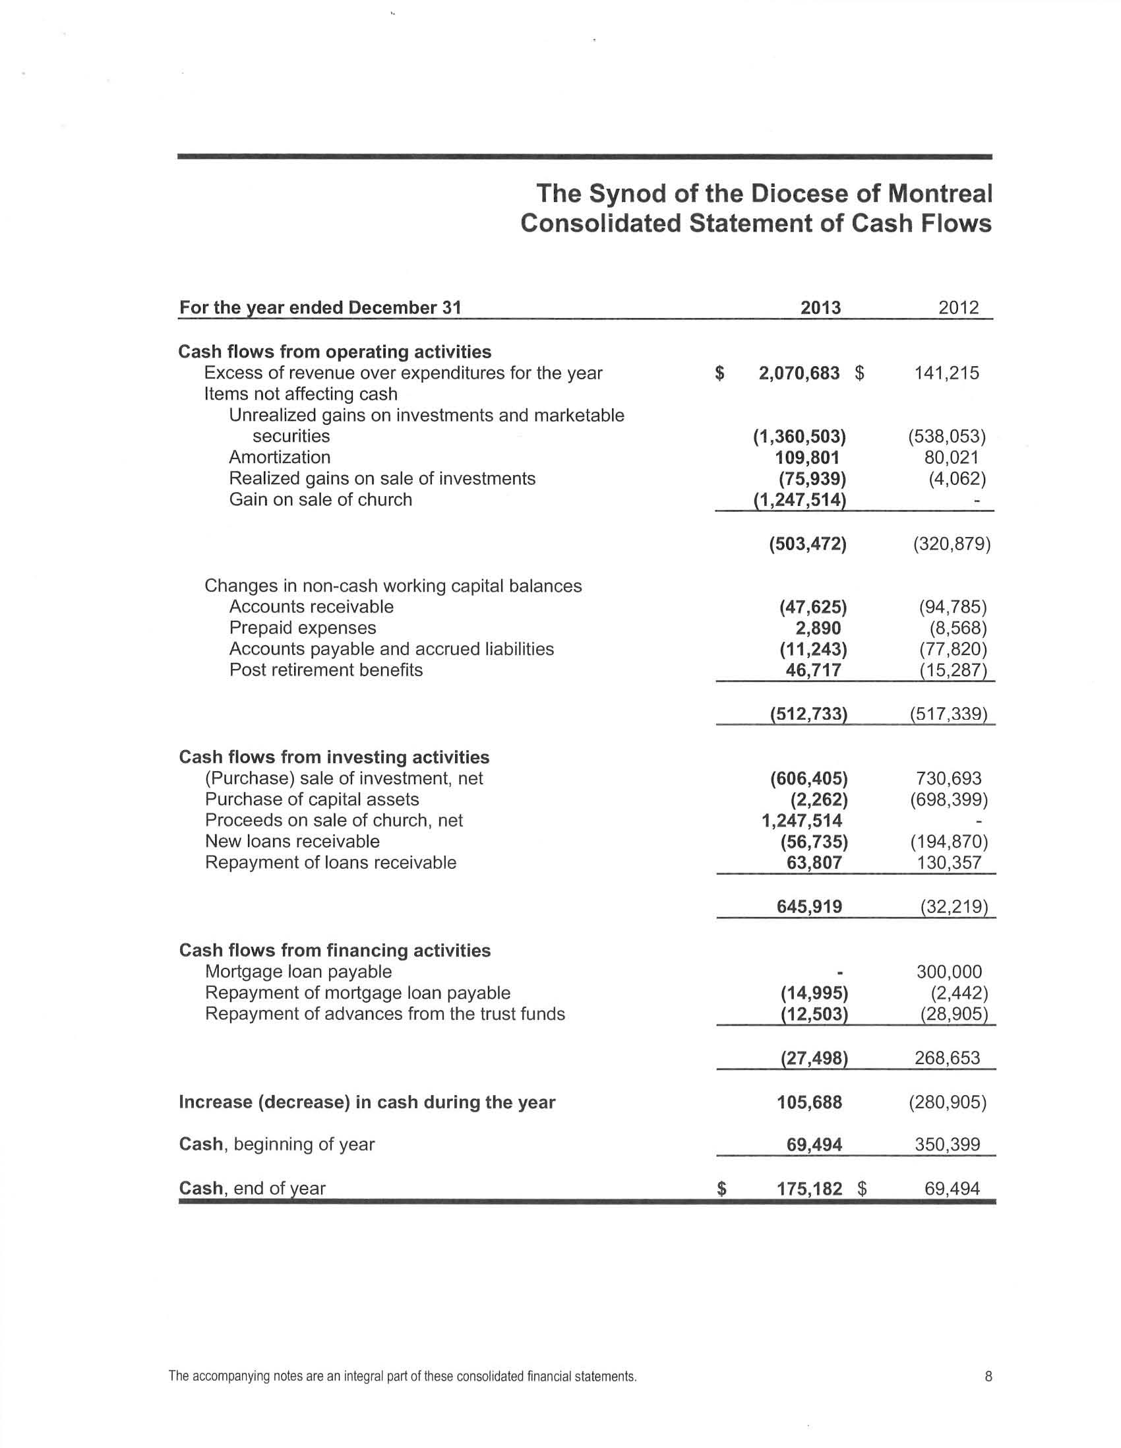
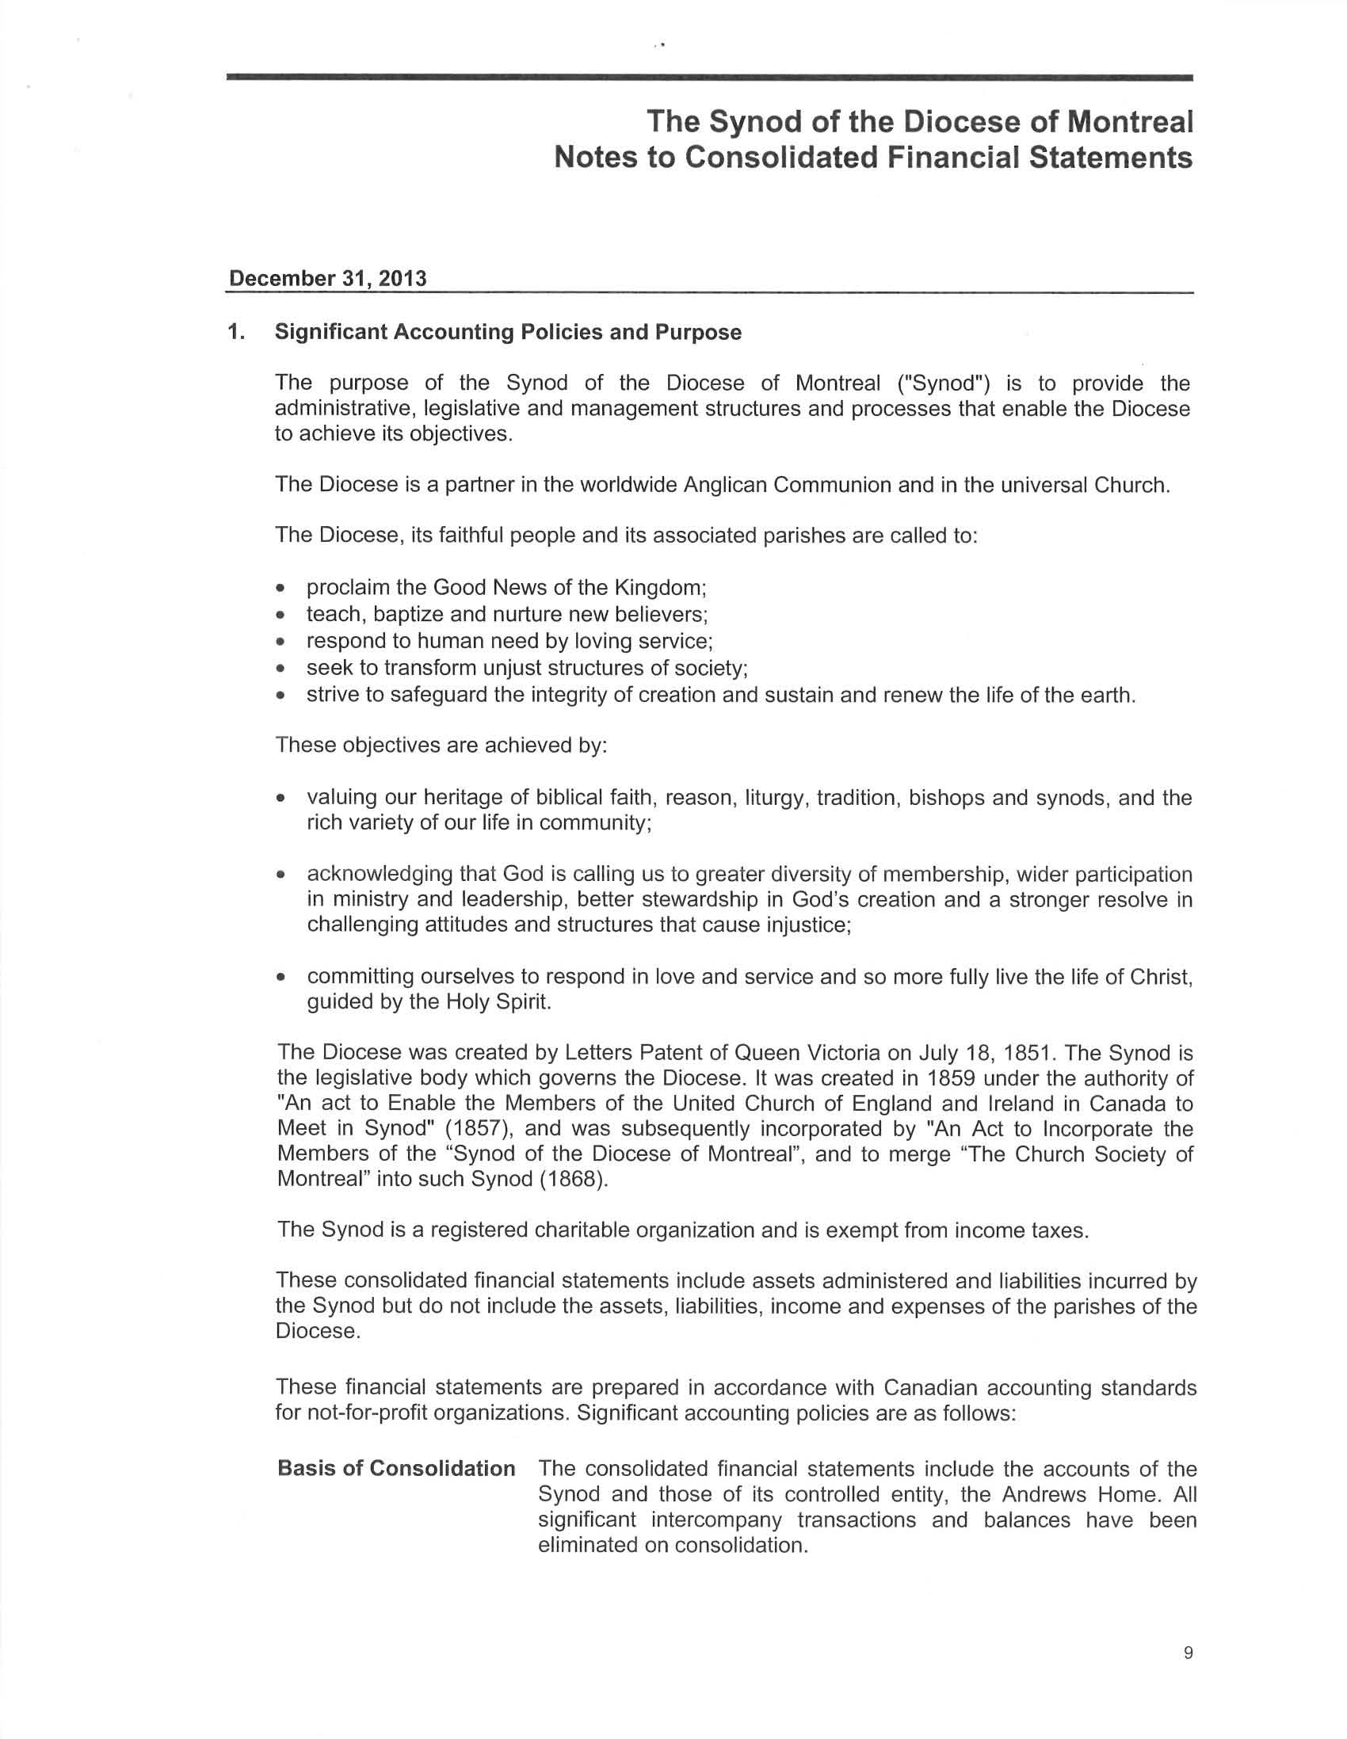
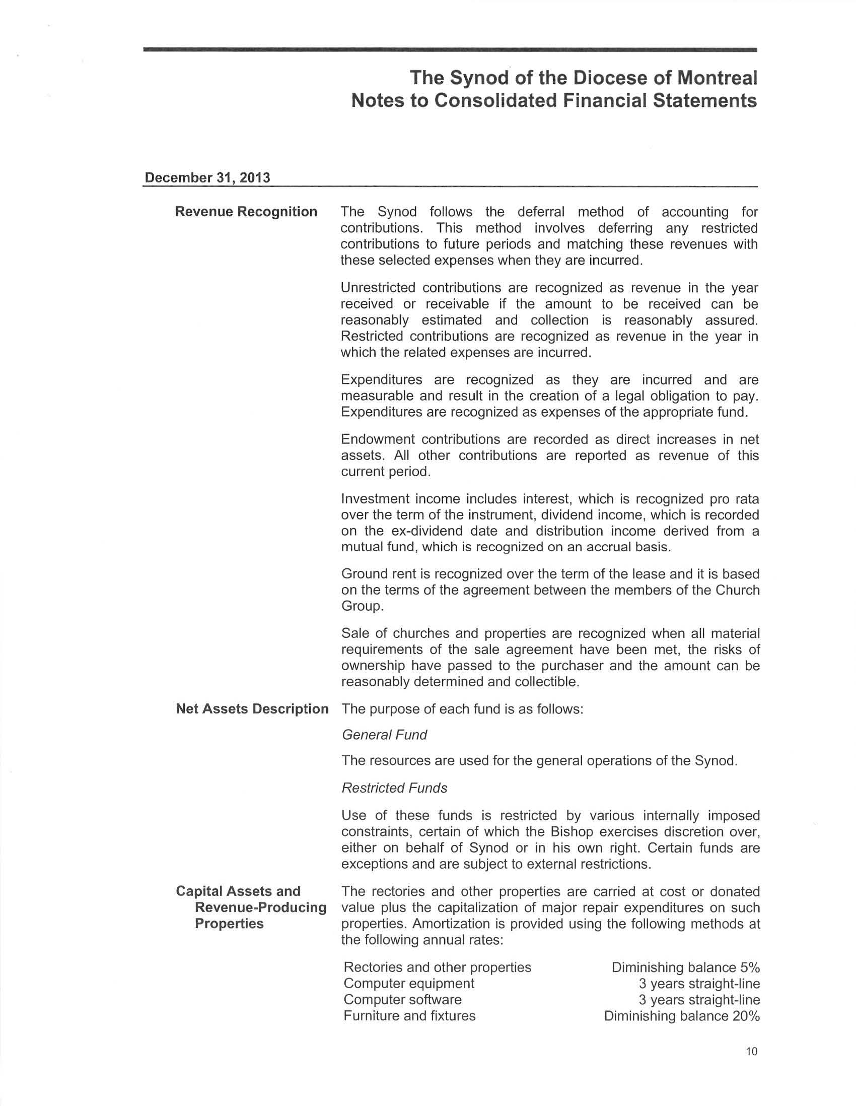
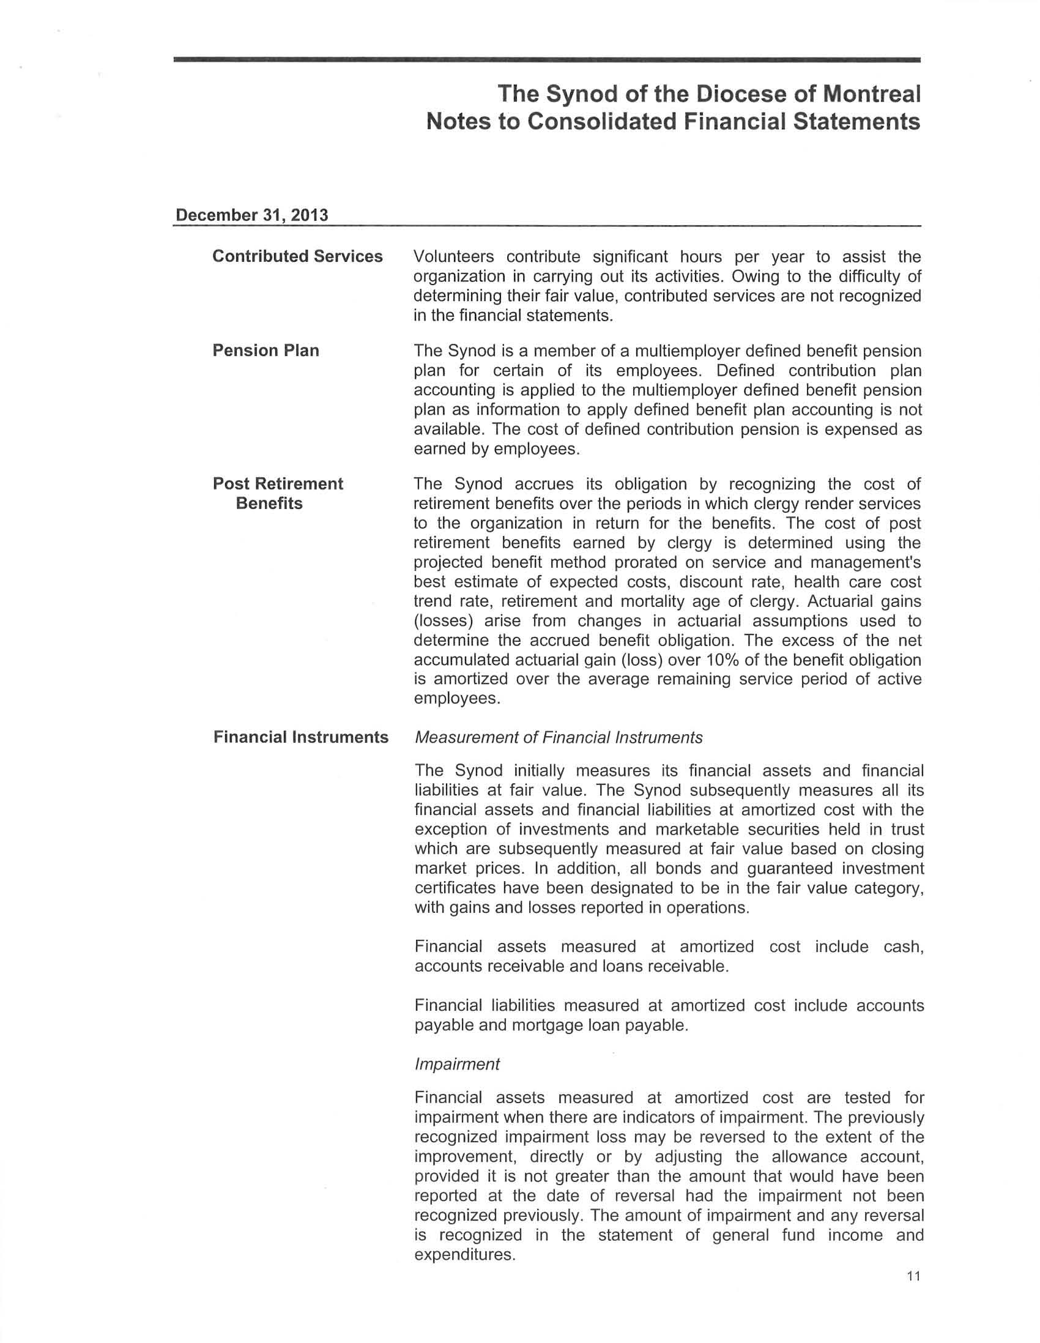
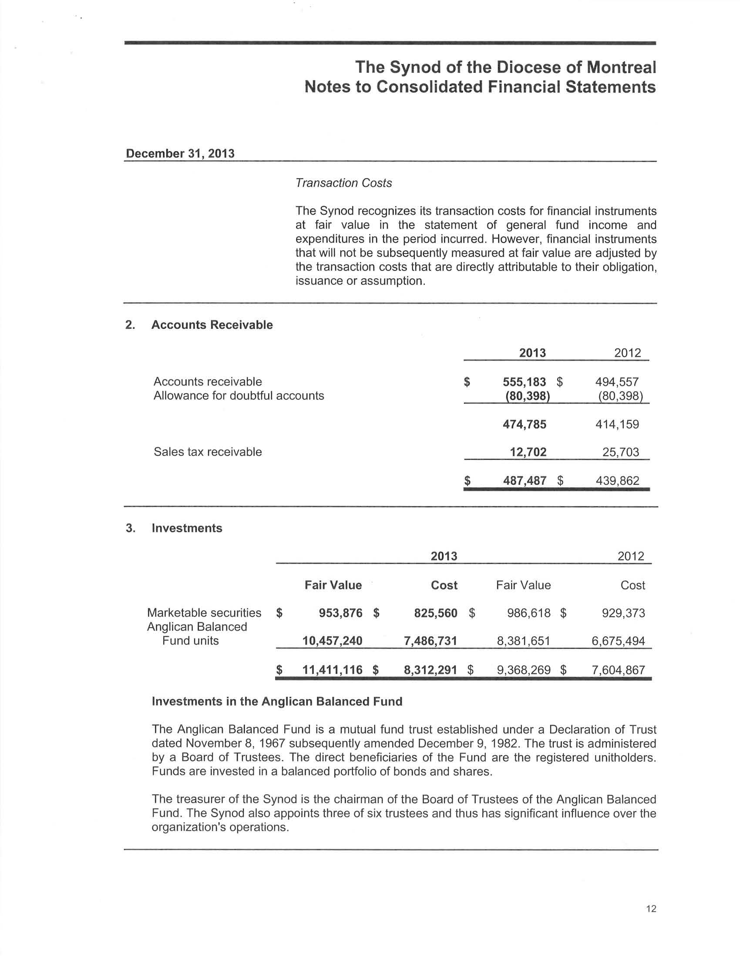
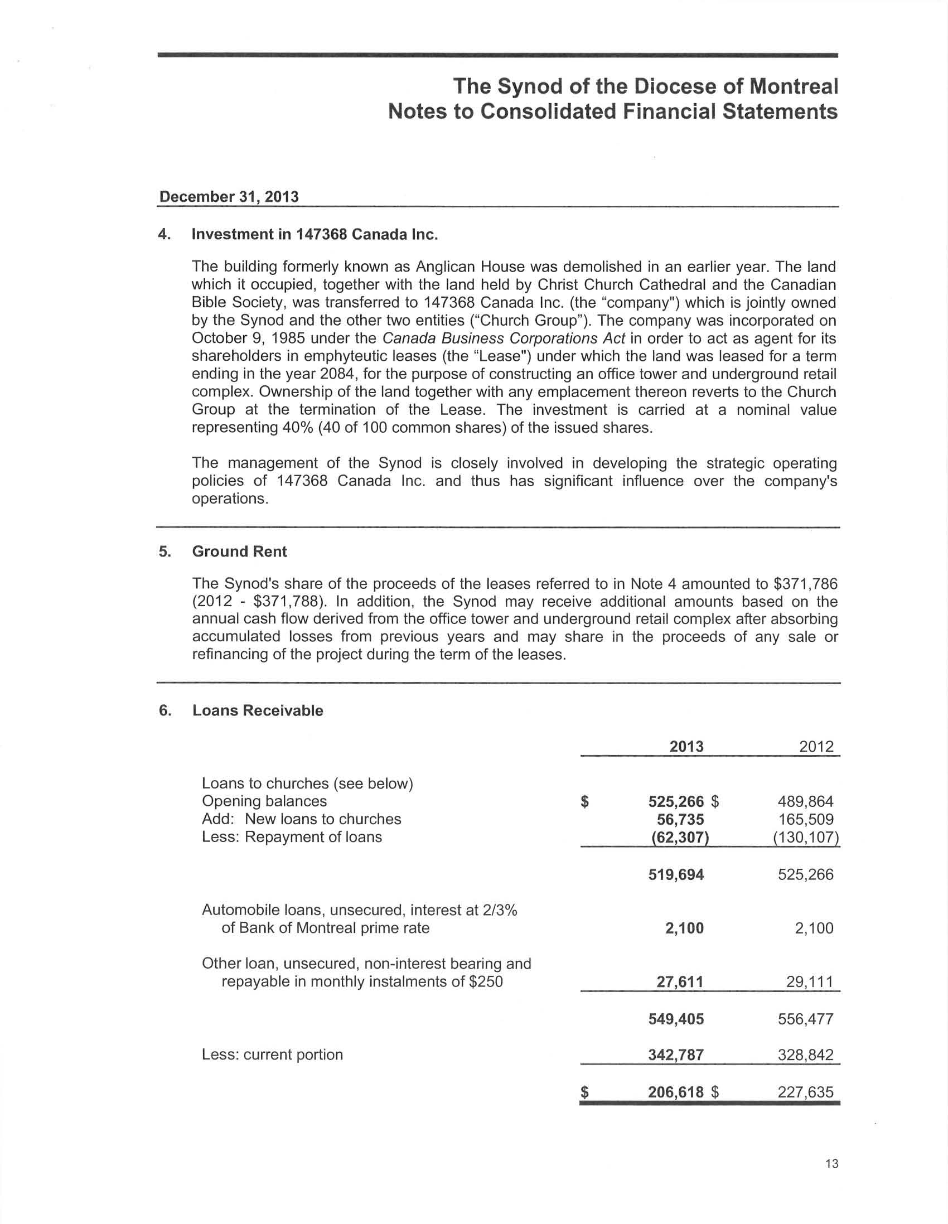
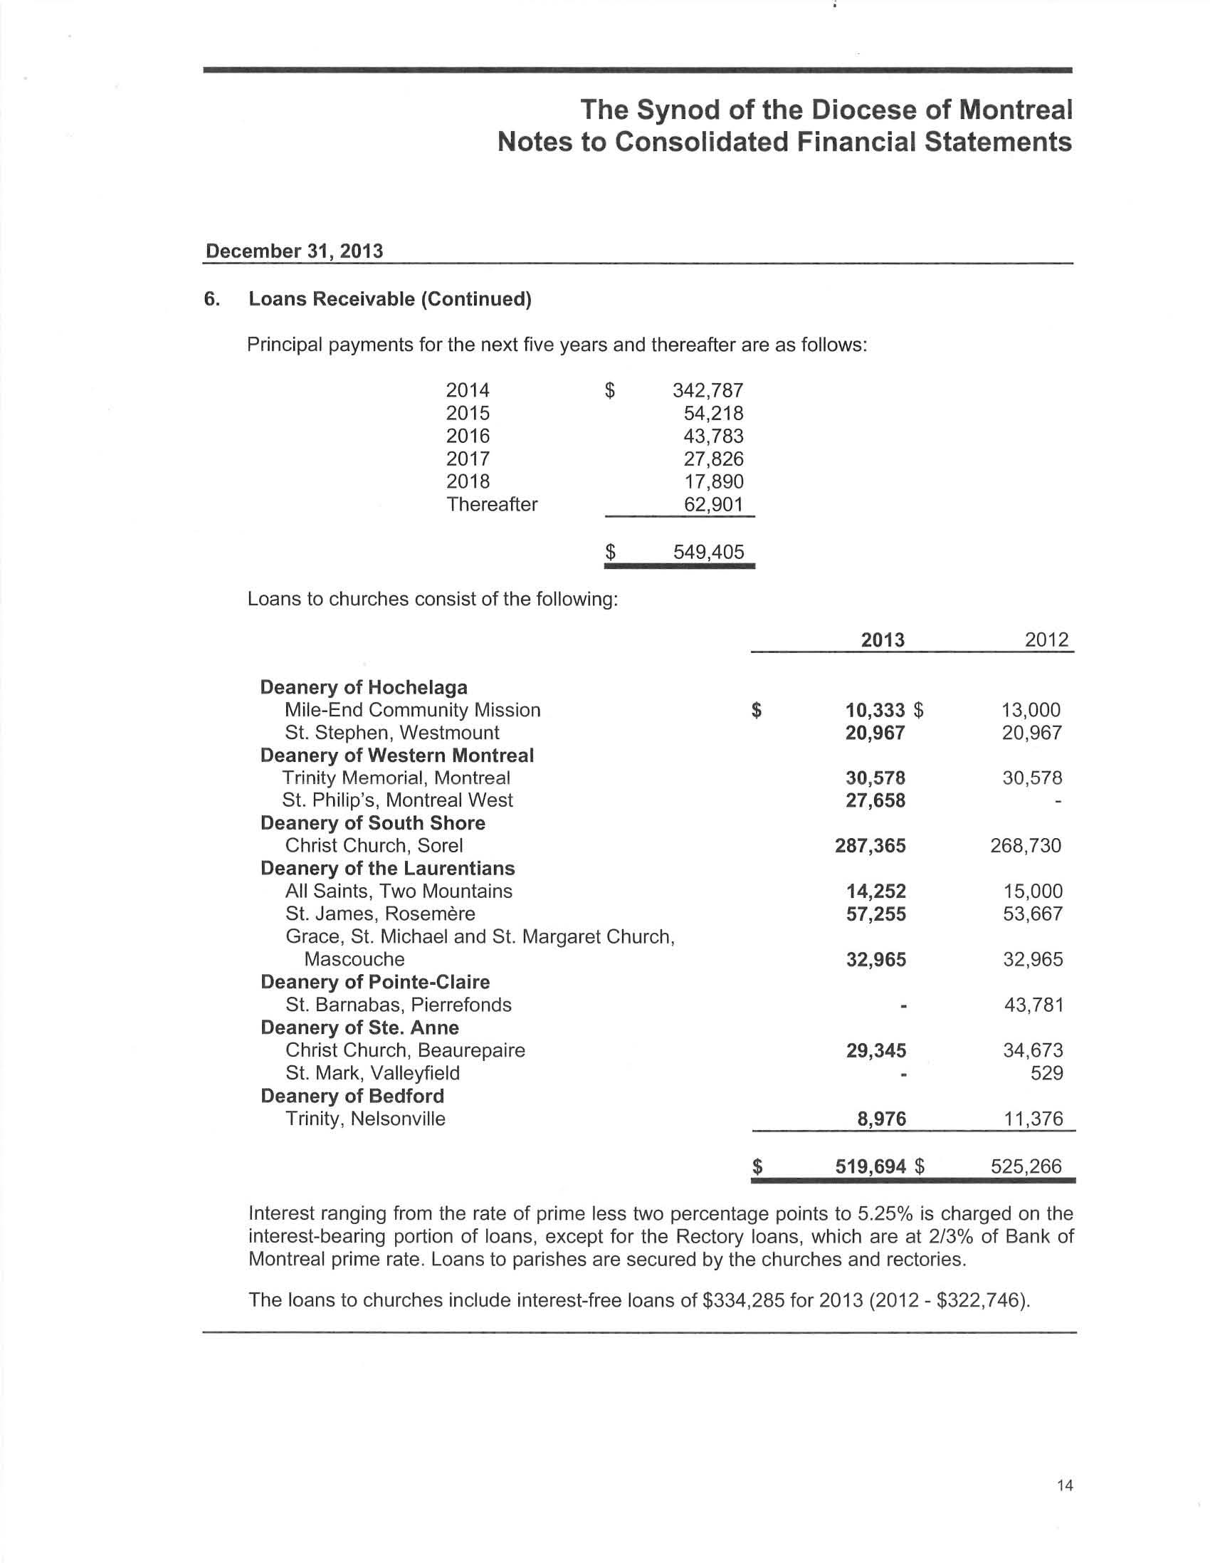
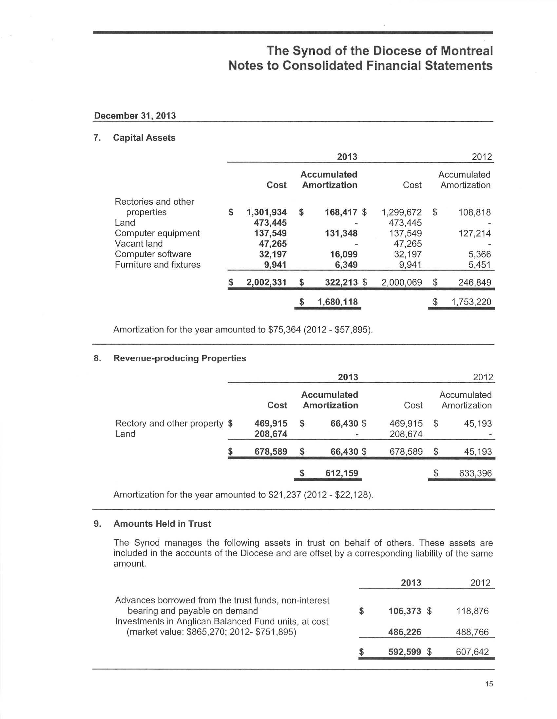
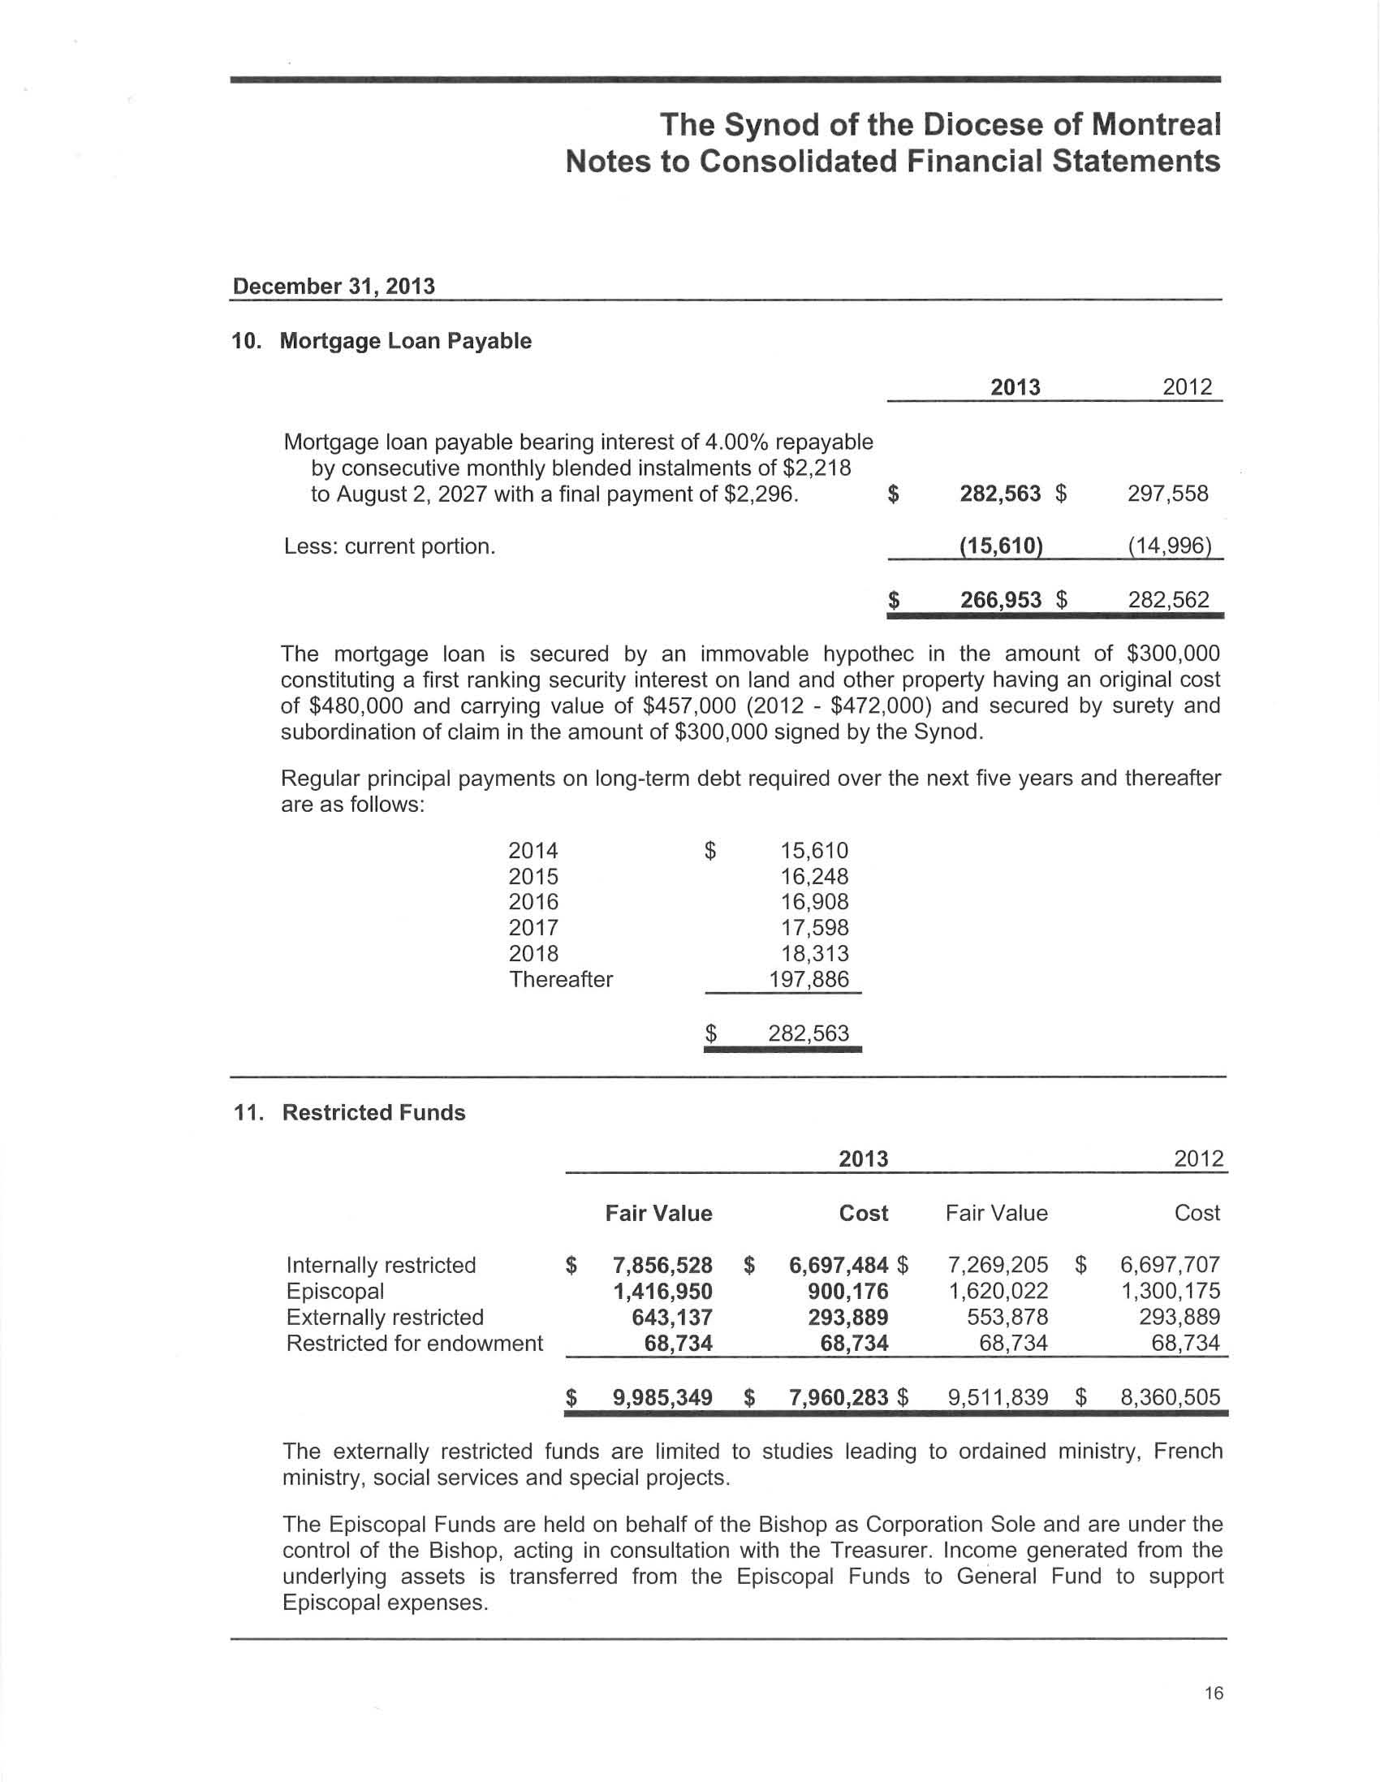
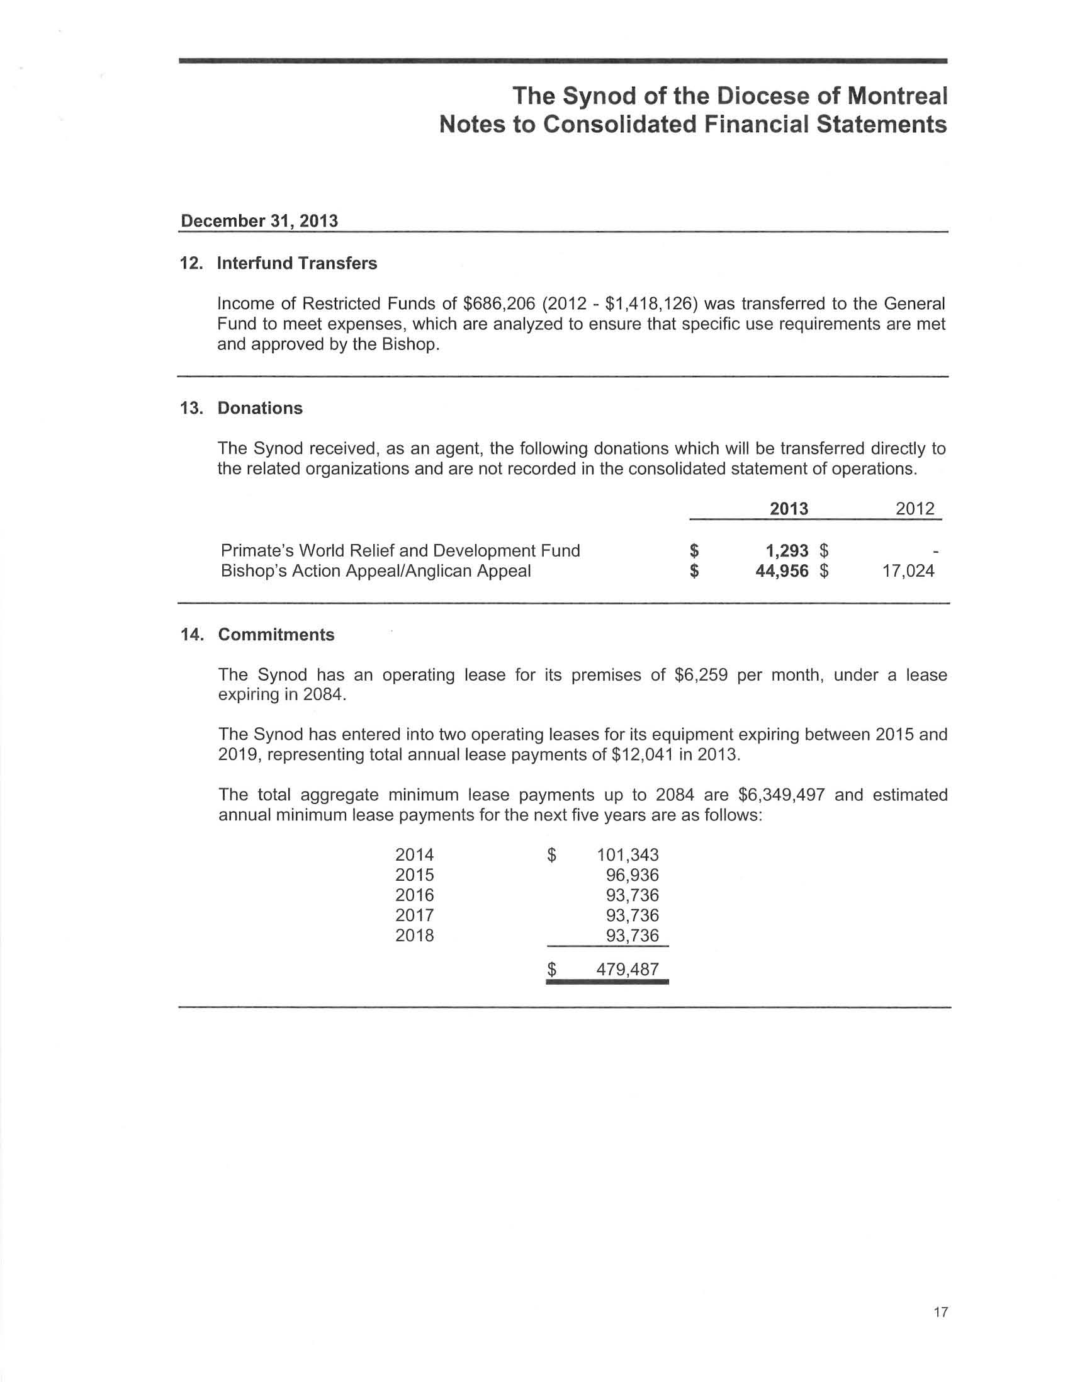
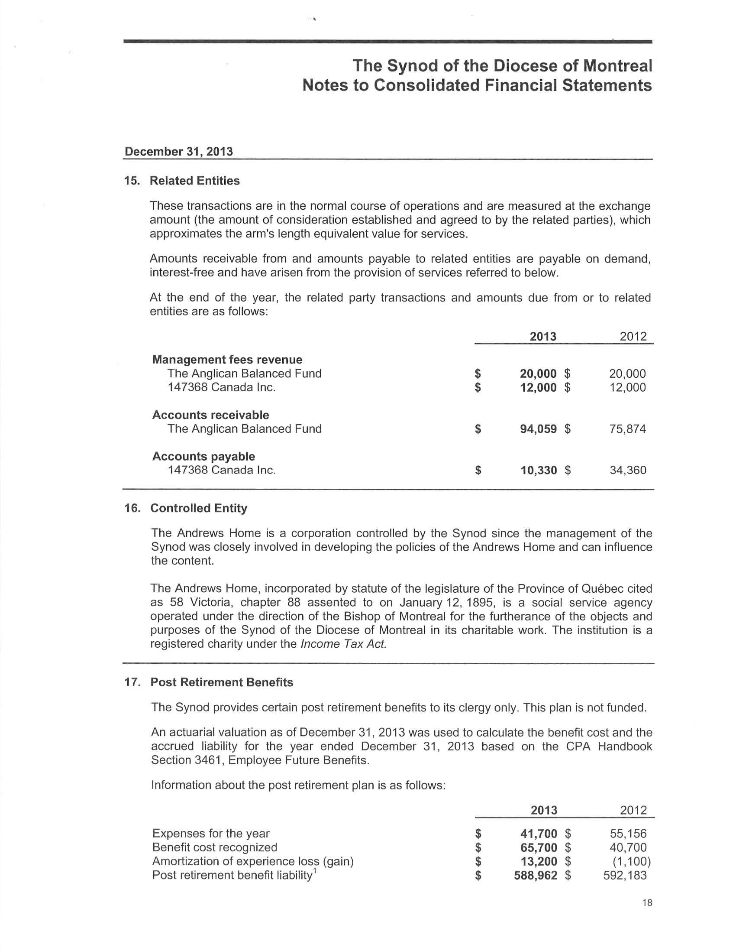
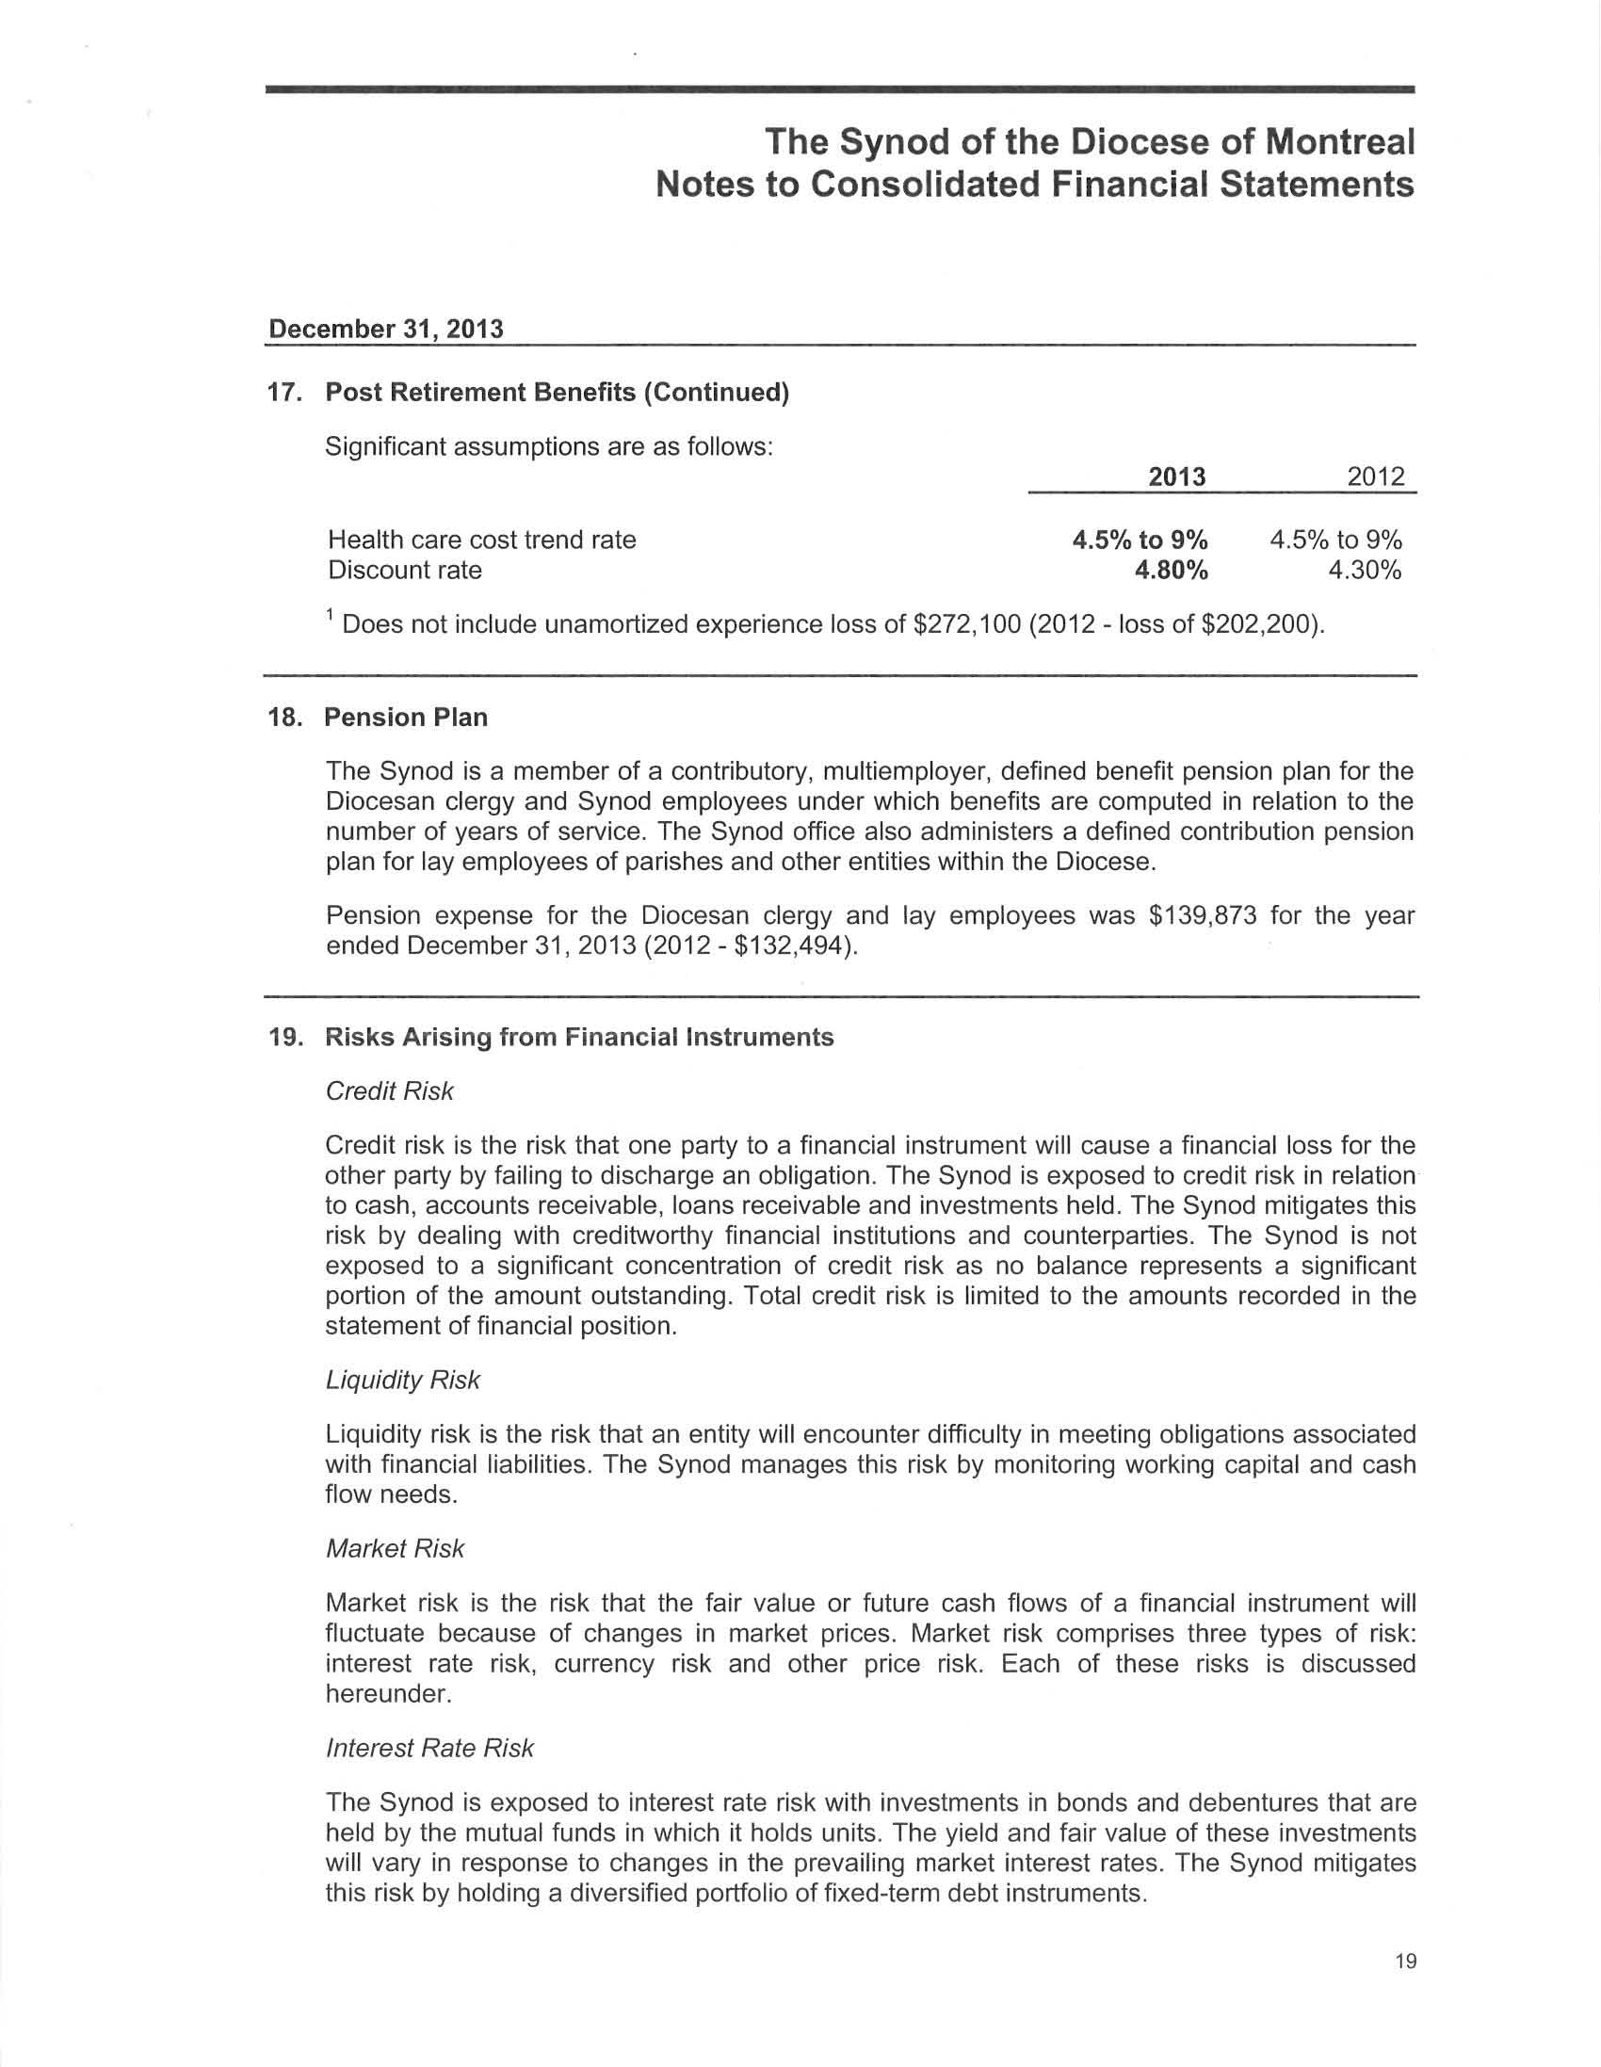
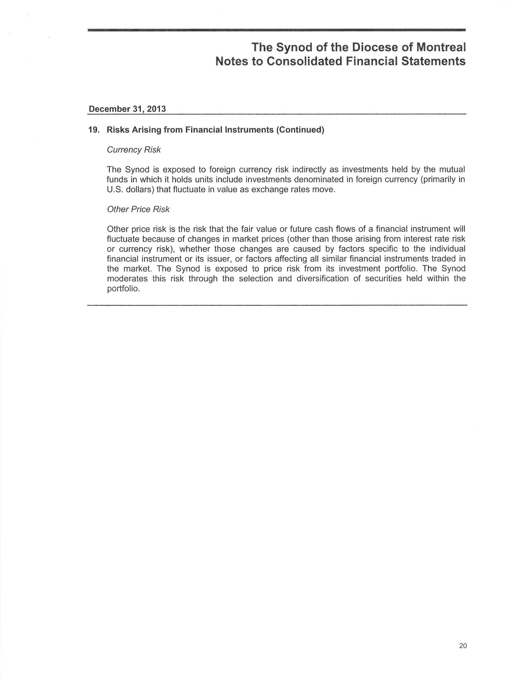
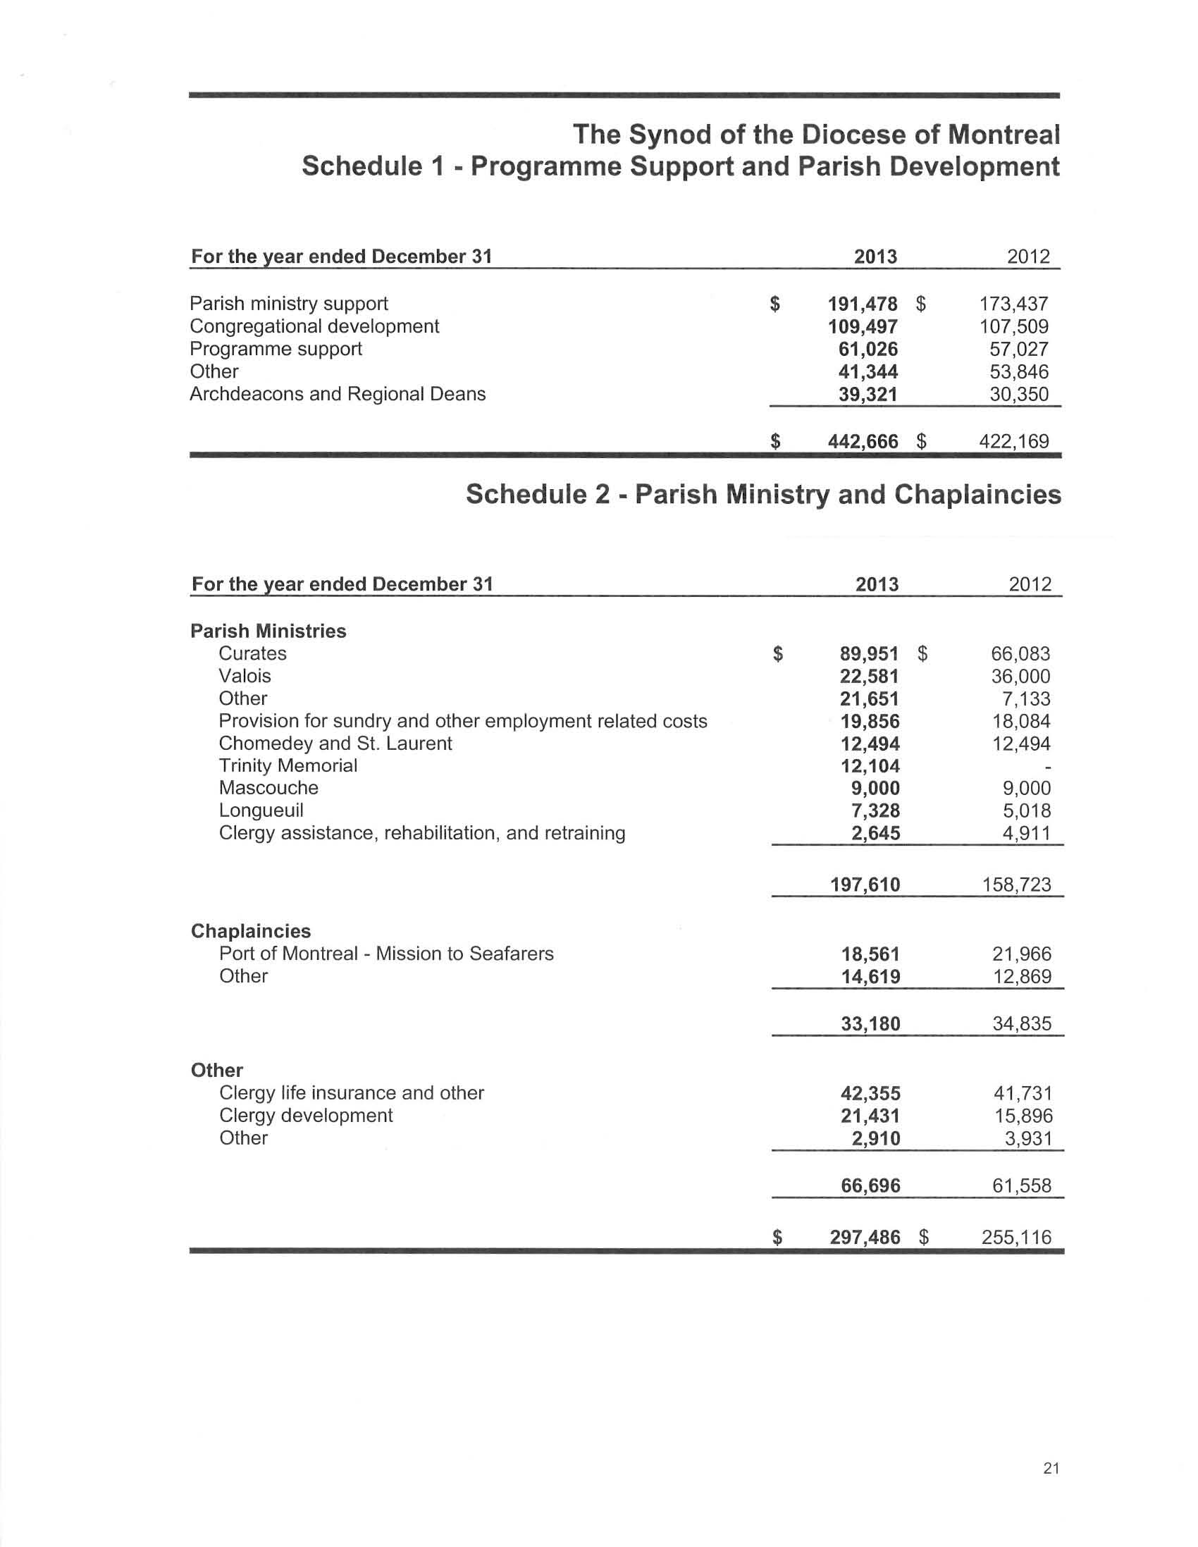
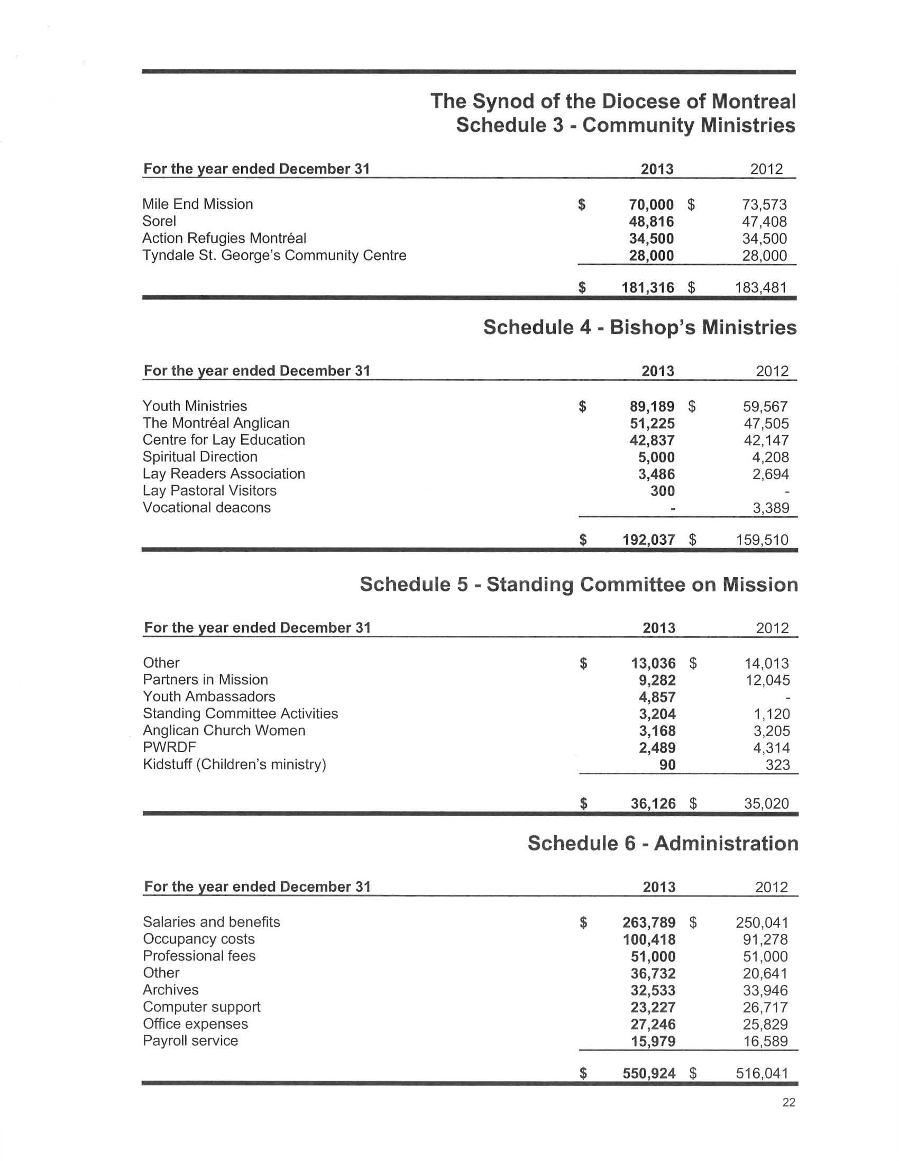

Section K: Draft Budget 2015 - Ébauche du Budget 2015

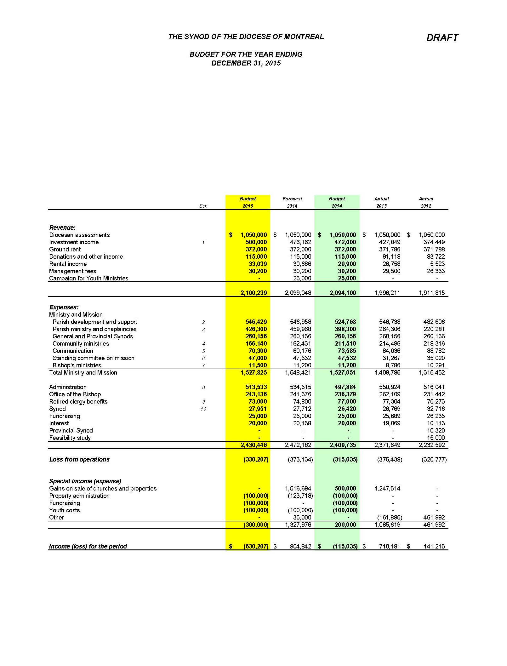
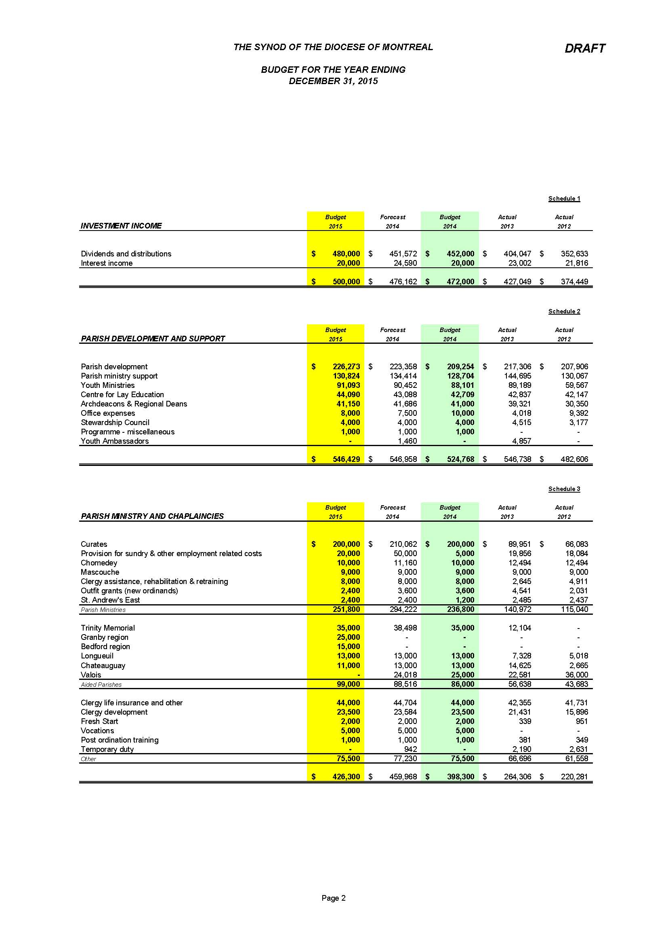
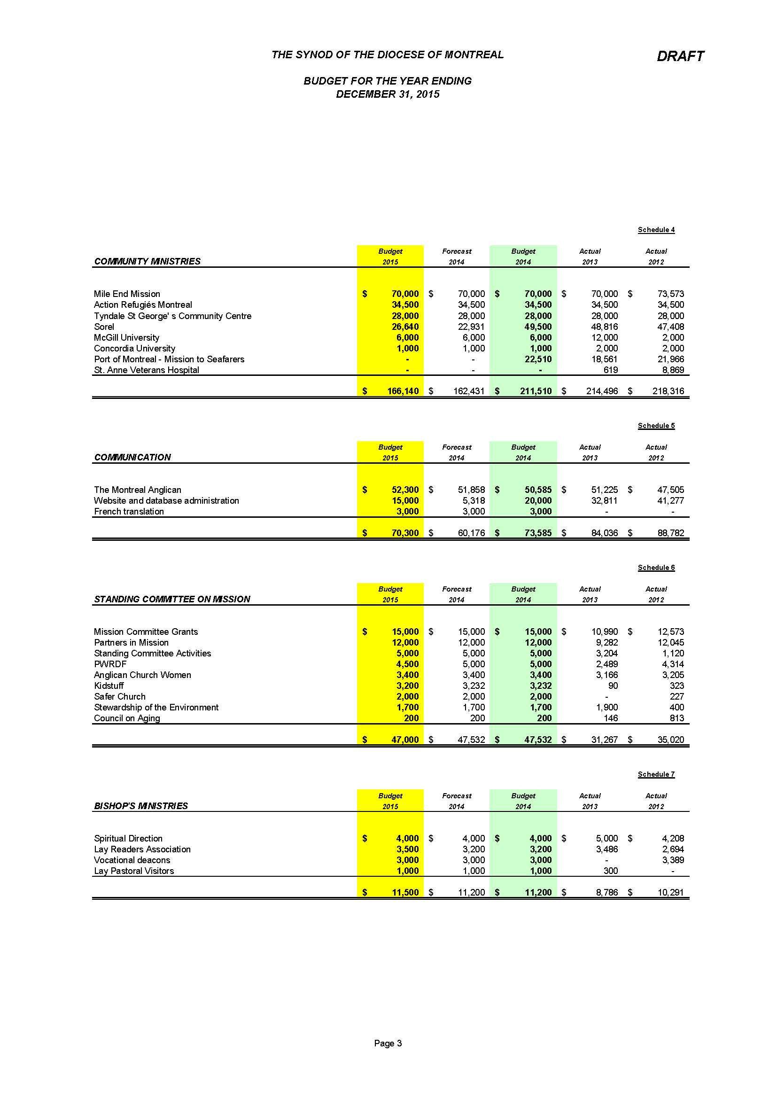
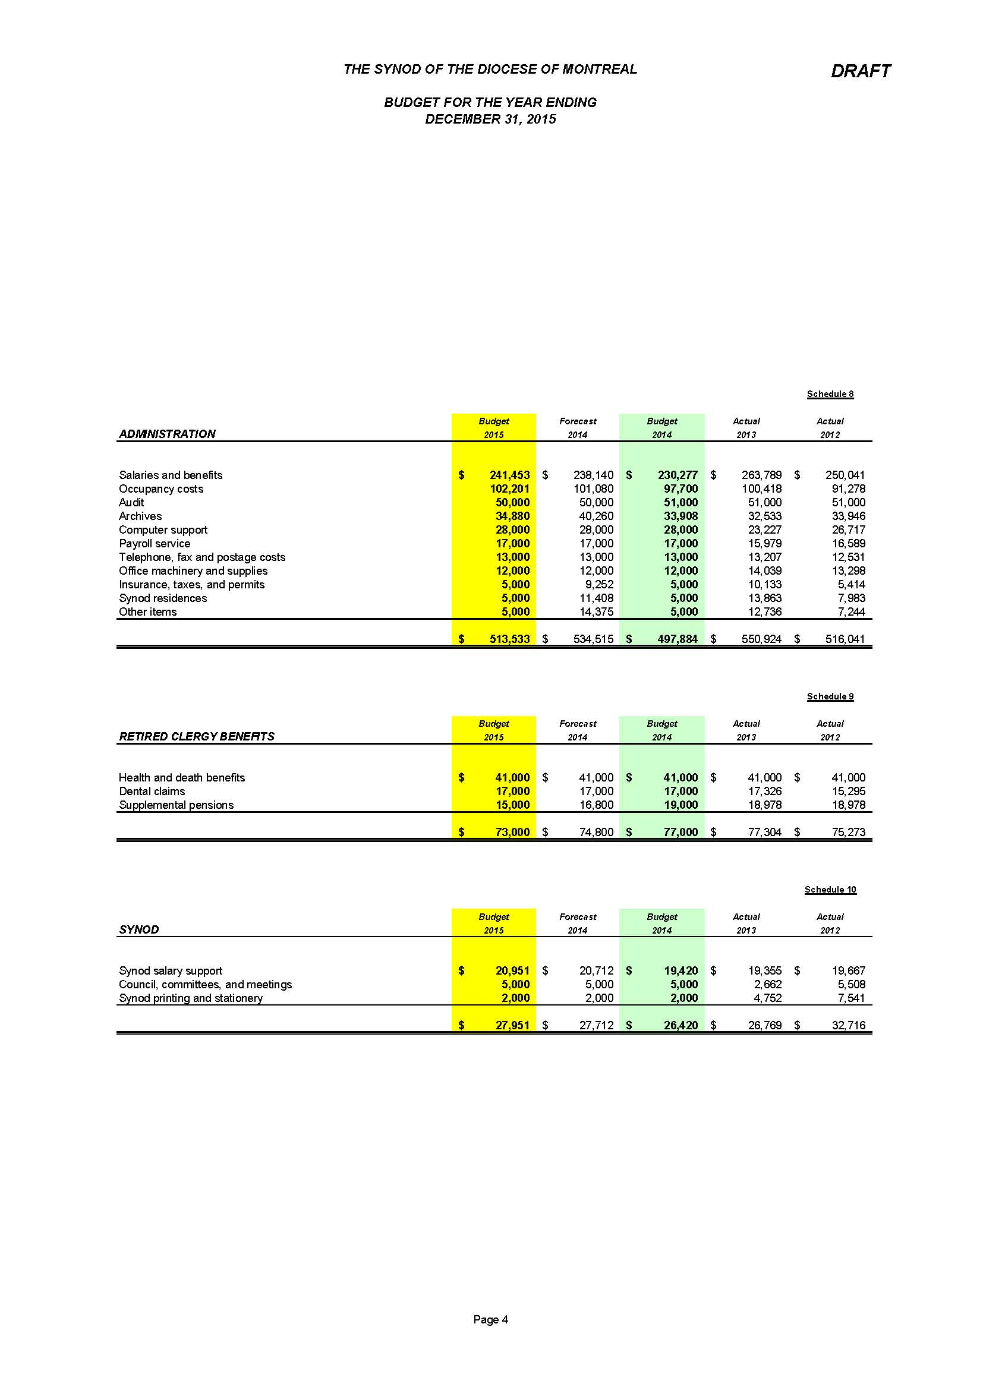

Section L: Parochial Statistics 2013 - Statistiques paroissiales 2013
